# 2016 Observing Notes

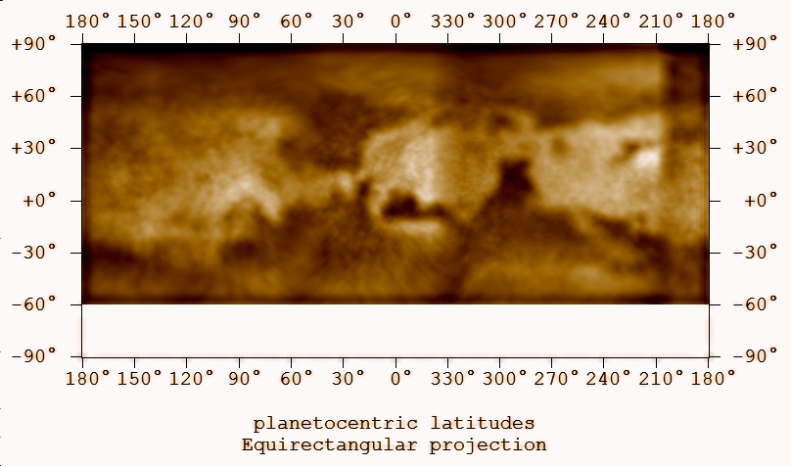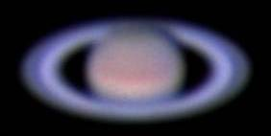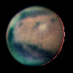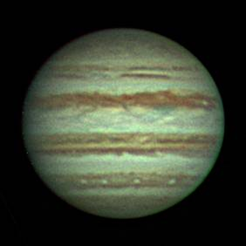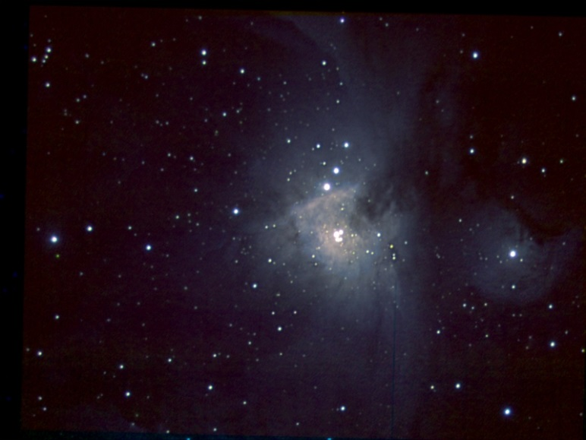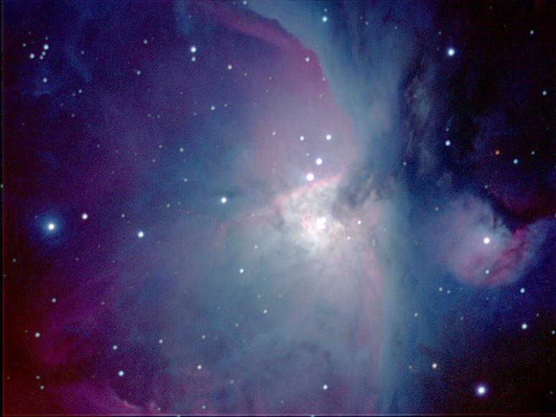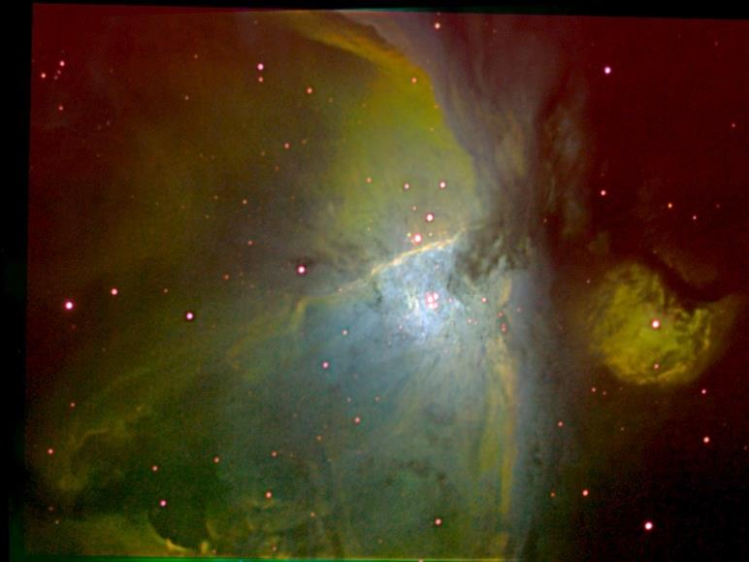

[2016 Observing Notes 1](#_Toc471232863)

[Year in Review 4](#_Toc471232864)

[January 6](#_Toc471232865)

[2016-Jan-26 (Jan-27 UT): M42 in OIII 6](#_Toc471232866)

[2016-Jan-27 (Jan-28 UT): M42 in SII 7](#_Toc471232867)

[2016-Jan-28 (Jan-29 UT): M42 in NIR > 742 and NIR > 807 8](#_Toc471232868)

[February 9](#_Toc471232869)

[2016-Feb-09 (Feb-10 UT): M42 in NIR > 807nm 9](#_Toc471232870)

[2016-Feb-16 (Feb-17 UT): M42 in HIB 10](#_Toc471232871)

[2016-Feb-20 (Feb-21 UT): M42 in OIII 11](#_Toc471232872)

[2016-Feb-23 (Feb-24 UT): M42 in SII 12](#_Toc471232873)

[2016-Feb-24 (Feb-25 UT): M42 in SII 13](#_Toc471232874)

[2016-Feb-25 (Feb-26 UT): M42 in HIB 14](#_Toc471232875)

[2016-Feb-28 (Feb-29 UT): M42 in HIB 15](#_Toc471232876)

[March 16](#_Toc471232877)

[2016-Mar-02 (Mar-03 UT): M42 in NIR > 742nm 16](#_Toc471232878)

[2016-Mar-10 (Mar-11 UT): M42 in NIR > 742nm 17](#_Toc471232879)

[2016-Mar-16 (Mar-17 UT): Rosette in SII 18](#_Toc471232880)

[2016-Mar-19 (Mar-20 UT): Rosette and M81+M82 in SII 19](#_Toc471232881)

[April 20](#_Toc471232882)

[2016-Apr-02 (Apr-03 UT): Jupiter Video with Europa, Ganymede and Callisto 20](#_Toc471232883)

[2016-Apr-21 (Apr-22 UT): Jupiter, Mars and Saturn Video with Europa, Ganymede and Callisto 24](#_Toc471232884)

[May 31](#_Toc471232885)

[2016-May-02 (May-03 UT): Jupiter Video with Io, Europa and Ganymede 31](#_Toc471232886)

[2016-May-03 (May-04 UT): Jupiter Video with Io, Europa, Ganymede and Callisto 34](#_Toc471232887)

[June 36](#_Toc471232888)

[Summer Observing Planning 36](#_Toc471232889)

[2016-Jun-15 (Jun-16 UT): Mars and Moon Video 37](#_Toc471232890)

[2016-Jun-26 (Jun-27 UT): Mars and Saturn Video 43](#_Toc471232891)

[July 49](#_Toc471232892)

[2016-Jul-06 (Jul-07 UT): Mars Video 49](#_Toc471232893)

[2016-Jul-10 (Jul-11 UT): Mars Video 51](#_Toc471232894)

[2016-Jul-14 (Jul-15 UT): Mars Video 53](#_Toc471232895)

[September 55](#_Toc471232896)

[2016-Sep-04 (Sep-05 UT): Vega, Beta Lyrae and Ring Nebula Spectra 55](#_Toc471232897)

[2016-Sep-08 (Sep-09 UT): NGC6888 Crescent Nebula Narrow Band Imaging 56](#_Toc471232898)

[2016-Sep-10 (Sep-11 UT): IC 1318 Butterfly Nebula Narrow Band (SII, HIA, OIII) Imaging 57](#_Toc471232899)

[2016-Sep-18 (Sep-19 UT): IC 1318 Butterfly Nebula Narrow Band (SII, HIA) Imaging 58](#_Toc471232900)

[2016-Sep-25 (Sep-26 UT): IC 1318 Butterfly Nebula Narrow Band Imaging 59](#_Toc471232901)

[2016-Sep-26 (Sep-27 UT): IC 1318 Butterfly Nebula Narrow Band Imaging 60](#_Toc471232902)

[2016-Sep-27 (Sep-28 UT): NGC7000 North America Nebula Narrow Band (HIA, SII) Imaging 62](#_Toc471232903)

[2016-Sep-28 (Sep-29 UT): NGC7000 North America Nebula Narrow Band (HIB, OIII) Imaging 63](#_Toc471232904)

[October 64](#_Toc471232905)

[2016-Oct-15 (Oct-16 UT): NGC6888 Crescent Nebula NIR 64](#_Toc471232906)

[2016-Oct-19 (Oct-20 UT): NGC6888 Crescent Nebula NUV 65](#_Toc471232907)

[2016-Oct-20 (Oct-21 UT): NGC6888 Crescent Nebula NUV 66](#_Toc471232908)

[2016-Oct-22 (Oct-23 UT): IC 1318 Butterfly Nebula NIR 67](#_Toc471232909)

[2016-Oct-26 (Oct-27 UT): IC 1318 Butterfly Nebula NUV 68](#_Toc471232910)

[November 69](#_Toc471232911)

[2016-Nov-02 (Nov-03 UT): NGC7000 North America Nebula NIR 69](#_Toc471232912)

[2016-Nov-03 (Nov-04 UT): NGC7000 North America Nebula NUV 70](#_Toc471232913)

[2016-Nov-05 (Nov-06 UT): M33 NUV 71](#_Toc471232914)

[2016-Nov-06 (Nov-07 UT): NGC7023 NUV 72](#_Toc471232915)

[2016-Nov-07 (Nov-08 UT): NGC7023 Iris Nebula NIR 73](#_Toc471232916)

[2016-Nov-08 (Nov-09 UT): NGC7023 HIA and NGC 7635 NIR 74](#_Toc471232917)

[2016-Nov-09 (Nov-10 UT): M33 NIR 807nm 75](#_Toc471232918)

[2016-Nov-13 (Nov-14 UT): M33 NIR 685nm and NGC 7023 NIR 742nm and 807nm 76](#_Toc471232919)

[2016-Nov-14 (Nov-15 UT): M33 NIR 685nm and 742nm 78](#_Toc471232920)

[2016-Nov-15 (Nov-16 UT): M33 NIR 742nm and NUV 79](#_Toc471232921)

[2016-Nov-23 (Nov-24 UT): M33 H-alpha 80](#_Toc471232922)

[2016-Nov-24 (Nov-25 UT): M33 Sulfur II 81](#_Toc471232923)

[December 82](#_Toc471232924)

[Winter 2016-17 Planning 82](#_Toc471232925)

[2016-Nov-30 (Dec-01 UT): M33 and NGC 7023 O III 83](#_Toc471232926)

[2016-Dec-03 (Dec-04 UT): M33 and NGC 7023 H II Beta 84](#_Toc471232927)

[2016-Dec-26 (Dec-27 UT): M33 and M42 85](#_Toc471232928)

[2016-Dec-27 (Dec-28 UT): M42 H II Beta and O III 87](#_Toc471232929)

[2016-Dec-28 (Dec-29 UT): M33 and M42 NIR >742nm and >807nm 88](#_Toc471232930)

[2016-Dec-29 (Dec-30 UT): M33 and M42 889 CH4 89](#_Toc471232931)

[2017-Dec-31 (Jan-01 UT): M42 380 NUV 90](#_Toc471232932)

[Planets 91](#_Toc471232933)

[Mars 91](#_Toc471232934)

[Jupiter 100](#_Toc471232935)

[Jovian Moons 107](#_Toc471232936)

[Saturn 109](#_Toc471232937)

[Stars 110](#_Toc471232938)

[Vega (Spectroscopy) 110](#_Toc471232939)

[Beta Lyrae (Spectroscopy) 120](#_Toc471232940)

[Nebulae 123](#_Toc471232941)

[Nebula Multi-Band Imaging – Techniques for Signal Decomposition 123](#_Toc471232942)

[M42 Multi-Band Imaging – Observations and First Steps 130](#_Toc471232943)

[NGC 6888, the Crescent Nebula – Multiband Imaging 159](#_Toc471232944)

[IC 1318, the Butterfly Nebula – Multiband Imaging 163](#_Toc471232945)

[NGC 7000, the North America Nebula – Multiband Imaging 165](#_Toc471232946)

[NGC 7023, the Iris Nebula – Multiband Imaging 166](#_Toc471232947)

[NGC 7635, the Bubble Nebula – Multiband Imaging 167](#_Toc471232948)

[M57, the Ring Nebula – Spectroscopy 168](#_Toc471232949)

[Galaxies 169](#_Toc471232950)

[M82 169](#_Toc471232951)

[M33 170](#_Toc471232952)

[Instrument and Filter Response Calibration 172](#_Toc471232953)

[Celestron 8 172](#_Toc471232954)

[Takahashi TKE Epsilon 130 174](#_Toc471232955)

[135 mm Lens 175](#_Toc471232956)

[Transmission of Narrow Band Filters (Normalized) 176](#_Toc471232957)

[Transmission of Broad Band Filter Transmission (Normalized) 181](#_Toc471232958)

[ASI120MM Response Characteristics 188](#_Toc471232959)

[Python Development 189](#_Toc471232960)

[Nebular Plasma Diagnosics using PyNeb and PySpecKit(?) 189](#_Toc471232961)

[Image Plotting and WCS 193](#_Toc471232962)

[Period Analysis – Lomb Scargile 194](#_Toc471232963)

[Computer Build 195](#_Toc471232964)

[Hardware 195](#_Toc471232965)

[Software (COTS) 195](#_Toc471232966)

[Archive and Backup 196](#_Toc471232967)

[500GB archive drive: 196](#_Toc471232968)

## Year in Review

This year I’ve been focused almost exclusively on narrowband imaging and diagnostics of nebulae and on planetary imaging. The focus was on high-resolution planetary imaging and multispectral nebula imaging. These observations provided opportunities to extend “research” in a few areas.

For Mars I was able to create the best albedo maps ever. I developed a pretty good process for creating the maps and began to retrospectively reprocess data from prior apparitions to build maps for those years. Ultimately I would like to combine multi-apparition data for full map coverage from the north to the south pole.

I also created a Python program that – in conjunction with WinJUPOS measurements of the polar cap and hood – plots cap and hood latitudes as a function of solar longitude, e.g., Martian season. This is the first step toward a more quantitative analysis of insolation versus surface-atmosphere exchange of CO2.

If I am able to code for the local solar time on Mars, then I will be able to look at cloud development as well.

For Jupiter, I have good longitudinal coverage as well as good cadence of observations for specific longitudes. I have been able to update GRS longitudinal drift and size evolution. I have also created a set of belt-zone latitude measurements using a Python program. Very nice observations of festoons have enabled the determination of a wave number of a planetary wave at TBD latitude consistent with the literature. Small white oval analysis may also yield information on another planetary wave. Finally, short term drift may be measureable over TBD days given the high quality of the observations.

The multispectral nebula observations, along with improved filter calibrations from prior data sets, enable analysis of the relative contributions of emitted and reflected light. In some cases quantitative analysis may be possible using regression techniques. The nebulae observed range from mostly emission (NGC6888) to mostly reflection (NGC7023) nebulae. I’ve established the process for applying WCS keywords for image navigation to the FITS headers using MaximDL along with a rudimentary Python code for displaying some of these images. I’ve also begun to use Aladin extensively for navigation and display of multiple images as well as extraction of photometric information for polygonal regions of interest. Extracting the photometric data is still a rather manual process and the data are tabulated in MS Excel.

So far, there are a couple of rather interesting findings. First, using the M42 data, one can difference scaled HIA and HIB images. This difference represents both reddening and NII contributions within the HIA filter. If one assume the reddening is negligible (probably a bad assumption most of the time), then one has a synthetic NII image. When assessed with SII imagery (ratio?) the result appears remarkably similar to electron density maps using just the SII doublet.

The second interesting finding is that the diffuse signal of all three NIR bands is very highly correlated. There appears to be negligible variation in the relative signal as a function of spatial positions. And when combined with a rough filter response, the absolute signal appears to be the same in each band. This suggests (perhaps) that the dominant signal resides within the longest pass band, >807nm.

## January

### 2016-Jan-26 (Jan-27 UT): M42 in OIII

Last Updated 1/31/2016

I reconfigured my set up for ST2000XM imaging through the C8 at 1260nm with narrow band (H I, O III, and S II) and NIR (>742nm, >807nm) filters. I took 146 30-second images of M42 in O III. Tccd was 0C. (I need to bake the desiccant to get below 0C without condensation or frost on the detector window.) Transparency was 4/5 and seeing was 3/5. I limited the exposures to 30 seconds to avoid large, saturated star images in the Trapezium. Signal levels in 5 second test exposures were ~38,000, so 30-second exposures are definitely saturated but the saturated regions are still small.

Guiding showed significant problems with oscillating errors in both axes of +/-3 pixels. The guiding exposure was set to 3 seconds. I will try to shorten that up on the next observing run. The guide star seems bright enough to significantly reduce the exposure. Due to the guiding errors, I had to throw out a large number of individual frames in the imaging run. Only 66 frames were worth stacking for a total integration time of 33 minutes.

I took no biases, darks or flats on this night. The calibration frames were taken on January 28 (LT).

|  |
| --- |
| D:\Astronomy\Projects\Nebulae-Diffuse\Orion Nebula (M42)\Imaging Data\20160127UT\M42-20160127UT-OIII-sum0h33m-Log-HalfSize.jpg |
| M42 501-OIII  M42-20160127UT-OIII-sum0h33m-Log-HalfSize.jpg |

**Data Disposition:** Raw data is zipped and archived on the 2TB archive drive. Processed data resides within the /Projects/Nebulae-Diffuse/Orion Nebula (M42) folder.

### 2016-Jan-27 (Jan-28 UT): M42 in SII

Last Updated 1/31/2016

I tried to image the brightest region of the Soul Nebula in H I. After much searching and verification using star-hopping and field pattern verification, I was on target. However, the surface brightness was so low as to be undetectable in a single 30-second exposure of H I, O III or S II.

I then turned M42 and began S II exposures of 60 seconds each. The longer exposure – than used for O III – was possible because the brightest stars are very blue and so were less saturated at the red wavelength of S II.

While I shortened the guiding exposure to 0.5 second, I inadvertently left the mount set on 4x siderial speed rather than 0.5x siderial speed for the first batch of images. “Fortunately,” MaximDL stopped on the Astronomy laptop after only 37 minutes[[1]](#footnote-1). I didn’t check back until maybe 45 minutes after the software hung. At that point I restarted everything and reset the mount speed to 0.5x siderial. I got about another 25 exposures. The total useable exposure time was only 31 minutes.

TCCD=0 oC. Transparency 4/5. Seeing 3/5.

|  |
| --- |
| D:\Astronomy\Projects\Nebulae-Diffuse\Orion Nebula (M42)\Imaging Data\20160128UT\M42-20160128UT-SII-sum0h31m-Log-HalfSize.jpg |
| M42 672-SII  M42-20160128UT-SII-sum0h31m-Log-HalfSize.jpg |

**Data Disposition:** Raw data is zipped and archived on the 2TB archive drive. Processed data resides within the /Projects/Nebulae-Diffuse/Orion Nebula (M42) folder.

### 2016-Jan-28 (Jan-29 UT): M42 in NIR > 742 and NIR > 807

Last Updated 1/31/2016

After two rough nights, I got things running pretty smoothly and imaged M42 in two NIR channels, >742 nm and >807 nm. I used 0.5 second guiding exposures and 30 second individual imaging exposures. Generally guiding was better than the prior two nights, but I still could only use about one third of the exposures, choosing only the best. TCCD=0 oC. Transparency 4/5. Seeing 3/5.

|  |  |
| --- | --- |
| D:\Astronomy\Projects\Nebulae-Diffuse\Orion Nebula (M42)\Imaging Data\20160129UT\M42-20160129UT-NIR807-sum0h23m30s-Log-HalfSize.jpg | D:\Astronomy\Projects\Nebulae-Diffuse\Orion Nebula (M42)\Imaging Data\20160129UT\M42-20160129UT-NIR742-sum0h23m30s-Log-HalfSize.jpg |
| M42 807-NIR  M42-20160129UT-NIR807-sum0h23m30s-Log-HalfSize.jpg | M42 742-NIR  M42-20160129UT-NIR742-sum0h23m30s-Log-HalfSize.jpg |

**Data Disposition:** Raw data is zipped and archived on the 2TB archive drive. Processed data resides within the /Projects/Nebulae-Diffuse/Orion Nebula (M42) folder.

## February

### 2016-Feb-09 (Feb-10 UT): M42 in NIR > 807nm

Last Updated 2/10/2016

Transparency was spectacular, 5/5. Imaging was set up easily, but the garden was muddy and rolling the telescope out was a bit difficult. Nathan helped.

I was able to achieve very good focus and tracking and began imaging pretty quickly. Unfortunately, MaximDL (5.0) hung after only 58 30-second images. I discovered this fact 45 minutes after the hang when I went out to check on progress.[[2]](#footnote-2) I had to kill and restart MaximDL and then checked much more frequently afterwards. I was able to get another 127 30-second exposures. After removing images that had substandard tracking, I had a total integration of 77 minutes.

|  |  |
| --- | --- |
| F:\Astronomy\Projects\Nebulae-Diffuse\Orion Nebula (M42)\Imaging Data\20160210UT\M42-20160210UT-NIR807-sum01h17m-Log-HalfSize.jpg | F:\Astronomy\Projects\Nebulae-Diffuse\Orion Nebula (M42)\Imaging Data\20160210UT\M42-20160XXXUT-NIR807-sum01h40m30s-Flattened-Log-HalfSize.jpg |
| M42-20160210UT-NIR807-sum01h17m-Log-HalfSize.jpg | M42-20160XXXUT-NIR807-sum01h40m30s-Flattened-Log-HalfSize.jpg |

**Data Disposition:** Raw data is zipped and archived on the 2TB archive drive. Processed data resides within the /Projects/Nebulae-Diffuse/Orion Nebula (M42) folder.

### 2016-Feb-16 (Feb-17 UT): M42 in HIB

Last Updated 2/25/2016

TBD

|  |
| --- |
| F:\Astronomy\Projects\Nebulae-Diffuse\Orion Nebula (M42)\Imaging Data\486-HIB\20160217UT\M42-20160217UT-486HIB-sum0h45m00s-Log-HalfSize.jpg |
| M42-20160217UT-486HIB-sum0h45m00s-Log-HalfSize.jpg |

**Data Disposition:** Raw data is zipped and archived on the 2TB archive drive. Processed data resides within the /Projects/Nebulae-Diffuse/Orion Nebula (M42) folder.

### 2016-Feb-20 (Feb-21 UT): M42 in OIII

Last Updated 2/25/2016

TBD

|  |  |
| --- | --- |
| F:\Astronomy\Projects\Nebulae-Diffuse\Orion Nebula (M42)\Imaging Data\501-OIII\20160221UT\M42-20160221UT-501OIII-sum00h04m00s-Log-HalfSize.jpg | F:\Astronomy\Projects\Nebulae-Diffuse\Orion Nebula (M42)\Imaging Data\501-OIII\M42-20160XXXUT-501OIII-sum00h37m00s-Log-HalfSize.jpg |
| M42-20160221UT-501OIII-sum00h04m00s-Log-HalfSize.jpg | M42-20160XXXUT-501OIII-sum00h37m00s-Log-HalfSize.jpg |

**Data Disposition:** Raw data is zipped and archived on the 2TB archive drive. Processed data resides within the /Projects/Nebulae-Diffuse/Orion Nebula (M42) folder.

### 2016-Feb-23 (Feb-24 UT): M42 in SII

Last Updated 2/25/2016

TBD

|  |
| --- |
| F:\Astronomy\Projects\Nebulae-Diffuse\Orion Nebula (M42)\Imaging Data\672-SII\20160224UT\M42-20160224UT-672SII-sum16m30s-Log-HalfSize.jpg |
| M42-20160224UT-672SII-sum16m30s-Log-HalfSize.jpg |

**Data Disposition:** Raw data is zipped and archived on the 2TB archive drive. Processed data resides within the /Projects/Nebulae-Diffuse/Orion Nebula (M42) folder.

### 2016-Feb-24 (Feb-25 UT): M42 in SII

Last Updated 2/25/2016

TBD

|  |  |
| --- | --- |
| E:\Astronomy\Projects\Nebulae-Diffuse\M42 - Orion Nebula\Imaging Data\672-SII\20160229UT\M42-20160229UT-672SII-sum37m00s-Log-HalfSize.jpg | E:\Astronomy\Projects\Nebulae-Diffuse\M42 - Orion Nebula\Imaging Data\672-SII\M42-20160XXXUT-672SII-sum2h10m30s-Log-HalfSize.jpg |
| M42-20160229UT-672SII-sum37m00s-Log-HalfSize.jpg | M42-20160XXXUT-672SII-sum2h10m30s-Log-HalfSize.jpg |

**Data Disposition:** Raw data is zipped and archived on the 2TB archive drive. Processed data resides within the /Projects/Nebulae-Diffuse/Orion Nebula (M42) folder.

### 2016-Feb-25 (Feb-26 UT): M42 in HIB

Last Updated 2/25/2016

TBD

|  |  |
| --- | --- |
| F:\Astronomy\Projects\Nebulae-Diffuse\Orion Nebula (M42)\Imaging Data\486-HIB\20160226UT\M42-20160225UT-486HIB-sum20m30s-Log-HalfSize.jpg | F:\Astronomy\Projects\Nebulae-Diffuse\Orion Nebula (M42)\Imaging Data\486-HIB\M42-201602XXUT-486HIB-sum01h05m30s-Log-HalfSize.jpg |
| M42-20160225UT-486HIB-sum20m30s-Log-HalfSize.jpg | M42-201602XXUT-486HIB-sum01h05m30s-Log-HalfSize.jpg |

**Data Disposition:** Raw data is zipped and archived on the 2TB archive drive. Processed data resides within the /Projects/Nebulae-Diffuse/Orion Nebula (M42) folder.

### 2016-Feb-28 (Feb-29 UT): M42 in HIB

Last Updated 2/25/2016

TBD

|  |  |
| --- | --- |
| E:\Astronomy\Projects\Nebulae-Diffuse\M42 - Orion Nebula\Imaging Data\486-HIB\20160229UT\M42-20160229UT-486HIB-sum40m30s-Log-HalfSize.jpg | E:\Astronomy\Projects\Nebulae-Diffuse\M42 - Orion Nebula\Imaging Data\486-HIB\M42-201602XXUT-486HIB-sum01h46m00s-Log-HalfSize.jpg |
| M42-20160229UT-486HIB-sum40m30s-Log-HalfSize.jpg | M42-201602XXUT-486HIB-sum01h46m00s-Log-HalfSize.jpg |

**Data Disposition:** Raw data is zipped and archived on the 2TB archive drive. Processed data resides within the /Projects/Nebulae-Diffuse/Orion Nebula (M42) folder.

## March

### 2016-Mar-02 (Mar-03 UT): M42 in NIR > 742nm

Last Updated 3/13/2016

TBD

|  |  |
| --- | --- |
| E:\Astronomy\Projects\Nebulae-Diffuse\M42 - Orion Nebula\Imaging Data\742-NIR\20160303UT\M42-20160303UT-742NIR-sum11m00s-Log-HalfSize.png | E:\Astronomy\Projects\Nebulae-Diffuse\M42 - Orion Nebula\Imaging Data\742-NIR\M42-20160XXXUT-742NIR-sum00h56m30s-Log-HalfSize.jpg |
| M42-20160303UT-742NIR-sum11m00s-Log-HalfSize.png | M42-20160XXXUT-742NIR-sum00h56m30s-Log-HalfSize.jpg |

### 2016-Mar-10 (Mar-11 UT): M42 in NIR > 742nm

Last Updated 3/13/2016

Ran on Shira’s computer with 4GB RAM (added 2GB).Crashed right at set up, but then ran fine for hours. I generally kept the guiding graph off. Note that the flat field correction appears to be poor with a ring artifact. It doesn’t seem to be due to a subset of images, but is throughout all the images.

|  |  |
| --- | --- |
| E:\Astronomy\Projects\Nebulae-Diffuse\M42 - Orion Nebula\Imaging Data\742-NIR\20160311UT\M42-20160311UT-742NIR-sum48m00s-Log-HalfSize.jpg | E:\Astronomy\Projects\Nebulae-Diffuse\M42 - Orion Nebula\Imaging Data\742-NIR\M42-20160XXXUT-742NIR-sum01h44m30s-Artifact-Log-HalfSize.jpg |
| M42-20160311UT-742NIR-sum48m00s-Log-HalfSize.jpg | M42-20160XXXUT-742NIR-sum01h44m30s-Artifact-Log-HalfSize.jpg |

### 2016-Mar-16 (Mar-17 UT): Rosette in SII

Last Updated 3/17/2016

Had clouds come in so didn’t get much integration time. Reset CFW8 filter wheel motor to increase tension because it was getting stuck in one position due to lack of engagement. Transparency ~3/5 ->2/5 then cloudy.

|  |
| --- |
| E:\Astronomy\Data\2016\03\17UT\Rosette\Rosette-20160317UT-SII-sum22m00s-BkgFlat-Log-HalfSize.jpg |
| Rosette-20160317UT-SII-sum22m00s-BkgFlat-Log-HalfSize.jpg |

### 2016-Mar-19 (Mar-20 UT): Rosette and M81+M82 in SII

Last Updated 3/17/2016

TBD

|  |  |
| --- | --- |
| E:\Astronomy\Data\2016\03\20UT\Rosette\Rosette-20160320UT-672SII-0h55m00s-BkgFlat-Log-HalfSize.jpg | E:\Astronomy\Data\2016\03\20UT\Rosette\Rosette-201603XXUT-672SII-1h17m00s-Log-HalfSize.jpg |
| Rosette-20160320UT-672SII-0h55m00s-BkgFlat-Log-HalfSize.jpg | Rosette-201603XXUT-672SII-1h17m00s-Log-HalfSize.jpg |

|  |
| --- |
| E:\Astronomy\Data\2016\03\20UT\M81+M82\M81+M82-20160320UT-672SII-sum05h56m-MedFilt-BkgFlat-Log-HalfSize.jpg |
| M81+M82-20160320UT-672SII-sum05h56m-MedFilt-BkgFlat-Log-HalfSize.jpg |

## April

### 2016-Apr-02 (Apr-03 UT): Jupiter Video with Europa, Ganymede and Callisto

Last Updated 4/4/2016

TBD

|  |  |  |  |  |  |
| --- | --- | --- | --- | --- | --- |
| Filter | Gamma | Gain | Brightness | Exposure | LT |
| NUV | 100 | 100 | 0 | 700 ms | 1:21 am |
| BLU | 100 | 50 | 0 | 51 ms | 1:15 am |
| GRN same as BLU? | 50 | 50 | 0 | 51 ms |  |
| RED | 50 | 50 | 0 | 91 ms | 1:30 am |
| >685 | 50 | 50 | 0 | 91 ms | 1:32 am |
| >807 | 50 | 50 | 0 | 523 ms | 1:36am |
| CH4 | 100 | 100 | 0 | 3000 ms | 1:07 am |
| >807 | 50 | 50 | 0 | 391 ms | 1:03 am |
| >685 | 50 | 50 | 0 | 122 ms | 12:57 am |
| NUV | 50 | 100 | 0 | 00? ms | ??:?? am |
| GRN | 50 | 50 | 0 | 38.3 ms | 12:41 am |
| BLU | 50 | 50 | 0 | 68 ms | ??:40 am |

Need to update with ratio images and full table of times and gain settings. Also need to add moon images. Need to delete extra WinJUPOS files.

Ultimately need to pick images for photometry and do appropriate background subtraction and exposure normalization.

Volume in drive C is OS

Volume Serial Number is 1E11-6114

Directory of C:\Users\Public\Documents

04/03/2016 12:38 AM 898,704,896 Jupiter-30160404UT-BLU 2016-04-03T00\_36\_07.avi

04/03/2016 12:40 AM 715,535,360 Jupiter-30160404UT-BLU 2016-04-03T00\_38\_40.avi

04/03/2016 12:43 AM 528,677,376 Jupiter-GRN 2016-04-03T00\_41\_42.avi

04/03/2016 12:48 AM 146,356,224 Jupiter-NUV 2016-04-03T00\_46\_18.avi

04/03/2016 12:52 AM 130,375,168 Jupiter-685 2016-04-03T00\_51\_13.avi

04/03/2016 12:58 AM 178,241,024 Jupiter-685 2016-04-03T00\_55\_59.avi

04/03/2016 01:01 AM 125,311,488 Jupiter-RED 2016-04-03T00\_59\_32.avi

04/03/2016 01:05 AM 93,615,616 Jupiter-807 2016-04-03T01\_03\_02.avi

04/03/2016 01:08 AM 12,375,552 Jupiter-889 2016-04-03T01\_06\_33.avi

04/03/2016 01:10 AM 12,375,552 Jupiter-889 2016-04-03T01\_08\_40.avi

04/03/2016 01:11 AM 3,143,680 Jupiter-889-Dark 2016-04-03T01\_11\_23.avi

04/03/2016 01:15 AM 682,914,816 Jupiter-BLU 2016-04-03T01\_13\_47.avi

04/03/2016 01:18 AM 654,911,488 Jupiter-GRN 2016-04-03T01\_16\_54.avi

04/03/2016 01:23 AM 51,149,312 Jupiter-NUV 2016-04-03T01\_21\_33.avi

04/03/2016 01:25 AM 12,683,264 Jupiter-NUV-Dark 2016-04-03T01\_24\_36.avi

04/03/2016 01:31 AM 392,111,616 Jupiter-RED 2016-04-03T01\_29\_43.avi

04/03/2016 01:34 AM 391,803,904 Jupiter-685 2016-04-03T01\_32\_03.avi

04/03/2016 01:37 AM 68,689,920 Jupiter-807 2016-04-03T01\_35\_19.avi

22 File(s) 5,425,124,864 bytes

0 Dir(s) 90,168,250,368 bytes free

|  |  |
| --- | --- |
| F:\Astronomy\Projects\Planets\Jupiter\Imaging Data\20160403UT\2016-04-03-0714.4-Hill-RGB-807-685-RED-DerotatedAll-Wavelets-Sat+ColAdj.jpg | F:\Astronomy\Projects\Planets\Jupiter\Imaging Data\20160403UT\2016-04-03-0651_8-Hill-Jupiter-RGB-RGB-Derotated-Wavelets.jpg |
| 2016-04-03-0714.4-Hill-RGB-807-685-RED-DerotatedAll-Wavelets-Sat+ColAdj.jpg | 2016-04-03-0651\_8-Hill-Jupiter-RGB-RGB-Derotated-Wavelets.jpg |
| F:\Astronomy\Projects\Planets\Jupiter\Imaging Data\20160403UT\2016-04-03-0642_4-Hill-Jupiter-RGB-GRN-BLU-NUV-Wavelets.jpg | F:\Astronomy\Projects\Planets\Jupiter\Imaging Data\20160403UT\2016-04-03-0656_7-Hill-Jupiter-RGB-807-GRN-NUV-Wavelets.jpg |
| 2016-04-03-0642\_4-Hill-Jupiter-RGB-GRN-BLU-NUV-Wavelets.jpg | 2016-04-03-0656\_7-Hill-Jupiter-RGB-807-GRN-NUV-Wavelets.jpg |
| F:\Astronomy\Projects\Planets\Jupiter\Imaging Data\20160403UT\2016-04-03-0652_5-Hill-Jupiter-RGB-889-GRN-NUV.jpg | F:\Astronomy\Projects\Planets\Jupiter\Imaging Data\20160403UT\2016-04-03-0711_7-Hill-Jupiter-RGB-889-807-685-Wavelets.jpg |
| 2016-04-03-0652\_5-Hill-Jupiter-RGB-889-GRN-NUV.jpg | 2016-04-03-0711\_7-Hill-Jupiter-RGB-889-807-685-Wavelets.jpg |

|  |  |  |  |  |  |
| --- | --- | --- | --- | --- | --- |
| Filter | Gamma | Gain | Brightness | Exposure | LT |
| Gany-RED | 50 | 70 | 0 | 523 ms | 1:42 am |
| GanyEuro-GRN | 50 | 70 | 0 | 293 ms | 1:48 am |

04/03/2016 01:42 AM 68,073,984 GanyEuro-685 2016-04-03T01\_40\_13.avi

04/03/2016 01:44 AM 67,766,272 GanyEuro-RED 2016-04-03T01\_42\_39.avi

04/03/2016 01:49 AM 122,234,368 GanyEuro-GRN 2016-04-03T01\_47\_00.avi

04/03/2016 01:54 AM 68,073,984 GanyEuro-BLU 2016-04-03T01\_52\_51.avi

|  |  |  |  |  |
| --- | --- | --- | --- | --- |
| D:\Astronomy\Projects\Jupiter Project 2015\Imaging\Data\20150311UT\2015-03-11-0327_0-Hill-Io-CH4-Stack4-Cropped4x.jpg |  |  | D:\Astronomy\Projects\Jupiter Project 2015\Imaging\Data\20150311UT\2015-03-11-0403_4-Hill-Io-BLU-Stack3-Cropped4x.jpg | D:\Astronomy\Projects\Jupiter Project 2015\Imaging\Data\20150311UT\2015-03-11-0224.9-Hill-Io-NUV-Stack1-Cropped4x.jpg |
| 2015-03-11-0327\_0-Hill-Io-CH4-Stack4-Cropped4x.jpg | 2015-03-11-0412\_0-Hill-Io-685-Stack4-Cropped4x.jpg | 2015-03-11-0327\_4-Hill-Io-RED-Stack2-Cropped4x.jpg | 2015-03-11-0403\_4-Hill-Io-BLU-Stack3-Cropped4x.jpg | 2015-03-11-0224.9-Hill-Io-NUV-Stack1-Cropped4x.jpg |

|  |  |  |  |  |
| --- | --- | --- | --- | --- |
| D:\Astronomy\Projects\Jupiter Project 2015\Imaging\Data\20150311UT\2015-03-11-0454.1-Hill-Europa-CH4-Cropped4x.jpg | D:\Astronomy\Projects\Jupiter Project 2015\Imaging\Data\20150311UT\2015-03-11-0436.3-Hill-Europa-685-Cropped4x.jpg | D:\Astronomy\Projects\Jupiter Project 2015\Imaging\Data\20150311UT\2015-03-11-0439.2-Hill-Europa-RED-Cropped4x.jpg | D:\Astronomy\Projects\Jupiter Project 2015\Imaging\Data\20150311UT\2015-03-11-0441.4-Hill-Europa-GRN-Cropped4x.jpg | D:\Astronomy\Projects\Jupiter Project 2015\Imaging\Data\20150311UT\2015-03-11-0443.9-Hill-Europa-BLU-Cropped4x.jpg |
| 2015-03-11-0454.1-Hill-Europa-CH4-Cropped4x.jpg | 5-03-11-0436.3-Hill-Europa-685-Cropped4x.jpg | 2015-03-11-0439.2-Hill-Europa-RED-Cropped4x.jpg | 2015-03-11-0441.4-Hill-Europa-GRN-Cropped4x.jpg | 2015-03-11-0443.9-Hill-Europa-BLU-Cropped4x.jpg |

### 2016-Apr-21 (Apr-22 UT): Jupiter, Mars and Saturn Video with Europa, Ganymede and Callisto

Last Updated 4/4/2016

**Jupiter**

Volume in drive C is OS

Volume Serial Number is 1E11-6114

Directory of C:\Users\Public\Documents\20160422UT\Jupiter

04/21/2016 09:56 PM 497,047,040 Jupiter-GRN 2016-04-21T21\_54\_33.avi

04/21/2016 09:59 PM 535,205,376 Jupiter-BLU 2016-04-21T21\_57\_22.avi

04/21/2016 10:01 PM 534,897,664 Jupiter-BLU 2016-04-21T21\_59\_35.avi

04/21/2016 10:05 PM 29,300,736 Jupiter-NUV 2016-04-21T22\_03\_28.avi

04/21/2016 10:07 PM 29,608,448 Jupiter-NUV 2016-04-21T22\_05\_35.avi

04/21/2016 10:11 PM 295,177,728 Jupiter-RED 2016-04-21T22\_09\_58.avi

04/21/2016 10:14 PM 295,177,728 Jupiter-685 2016-04-21T22\_12\_41.avi

04/21/2016 10:19 PM 68,689,920 Jupiter-807 2016-04-21T22\_17\_24.avi

04/21/2016 10:21 PM 68,689,920 Jupiter-807 2016-04-21T22\_19\_33.avi

04/21/2016 10:28 PM 48,071,680 Jupiter-889 2016-04-21T22\_22\_39.avi

04/21/2016 10:33 PM 4,066,816 Jupiter-889-Dark 2016-04-21T22\_33\_26.avi

04/21/2016 10:37 PM 393,342,464 Jupiter-807 2016-04-21T22\_35\_53.avi

12 File(s) 2,799,275,520 bytes

0 Dir(s) 74,972,643,328 bytes free

|  |  |  |  |  |  |
| --- | --- | --- | --- | --- | --- |
| Filter | Gamma | Gain | Brightness | Exposure | LT |
| GRN | 50 | 50 | 0 | 68 ms | 9:54 pm |
| BLU | 50 | 50 | 0 | 68 ms | 10:01 pm |
| NUV | 50 | 100 | 0 | 1251 ms | 10:03 am |
| >685 | 50 | 50 | 0 | 122 ms | 10:12 pm |
| >807 | 50 | 50 | 0 | 523 ms | 10:17 pm |
| CH4 | 100 | 100 | 0 | 2200 ms | 10:33 pm |

|  |  |
| --- | --- |
| F:\Astronomy\Projects\Planets\Jupiter\Imaging Data\20160422UT\2016-04-22-0416_7-Hill-RGB-807-685-RED-SatSmoothEtc-Wavelets1x3+2x3.png | F:\Astronomy\Projects\Planets\Jupiter\Imaging Data\20160422UT\2016-04-22-0402_0-Hill-RGB-SmoothColBalEtc-Wavelets1x5+2x3.png |
| 2016-04-22-0416\_7-Hill-RGB-807-685-RED-SatSmoothEtc-Wavelets1x3+2x3.png | 2016-04-22-0402\_0-Hill-RGB-SmoothColBalEtc-Wavelets1x5+2x3.png |
| F:\Astronomy\Projects\Planets\Jupiter\Imaging Data\20160422UT\2016-04-22-0400_2-Hill-RGB-GRN-BLU-NUV-SmoothColBalEtc-Wavelets1x5+2x3.png | F:\Astronomy\Projects\Planets\Jupiter\Imaging Data\20160422UT\2016-04-22-0408_8-Hill-RGB-807-GRN-NUV-SmoothColBalEtc-Wavelets1x5+2x3.png |
| 2016-04-22-0400\_2-Hill-RGB-GRN-BLU-NUV-SmoothColBalEtc-Wavelets1x5+2x3.png | 2016-04-22-0408\_8-Hill-RGB-807-GRN-NUV-SmoothColBalEtc-Wavelets1x5+2x3.png |
| F:\Astronomy\Projects\Planets\Jupiter\Imaging Data\20160422UT\2016-04-22-0413_9-Hill-RGB-889-GRN-NUV-SmoothColBalEtc-Wavelets.png | F:\Astronomy\Projects\Planets\Jupiter\Imaging Data\20160422UT\2016-04-22-0426_5-Hill-RGB-889-807-685-SmoothColBalEtc-Wavelets2x2+3x3.png |
| 2016-04-22-0413\_9-Hill-RGB-889-GRN-NUV-SmoothColBalEtc-Wavelets.png | 2016-04-22-0426\_5-Hill-RGB-889-807-685-SmoothColBalEtc-Wavelets2x2+3x3.png |

**Jovian Moons**

Volume in drive C is OS

Volume Serial Number is 1E11-6114

Directory of C:\Users\Public\Documents\20160422UT\Jupiter Moons

04/21/2016 10:53 PM 164,700,672 Ganymede-685 2016-04-21T22\_51\_50.avi

04/21/2016 10:57 PM 125,311,488 Ganymede-RED 2016-04-21T22\_55\_12.avi

04/21/2016 11:00 PM 292,100,096 Ganymede-GRN 2016-04-21T22\_58\_27.avi

04/21/2016 11:03 PM 167,778,304 Ganymede-BLU 2016-04-21T23\_01\_18.avi

04/21/2016 11:10 PM 51,149,312 Callisto-BLU 2016-04-21T23\_08\_46.avi

04/21/2016 11:13 PM 69,305,344 Callisto-BLU 2016-04-21T23\_11\_35.avi

04/21/2016 11:16 PM 38,532,096 Callisto-RED 2016-04-21T23\_14\_53.avi

04/21/2016 11:19 PM 50,841,600 Callisto-685 2016-04-21T23\_17\_37.avi

04/21/2016 11:27 PM 39,148,032 Europa-685 2016-04-21T23\_25\_04.avi

04/21/2016 11:29 PM 38,532,096 Europa-RED 2016-04-21T23\_27\_38.avi

04/21/2016 11:33 PM 69,305,344 Europa-grn 2016-04-21T23\_31\_32.avi

04/21/2016 11:36 PM 39,148,032 Europa-BLU 2016-04-21T23\_34\_15.avi

12 File(s) 1,145,852,416 bytes

0 Dir(s) 74,972,516,352 bytes free

|  |  |  |  |  |  |
| --- | --- | --- | --- | --- | --- |
| Filter | Gamma | Gain | Brightness | Exposure | LT |
| Gany >685 | 50 | 68 | 0 | 219 ms | 10:52 pm |
| Gany RED | 50 | 68 | 0 | 293 ms | 10:55 pm |
| Gany GRN | 50 | 68 | 0 | 122 ms | 11:00 pm |
| Gany BLU | 50 | 68 | 0 | 219 ms | 11:01 pm |
| Gany BLU | 50 | 68 | 0 | 700 ms | 11:08 pm |
| Callisto BLU | 50 | 68 | 0 | 523 ms | 11:11 pm |
| Callisto RED | 50 | 68 | 0 | 935 ms | 11:15 pm |
| Callisto >685 | 50 | 68 | 0 | 700 ms | 11:17 pm |
| Europa >685 | 50 | 68 | 0 | 935 ms | 11:25 pm |
| Europa RED | 50 | 68 | 0 | 935 ms | 11:27 pm |
| Europa GRN | 50 | 68 | 0 | 523 ms | 11:31 pm |
| Europa BLU | 50 | 68 | 0 | 935 ms | 11:34 pm |

**Mars**

Volume in drive C is OS

Volume Serial Number is 1E11-6114

Directory of C:\Users\Public\Documents\20160422UT\Mars

04/22/2016 03:38 AM 931,866,624 Mars-GRN 2016-04-22T03\_36\_22.avi

04/22/2016 03:41 AM 529,050,624 Mars-BLU 2016-04-22T03\_39\_48.avi

04/22/2016 03:48 AM 28,377,088 Mars-NUV 2016-04-22T03\_46\_56.avi

04/22/2016 03:51 AM 29,300,736 Mars-NUV 2016-04-22T03\_49\_05.avi

04/22/2016 03:55 AM 1,504,250,880 Mars-685 2016-04-22T03\_53\_32.avi

04/22/2016 03:58 AM 920,788,480 Mars-RED 2016-04-22T03\_56\_37.avi

04/22/2016 04:02 AM 1,594,718,208 Mars-685 2016-04-22T04\_00\_06.avi

04/22/2016 04:07 AM 385,957,376 Mars-807 2016-04-22T04\_05\_30.avi

04/22/2016 04:11 AM 36,378,112 Mars-889 2016-04-22T04\_09\_16.avi

04/22/2016 04:13 AM 35,147,264 Mars-889 2016-04-22T04\_11\_24.avi

04/22/2016 04:16 AM 601,982,464 Mars-685 2016-04-22T04\_14\_32.avi

11 File(s) 6,597,817,856 bytes

0 Dir(s) 74,972,729,344 bytes free

|  |  |  |  |  |  |
| --- | --- | --- | --- | --- | --- |
| Filter | Gamma | Gain | Brightness | Exposure | LT |
| GRN | 50? | 50? | 0? | 38.3 ms | ? |
| BLU | 50? | 50? | 0? | 51 ms (?) | ? |
| NUV | 50 | 100 | 0 | 1251 ms | 3:46 am |
| >685 | 50 | 50 | 0 | 21.4 ms | 3:54 am |
| RED | 50 | 100 | 0 | 38.3 ms | 3:57 am |
| >685 | 50 | 50 | 0 | 21.4 ms | 4:01 am |
| >807 | 50 | 50 | 0 | 91 ms | 4:05 am |
| CH4 | 50 | 70 | 0 | 971 ms | 4:09 am |

|  |  |  |  |
| --- | --- | --- | --- |
| F:\Astronomy\Projects\Planets\Mars\Imaging Data\20160422UT\2016-04-22-1011_3-Hill-Mars-889-Composite-Wavelets4x5.png | F:\Astronomy\Projects\Planets\Mars\Imaging Data\20160422UT\2016-04-22-1006_5-Hill-Mars-807-Derotated-Wavelets.png | F:\Astronomy\Projects\Planets\Mars\Imaging Data\20160422UT\2016-04-22-1003_7-Hill-Mars-685-Wavelets2x3.png | F:\Astronomy\Projects\Planets\Mars\Imaging Data\20160422UT\2016-04-22-1002_6-Hill-Mars-RED+685+807-Wavelets.png |
| 2016-04-22-1011\_3-Hill-Mars-889-Composite-Wavelets4x5.png | 2016-04-22-1006\_5-Hill-Mars-807-Derotated.png | 2016-04-22-1003\_7-Hill-Mars-685-Wavelets2x3.png | 2016-04-22-1002\_6-Hill-Mars-RED+685+807-Wavelets.png |
| F:\Astronomy\Projects\Planets\Mars\Imaging Data\20160422UT\2016-04-22-0957_6-Hill-Mars-RED-Derotated-Wavelets3x4.png | F:\Astronomy\Projects\Planets\Mars\Imaging Data\20160422UT\2016-04-22-0937_4-Hill-Mars-GRN-Derotated-Wavelets.png | F:\Astronomy\Projects\Planets\Mars\Imaging Data\20160422UT\2016-04-22-0940_8-Hill-Mars-BLU-Derotated-Wavelets.png | F:\Astronomy\Projects\Planets\Mars\Imaging Data\20160422UT\2016-04-22-0949_0-Hill-Mars-NUV-Composite-Wavelets6x5-Wavelets.png |
| 2016-04-22-0957\_6-Hill-Mars-RED-Derotated-Wavelets3x4.png | 2016-04-22-0937\_4-Hill-Mars-GRN-Derotated-Wavelets.png | 2016-04-22-0940\_8-Hill-Mars-BLU-Derotated-Wavelets.png | 2016-04-22-0949\_0-Hill-Mars-NUV-Composite-Wavelets6x5-Wavelets.png |

|  |  |  |
| --- | --- | --- |
| F:\Astronomy\Projects\Planets\Mars\Imaging Data\20160422UT\2016-04-22-1002_6-Hill-Mars-L(807)-807-685-RED.png | F:\Astronomy\Projects\Planets\Mars\Imaging Data\20160422UT\2016-04-22-1002_6-Hill-Mars-807-685-RED.png | F:\Astronomy\Projects\Planets\Mars\Imaging Data\20160422UT\2016-04-22-1002_6-Hill-Mars-L(RED)-807-685-RED.png |
| 2016-04-22-1002\_6-Hill-Mars-L(807)-807-685-RED.png | 2016-04-22-1002\_6-Hill-Mars-807-685-RED.png | 2016-04-22-1002\_6-Hill-Mars-L(RED)-807-685-RED.png |
| F:\Astronomy\Projects\Planets\Mars\Imaging Data\20160422UT\2016-04-22-0945_3-Hill-Mars-L(R)RGB-Wavelets.png | F:\Astronomy\Projects\Planets\Mars\Imaging Data\20160422UT\2016-04-22-0945_3-Hill-Mars-RGB-Wavelets.png | F:\Astronomy\Projects\Planets\Mars\Imaging Data\20160422UT\2016-04-22-0945_3-Hill-Mars-L(B)RGB-Wavelets.png |
| 2016-04-22-0945\_3-Hill-Mars-L(R)RGB-Wavelets.png | 2016-04-22-0945\_3-Hill-Mars-RGB-Wavelets.png | 2016-04-22-0945\_3-Hill-Mars-L(B)RGB-Wavelets.png |
| F:\Astronomy\Projects\Planets\Mars\Imaging Data\20160422UT\2016-04-22-0950_0-Hill-Mars-L(685)-685-GRN-NUV-WhtBal.png | F:\Astronomy\Projects\Planets\Mars\Imaging Data\20160422UT\2016-04-22-0950_0-Hill-Mars-685-GRN-NUV-WhtBal.png | F:\Astronomy\Projects\Planets\Mars\Imaging Data\20160422UT\2016-04-22-0950_0-Hill-Mars-L(NUV)-685-GRN-NUV-WhtBal.png |
| 2016-04-22-0950\_0-Hill-Mars-L(685)-685-GRN-NUV-WhtBal.png | 2016-04-22-0950\_0-Hill-Mars-685-GRN-NUV-WhtBal.png | 2016-04-22-0950\_0-Hill-Mars-L(NUV)-685-GRN-NUV-WhtBal.png |
| F:\Astronomy\Projects\Planets\Mars\Imaging Data\20160422UT\2016-04-22-0942_4-Hill-Mars-L(GRN)-GRN-BLU-NUV.png | F:\Astronomy\Projects\Planets\Mars\Imaging Data\20160422UT\2016-04-22-0942_4-Hill-Mars-GRN-BLU-NUV.png | F:\Astronomy\Projects\Planets\Mars\Imaging Data\20160422UT\2016-04-22-0942_4-Hill-Mars-L(NUV)-GRN-BLU-NUV.png |
| 2016-04-22-0942\_4-Hill-Mars-L(GRN)-GRN-BLU-NUV.png | 2016-04-22-0942\_4-Hill-Mars-GRN-BLU-NUV.png | 2016-04-22-0942\_4-Hill-Mars-L(NUV)-GRN-BLU-NUV.png |

**Saturn**

Volume in drive C is OS

Volume Serial Number is 1E11-6114

Directory of C:\Users\Public\Documents\20160422UT\Saturn\Saturn

04/22/2016 04:23 AM 377,648,640 Saturn-685 2016-04-22T04\_21\_36.avi

04/22/2016 04:27 AM 87,460,864 Saturn-807 2016-04-22T04\_25\_02.avi

04/22/2016 04:34 AM 85,614,592 Saturn-889 2016-04-22T04\_28\_18.avi

04/22/2016 04:40 AM 282,560,512 Saturn-RED 2016-04-22T04\_38\_42.avi

04/22/2016 04:44 AM 503,509,504 Saturn-GRN 2016-04-22T04\_42\_45.avi

04/22/2016 04:50 AM 276,406,272 Saturn-BLU 2016-04-22T04\_48\_02.avi

04/22/2016 04:54 AM 12,067,840 Saturn-NUV 2016-04-22T04\_52\_30.avi

04/22/2016 04:55 AM 2,220,544 Saturn-NUV-Dark 2016-04-22T04\_55\_18.avi

04/22/2016 04:57 AM 7,451,648 Saturn-889-Dark 2016-04-22T04\_56\_32.avi

9 File(s) 1,634,940,416 bytes

0 Dir(s) 72,299,446,272 bytes free

|  |  |  |  |  |  |
| --- | --- | --- | --- | --- | --- |
| Filter | Gamma | Gain | Brightness | Exposure | LT |
| >685 | 50 | 85 | 0 | 91 ms | 4:21 am |
| >807 | 50 | 85 | 0 | 391 ms | 4:25 am |
| CH4 | 100 | 100 | 0 | 1251 ms | 4:28 am |
| RED | 50 | 85 | 0 | 122 ms | 4:39 am |
| GRN | 50 | 85 | 0 | 68 ms | 4:43 am |
| NUV | 100 | 100 | 0 | 3000 ms | 4:53 am |

|  |  |  |
| --- | --- | --- |
| F:\Astronomy\Projects\Planets\Saturn\Imaging\20160422UT\2016-04-22-1029_3-Hill-Saturn-889-Derotated-CropTight.jpg | F:\Astronomy\Projects\Planets\Saturn\Imaging\20160422UT\2016-04-22-1025_0-Hill-Saturn-807-Derotated-CropTight.jpg | F:\Astronomy\Projects\Planets\Saturn\Imaging\20160422UT\2016-04-22-1022_6-Hill-Saturn-685-Derotated-CropTight.jpg |
| 2016-04-22-1029\_3-Hill-Saturn-889-Derotated-CropTight.jpg | 2016-04-22-1025\_0-Hill-Saturn-807-Derotated-CropTight.jpg | 2016-04-22-1022\_6-Hill-Saturn-685-Derotated-CropTight.jpg |
| F:\Astronomy\Projects\Planets\Saturn\Imaging\20160422UT\2016-04-22-1039_7-Hill-Saturn-RED-Derotated-CropTight.jpg | F:\Astronomy\Projects\Planets\Saturn\Imaging\20160422UT\2016-04-22-1043_8-Hill-Saturn-GRN-Derotated-CropTight.jpg | F:\Astronomy\Projects\Planets\Saturn\Imaging\20160422UT\2016-04-22-1049_0-Hill-Saturn-BLU-Derotated-CropTight.jpg |
| 2016-04-22-1039\_7-Hill-Saturn-RED-Derotated-CropTight.jpg | 2016-04-22-1043\_8-Hill-Saturn-GRN-Derotated-CropTight.jpg | 2016-04-22-1049\_0-Hill-Saturn-BLU-Derotated-CropTight.jpg |
| F:\Astronomy\Projects\Planets\Saturn\Imaging\20160422UT\2016-04-22-1053_3-Hill-Saturn-NUV-Derotated-CropTight.jpg | F:\Astronomy\Projects\Planets\Saturn\Imaging\20160422UT\2016-04-22-1029_1-Hill-Saturn-RGB-807-685-RED-SmthColBal-CropTight.jpg | F:\Astronomy\Projects\Planets\Saturn\Imaging\20160422UT\2016-04-22-1040_7-Hill-Saturn-RGB-889-GRN-BLU-SmthColBal-CropTight.jpg |
| 2016-04-22-1053\_3-Hill-Saturn-NUV-Derotated-CropTight.jpg | 2016-04-22-1029\_1-Hill-Saturn-RGB-807-685-RED-SmthColBal-CropTight.jpg | 2016-04-22-1040\_7-Hill-Saturn-RGB-889-GRN-BLU-SmthColBal-CropTight.jpg |
| F:\Astronomy\Projects\Planets\Saturn\Imaging\20160422UT\2016-04-22-1040_7-Hill-Saturn-RGB-889-GRN-BLU-SmthColBal-Rev2-CropTight.jpg | F:\Astronomy\Projects\Planets\Saturn\Imaging\20160422UT\2016-04-22-1040_7-Hill-Saturn-RGB-807-GRN-NUV-SmthColBal-CropTight.jpg | F:\Astronomy\Projects\Planets\Saturn\Imaging\20160422UT\2016-04-22-1044_2-Hill-Saturn-RGB-RED-GRN-BLU-SmthColBal-CropTight.jpg |
| 2016-04-22-1040\_7-Hill-Saturn-RGB-889-GRN-BLU-SmthColBal-Rev2-CropTight.jpg | 2016-04-22-1040\_7-Hill-Saturn-RGB-807-GRN-NUV-SmthColBal-CropTight.jpg | 2016-04-22-1044\_2-Hill-Saturn-RGB-RED-GRN-BLU-SmthColBal-CropTight.jpg |

## May

### 2016-May-02 (May-03 UT): Jupiter Video with Io, Europa and Ganymede

Last Updated 4/4/2016

TBD

Volume in drive C is OS

Volume Serial Number is 1E11-6114

Directory of C:\Users\Astronomy\Desktop\SharpCap Captures\20160503UT

05/02/2016 09:36 PM 564,439,552 Jupiter-GRN 2016-05-03T21\_33\_57.avi

05/02/2016 09:43 PM 527,512,064 Jupiter-BLU 2016-05-02T21\_41\_14.avi

05/02/2016 09:47 PM 313,948,672 Jupiter-RED 2016-05-02T21\_45\_38.avi

05/02/2016 09:49 PM 177,933,312 Jupiter-685 2016-05-02T21\_48\_09.avi

05/02/2016 09:51 PM 315,180,032 Jupiter-685 2016-05-02T21\_49\_28-685.avi

05/02/2016 09:55 PM 199,781,888 Jupiter-807-2016-05-02T21\_53\_51.avi

05/02/2016 09:57 PM 199,781,888 Jupiter-807-2016-05-02T21\_55\_57.avi

05/02/2016 10:05 PM 55,457,280 Jupiter-889-2016-05-02T21\_59\_23.avi

05/02/2016 10:06 PM 4,682,240 Jupiter-889-2016-05-02T22\_06\_02.avi

05/02/2016 10:17 PM 144,698,368 Jupiter-NUV-2016-05-02T22\_11\_08.avi

05/02/2016 10:19 PM 12,375,552 Jupiter-NUV-Dark-2016-05-02T22\_18\_59.avi

05/02/2016 10:24 PM 692,454,400 Jupiter-GRN 2016-05-02T22\_21\_52.avi

05/02/2016 10:26 PM 648,449,024 Jupiter-BLU 2016-05-02T22\_24\_25.avi

05/02/2016 10:29 PM 594,289,152 Jupiter-RED-2016-05-02T22\_27\_18.avi

05/02/2016 10:34 PM 135,292,416 Jupiter-Wide-GRN-2016-05-02T22\_33\_11.avi

05/02/2016 10:38 PM 590,144,000 Moons-685-2016-05-02T22\_35\_54.avi

16 File(s) 5,176,419,840 bytes

0 Dir(s) 64,660,910,080 bytes free

|  |  |
| --- | --- |
| F:\Astronomy\Projects\Planets\Jupiter\Imaging Data\20160503UT\2016-05-03-0357_7-Hill-Jupiter-RGB-807-685-RED-Wavelets-CmthColBal.jpg | F:\Astronomy\Projects\Planets\Jupiter\Imaging Data\20160503UT\2016-05-03-0403_2-Hill-RGB-Wavelets-SmthColBal.jpg |
| 2016-05-03-0357\_7-Hill-Jupiter-RGB-807-685-RED-Wavelets-CmthColBal.jpg | 2016-05-03-0403\_2-Hill-RGB-Wavelets-SmthColBal.jpg |
| F:\Astronomy\Projects\Planets\Jupiter\Imaging Data\20160503UT\2016-05-03-0404_8-Hill-Jupiter-RGB-GRN-BLU-NUV-Wavelets-SmoothColBal.jpg | F:\Astronomy\Projects\Planets\Jupiter\Imaging Data\20160503UT\2016-05-03-0402_4-Hill-Jupiter-RGB-807-GRN-NUV-Wavelets.jpg |
| 2016-05-03-0404\_8-Hill-Jupiter-RGB-GRN-BLU-NUV-Wavelets-SmoothColBal.jpg | 2016-05-03-0402\_4-Hill-Jupiter-RGB-807-GRN-NUV-Wavelets.jpg |
| F:\Astronomy\Projects\Planets\Jupiter\Imaging Data\20160503UT\2016-05-03-0403_8-Hill-Jupiter-RGB-889-GRN-NUV-Wavelets-SmthColBal.jpg | F:\Astronomy\Projects\Planets\Jupiter\Imaging Data\20160503UT\2016-05-03-0355_4-Hill-Jupiter-RGB-889-807-685-Wavelets.jpg |
| 2016-05-03-0403\_8-Hill-Jupiter-RGB-889-GRN-NUV-Wavelets-SmthColBal.jpg | 2016-05-03-0355\_4-Hill-Jupiter-RGB-889-807-685-Wavelets.jpg |

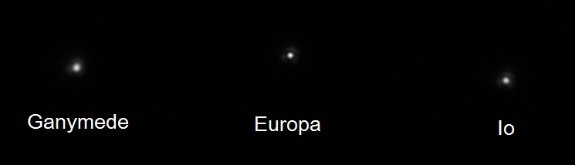

Moons-685-2016-05-02T22\_35\_54-Stack100-EuropaFocus-Wavelets1x40-Stretch128-RotCrop-Annotated.jpg

**Data Disposition:** Raw data zipped on Shira laptop ready to move to 2TB archive drive. Processed data on Astronomy thumb drive.

### 2016-May-03 (May-04 UT): Jupiter Video with Io, Europa, Ganymede and Callisto

Last Updated 4/4/2016

TBD

Volume in drive C is OS

Volume Serial Number is 1E11-6114

Directory of C:\Users\Astronomy\Desktop\SharpCap Captures\20160504UT

05/03/2016 09:32 PM 737,690,112 Jupiter-GRN 2016-05-03T21\_30\_50.avi

05/03/2016 09:35 PM 738,613,760 Jupiter-BLU 2016-05-03T21\_33\_13.avi

05/03/2016 09:37 PM 372,417,024 Jupiter-RED 2016-05-03T21\_35\_51.avi

05/03/2016 09:40 PM 369,955,328 Jupiter-685 2016-05-03T21\_38\_47.avi

05/03/2016 09:46 PM 374,879,232 Jupiter-807 2016-05-03T21\_42\_02.avi

05/03/2016 09:58 PM 56,380,416 Jupiter-889 2016-05-03T21\_52\_27.avi

05/03/2016 09:59 PM 4,682,240 Jupiter-889-DARK 2016-05-03T21\_59\_10.avi

05/03/2016 10:00 PM 4,989,952 Jupiter-889-DARK 2016-05-03T21\_59\_49.avi

05/03/2016 10:11 PM 142,544,384 Jupiter-NUV 2016-05-03T22\_05\_11.avi

05/03/2016 10:12 PM 12,067,840 Jupiter-NUV-DARK 2016-05-03T22\_11\_47.avi

05/03/2016 10:17 PM 615,959,552 Moons-685 2016-05-03T22\_15\_47.avi

05/03/2016 10:22 PM 437,707,264 Moons-685 2016-05-03T22\_20\_39.avi

12 File(s) 3,867,887,104 bytes

0 Dir(s) 64,687,022,080 bytes free

|  |  |
| --- | --- |
| F:\Astronomy\Projects\Planets\Jupiter\Imaging Data\20160504UT\2016-05-04-0339_9-Hill-RGB-807-685-RED-Wavelets-SmthColBal.jpg | F:\Astronomy\Projects\Planets\Jupiter\Imaging Data\20160504UT\2016-05-04-0334_3-Hill-RGB-Wavlets2x3+3x2.jpg |
| 2016-05-04-0339\_9-Hill-RGB-807-685-RED-Wavelets-SmthColBal.jpg | 2016-05-04-0334\_3-Hill-RGB-Wavlets2x3+3x2.jpg |
| F:\Astronomy\Projects\Planets\Jupiter\Imaging Data\20160504UT\2016-05-04-0344_1-Hill-Jupiter-RGB-GRN-BLU-NUV-Wavelets-SmthColBal.jpg | F:\Astronomy\Projects\Planets\Jupiter\Imaging Data\20160504UT\2016-05-04-0347_0-Hill-Jupiter-RGB-807-GRN-NUV-Wavelets-SmthColBal.jpg |
| 2016-05-04-0344\_1-Hill-Jupiter-RGB-GRN-BLU-NUV-Wavelets-SmthColBal.jpg | 2016-05-04-0347\_0-Hill-Jupiter-RGB-807-GRN-NUV-Wavelets-SmthColBal.jpg |
| F:\Astronomy\Projects\Planets\Jupiter\Imaging Data\20160504UT\2016-05-04-0350_5-Hill-Jupiter-RGB-889-GRN-NUV-Wavelets-SmthColBal.jpg | F:\Astronomy\Projects\Planets\Jupiter\Imaging Data\20160504UT\2016-05-04-0345_4-Hill-Jupiter-RGB-889-807-685-Wavelets-SmthColBal.jpg |
| 2016-05-04-0350\_5-Hill-Jupiter-RGB-889-GRN-NUV-Wavelets-SmthColBal.jpg | 2016-05-04-0345\_4-Hill-Jupiter-RGB-889-807-685-Wavelets-SmthColBal.jpg |

**Data Disposition:** Raw data zipped and archived on 2TB archive disk. Processed data on astronomy thumb drive.

## June

### Summer Observing Planning

Last Updated 6/7/2016

* Stars
  + SN 2016coj in NGC 4125 (Draco, transits ~8:30pm MDT)
    - <http://www.supernova.thistlethwaites.com/snimages/>
    - <http://www.supernova.thistlethwaites.com/snimages/sndate.html>
* Jupiter - Spectrum
* Saturn
* Mars
* 3C273

Timeline:

* 6/21 – **Mars new CM**; Saturn (need a good one!)
* 6/22– Spectra (narrow angle) Jovian Moons, **Titan**, **3c273**
* 6/26 – M101 HIA?
* 6/26 – Spectra (wide angle) Jupiter, Mars, Saturn
* July – Cat’s Eye, Blinking and Ring Nebulae
* July – **Mars new CM**

TBD

### 2016-Jun-15 (Jun-16 UT): Mars and Moon Video

Last Updated 4/4/2016

**All Done**

|  |  |  |  |
| --- | --- | --- | --- |
| F:\Astronomy\Projects\Planets\Mars\Imaging Data\20160616UT\2016-06-16-0425_1-Mars_889-Wavelets.jpg | F:\Astronomy\Projects\Planets\Mars\Imaging Data\20160616UT\2016-06-16-0428_4-Mars_807-Wavelets.jpg | F:\Astronomy\Projects\Planets\Mars\Imaging Data\20160616UT\2016-06-16-0419_4-Mars_685-Wavelets.jpg | F:\Astronomy\Projects\Planets\Mars\Imaging Data\20160616UT\2016-06-16-0422_0-Mars_RED-Wavelets.jpg |
| 2016-06-16-0425\_1-Mars\_889-Wavelets.jpg | 2016-06-16-0428\_4-Mars\_807-Wavelets.jpg | 2016-06-16-0419\_4-Mars\_685-Wavelets.jpg | 2016-06-16-0422\_0-Mars\_RED-Wavelets.jpg |
| F:\Astronomy\Projects\Planets\Mars\Imaging Data\20160616UT\2016-06-16-0423_3-Mars_807+685+RED-Wavelets-Cont90.jpg | F:\Astronomy\Projects\Planets\Mars\Imaging Data\20160616UT\2016-06-16-0432_8-Mars_GRN-Wavelets.jpg | F:\Astronomy\Projects\Planets\Mars\Imaging Data\20160616UT\2016-06-16-0435_2-Mars_BLU-Wavelets.jpg |  |
| 2016-06-16-0423\_3-Mars\_807+685+RED-Wavelets-Cont90.jpg | 2016-06-16-0432\_8-Mars\_GRN-Wavelets.jpg | 2016-06-16-0435\_2-Mars\_BLU-Wavelets.jpg | No NUV |

|  |  |  |
| --- | --- | --- |
| F:\Astronomy\Projects\Planets\Mars\Imaging Data\20160616UT\2016-06-16-0424_3-Hill-889-807-685-RGB-WhtBal-Wavelets-L(889)RGB.jpg | F:\Astronomy\Projects\Planets\Mars\Imaging Data\20160616UT\2016-06-16-0424_3-Hill-889-807-685-RGB-WhtBal-Wavelets.jpg | F:\Astronomy\Projects\Planets\Mars\Imaging Data\20160616UT\2016-06-16-0424_3-Hill-889-807-685-RGB-WhtBal-Wavelets-L(685)RGB.jpg |
| 2016-06-16-0424\_3-Hill-889-807-685-RGB-WhtBal-Wavelets-L(889)RGB.jpg | 2016-06-16-0424\_3-Hill-889-807-685-RGB-WhtBal-Wavelets.jpg | 2016-06-16-0424\_3-Hill-889-807-685-RGB-WhtBal-Wavelets-L(685)RGB.jpg |
| F:\Astronomy\Projects\Planets\Mars\Imaging Data\20160616UT\2016-06-16-0423_3-Hill-807-685-RED-RGB-WhtBal-Wavelets-L(807)RGB.jpg | F:\Astronomy\Projects\Planets\Mars\Imaging Data\20160616UT\2016-06-16-0423_3-Hill-807-685-RED-RGB-WhtBal-Wavelets.jpg | F:\Astronomy\Projects\Planets\Mars\Imaging Data\20160616UT\2016-06-16-0423_3-Hill-807-685-RED-RGB-WhtBal-Wavelets-L(RED)RGB.jpg |
| 2016-06-16-0423\_3-Hill-807-685-RED-RGB-WhtBal-Wavelets-L(807)RGB.jpg | 2016-06-16-0423\_3-Hill-807-685-RED-RGB-WhtBal-Wavelets.jpg | 2016-06-16-0423\_3-Hill-807-685-RED-RGB-WhtBal-Wavelets-L(RED)RGB.jpg |
| F:\Astronomy\Projects\Planets\Mars\Imaging Data\20160616UT\2016-06-16-0430_0-Hill-RGB-WhtBal-WaveletsCont90-L(RED)RGB.jpg | F:\Astronomy\Projects\Planets\Mars\Imaging Data\20160616UT\2016-06-16-0430_0-Hill-RGB-WhtBal-WaveletsCont90.png | F:\Astronomy\Projects\Planets\Mars\Imaging Data\20160616UT\2016-06-16-0430_0-Hill-RGB-WhtBal-WaveletsCont90-L(BLU)RGB.jpg |
| 2016-06-16-0430\_0-Hill-RGB-WhtBal-WaveletsCont90-L(RED)RGB.jpg | 2016-06-16-0430\_0-Hill-RGB-WhtBal-WaveletsCont90.jpg | 2016-06-16-0430\_0-Hill-RGB-WhtBal-WaveletsCont90-L(BLU)RGB.jpg |
| F:\Astronomy\Projects\Planets\Mars\Imaging Data\20160616UT\2016-06-16-0430_4-Hill-(807+685+RED)-GRN-BLU-RGB-WhtBal-WaveletsCont80-L(807+685+RED)RGB.jpg | F:\Astronomy\Projects\Planets\Mars\Imaging Data\20160616UT\2016-06-16-0430_4-Hill-(807+685+RED)-GRN-BLU-RGB-WhtBal-WaveletsCont80.jpg | F:\Astronomy\Projects\Planets\Mars\Imaging Data\20160616UT\2016-06-16-0430_4-Hill-(807+685+RED)-GRN-BLU-RGB-WhtBal-WaveletsCont80-L(BLU)RGB.jpg |
| 2016-06-16-0430\_4-Hill-(807+685+RED)-GRN-BLU-RGB-WhtBal-WaveletsCont80-L(807+685+RED)RGB.jpg | 2016-06-16-0430\_4-Hill-(807+685+RED)-GRN-BLU-RGB-WhtBal-WaveletsCont80.jpg | 2016-06-16-0430\_4-Hill-(807+685+RED)-GRN-BLU-RGB-WhtBal-WaveletsCont80-L(BLU)RGB.jpg |

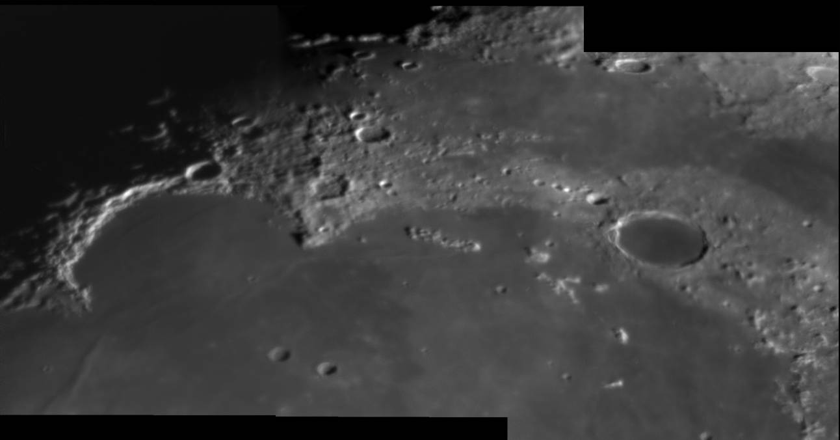

2016-06-16-0357\_8-Moon-Mosaic-HalfSize.jpg

|  |  |
| --- | --- |
| F:\Astronomy\Projects\Moon\Imaging Data\20160616UT\2016-06-16-0351_8-Moon-Mosaic2-HalfSize.jpg | F:\Astronomy\Projects\Moon\Imaging Data\20160616UT\2016-06-16-0349_1-Moon-Mosaic3-HalfSize-Gamma.jpg |
| 2016-06-16-0351\_8-Moon-Mosaic2-HalfSize.jpg | 2016-06-16-0349\_1-Moon-Mosaic3-HalfSize-Gamma.jpg |
| F:\Astronomy\Projects\Moon\Imaging Data\20160616UT\2016-06-16-0354_0-Moon-Stack100-Wavelets1x10+2x30+3x20-HalfSize.jpg |  |
| 2016-06-16-0354\_0-Moon-Stack100-Wavelets1x10+2x30+3x20-HalfSize.jpg |  |

**Data Disposition:** Mars and Moon raw data zipped and archived on 2TB archive drive. Processed data is on the astronomy thumb drive.

**Jupiter Exposure Guide**

|  |  |  |  |  |  |
| --- | --- | --- | --- | --- | --- |
| Filter | Gamma | Gain | Brightness | Exposure | LT |
| NUV | 50 | 100 | 0 | 1251 ms |  |
| BLU | 50 | 50 | 0 | 68 ms |  |
| GRN | 50 | 50 | 0 | 38-68 ms |  |
| RED | 50 | 50 | 0 | 91 ms |  |
| >685 | 50 | 50 | 0 | 91-122 ms |  |
| >807 | 50 | 50 | 0 | 391-523 ms |  |
| CH4 | 100 | 100 | 0 | 2200-3000 ms |  |

**Jovian Moons Exposure Guide**

|  |  |  |  |  |  |
| --- | --- | --- | --- | --- | --- |
| Filter | Gamma | Gain | Brightness | Exposure | LT |
| Gany BLU | 50 | 68 | 0 | 219-700 ms |  |
| GANY-GRN | 50 | 70 | 0 | 122-293 ms |  |
| GANY-RED | 50 | 70 | 0 | 523 ms |  |
| Gany >685 | 50 | 68 | 0 | 219 ms |  |
| Callisto BLU | 50 | 68 | 0 | 523 ms |  |
| Callisto RED | 50 | 68 | 0 | 935 ms |  |
| Callisto >685 | 50 | 68 | 0 | 700 ms |  |
| Europa BLU | 50 | 68 | 0 | 935 ms |  |
| Europa GRN | 50 | 68 | 0 | 523 ms |  |
| Europa RED | 50 | 68 | 0 | 935 ms |  |
| Europa >685 | 50 | 68 | 0 | 935 ms |  |

**Mars Exposure Guide**

|  |  |  |  |  |  |
| --- | --- | --- | --- | --- | --- |
| Filter | Gamma | Gain | Brightness | Exposure | LT |
| NUV | 50 | 100 | 0 | 1251 ms |  |
| BLU | 50? | 50? | 0? | 51 ms (?) |  |
| GRN | 50? | 50? | 0? | 38.3 ms |  |
| RED | 50 | 100 | 0 | 38.3 ms |  |
| >685 | 50 | 50 | 0 | 21.4 ms |  |
| >807 | 50 | 50 | 0 | 91 ms |  |
| CH4 | 50 | 70 | 0 | 971 ms |  |

**Saturn Exposure Guide??? Is this right? Exposures seem too short compared to Jupiter**

|  |  |  |  |  |  |
| --- | --- | --- | --- | --- | --- |
| Filter | Gamma | Gain | Brightness | Exposure | LT |
| NUV | 100 | 100 | 0 | 3000 ms |  |
| BLU |  |  |  |  |  |
| GRN | 50 | 85 | 0 | 68 ms |  |
| RED | 50 | 85 | 0 | 122 ms |  |
| >685 | 50 | 85 | 0 | 91 ms |  |
| >807 | 50 | 85 | 0 | 391 ms |  |
| CH4 | 100 | 100 | 0 | 1251 ms |  |

### 2016-Jun-26 (Jun-27 UT): Mars and Saturn Video

Last Updated 7/1/2016

**ALL DONE**

**0330UT Observations**

|  |  |  |  |
| --- | --- | --- | --- |
| F:\Astronomy\Projects\Planets\Mars\Imaging Data\20160627UT\2016-06-27-0338_3-Mars_889.jpg | F:\Astronomy\Projects\Planets\Mars\Imaging Data\20160627UT\2016-06-27-0330_9-Mars_807.jpg | F:\Astronomy\Projects\Planets\Mars\Imaging Data\20160627UT\2016-06-27-0328_0-Mars_685.jpg | F:\Astronomy\Projects\Planets\Mars\Imaging Data\20160627UT\2016-06-27-0342_0-Mars_RED.jpg |
| 2016-06-27-0338\_3-Mars\_889.jpg | 2016-06-27-0330\_9-Mars\_807.jpg | 2016-06-27-0328\_0-Mars\_685.jpg | 2016-06-27-0342\_0-Mars\_RED.jpg |
| F:\Astronomy\Projects\Planets\Mars\Imaging Data\20160627UT\2016-06-27-0333_6-Mars_807-685-RED.jpg | F:\Astronomy\Projects\Planets\Mars\Imaging Data\20160627UT\2016-06-27-0343_0-Mars_GRN.jpg | F:\Astronomy\Projects\Planets\Mars\Imaging Data\20160627UT\2016-06-27-0345_7-Mars_BLU.jpg | F:\Astronomy\Projects\Planets\Mars\Imaging Data\20160627UT\2016-06-27-0349_5-Mars_NUV.jpg |
| 2016-06-27-0333\_6-Mars\_807-685-RED.jpg | 2016-06-27-0343\_0-Mars\_GRN.jpg | 2016-06-27-0345\_7-Mars\_BLU.jpg | 2016-06-27-0349\_5-Mars\_NUV.jpg |

|  |  |  |
| --- | --- | --- |
| F:\Astronomy\Projects\Planets\Mars\Imaging Data\20160627UT\2016-06-27-0333_6-Hill-807-685-RED-RGB-L(R)RGB.jpg | F:\Astronomy\Projects\Planets\Mars\Imaging Data\20160627UT\2016-06-27-0333_6-Hill-807-685-RED-RGB.jpg | F:\Astronomy\Projects\Planets\Mars\Imaging Data\20160627UT\2016-06-27-0333_6-Hill-807-685-RED-RGB-L(B)RGB.jpg |
| 2016-06-27-0333\_6-Hill-807-685-RED-RGB-L(R)RGB.jpg | 2016-06-27-0333\_6-Hill-807-685-RED-RGB.jpg | 2016-06-27-0333\_6-Hill-807-685-RED-RGB-L(B)RGB.jpg |
| F:\Astronomy\Projects\Planets\Mars\Imaging Data\20160627UT\2016-06-27-0343_6-Hill-RGB-L(R)RGB.jpg | F:\Astronomy\Projects\Planets\Mars\Imaging Data\20160627UT\2016-06-27-0343_6-Hill-RGB.jpg | F:\Astronomy\Projects\Planets\Mars\Imaging Data\20160627UT\2016-06-27-0343_6-Hill-RGB-L(B)RGB.jpg |
| 2016-06-27-0343\_6-Hill-RGB-L(R)RGB.jpg | 2016-06-27-0343\_6-Hill-RGB.jpg | 2016-06-27-0343\_6-Hill-RGB-L(B)RGB.jpg |
| F:\Astronomy\Projects\Planets\Mars\Imaging Data\20160627UT\2016-06-27-0341_1-Hill-807-GRN-NUV-RGB-WhtBal-L(R)RGB.jpg | F:\Astronomy\Projects\Planets\Mars\Imaging Data\20160627UT\2016-06-27-0341_1-Hill-807-GRN-NUV-RGB-WhtBal.jpg | F:\Astronomy\Projects\Planets\Mars\Imaging Data\20160627UT\2016-06-27-0341_1-Hill-807-GRN-NUV-RGB-WhtBal-L(B)RGB.jpg |
| 2016-06-27-0341\_1-Hill-807-GRN-NUV-RGB-WhtBal-L(R)RGB.jpg | 2016-06-27-0341\_1-Hill-807-GRN-NUV-RGB-WhtBal.jpg | 2016-06-27-0341\_1-Hill-807-GRN-NUV-RGB-WhtBal-L(B)RGB.jpg |
| F:\Astronomy\Projects\Planets\Mars\Imaging Data\20160627UT\2016-06-27-0346_1-Hill-GRN-BLU-NUV-RGB-WhtBal-L(R)RGB.jpg | F:\Astronomy\Projects\Planets\Mars\Imaging Data\20160627UT\2016-06-27-0346_1-Hill-GRN-BLU-NUV-RGB-WhtBal.jpg | F:\Astronomy\Projects\Planets\Mars\Imaging Data\20160627UT\2016-06-27-0346_1-Hill-GRN-BLU-NUV-RGB-WhtBal-L(B)RGB.jpg |
| 2016-06-27-0346\_1-Hill-GRN-BLU-NUV-RGB-WhtBal-L(R)RGB.jpg | 2016-06-27-0346\_1-Hill-GRN-BLU-NUV-RGB-WhtBal.jpg | 2016-06-27-0346\_1-Hill-GRN-BLU-NUV-RGB-WhtBal-L(B)RGB.jpg |

**0545UT Observations**

|  |  |  |  |
| --- | --- | --- | --- |
| F:\Astronomy\Projects\Planets\Mars\Imaging Data\20160627UT\2016-06-27-0548_3-Mars_889.jpg | F:\Astronomy\Projects\Planets\Mars\Imaging Data\20160627UT\2016-06-27-0542_4-Mars_807.jpg | F:\Astronomy\Projects\Planets\Mars\Imaging Data\20160627UT\2016-06-27-0540_1-Mars_685.jpg | F:\Astronomy\Projects\Planets\Mars\Imaging Data\20160627UT\2016-06-27-0544_5-Mars_RED.jpg |
| 2016-06-27-0548\_3-Mars\_889.jpg | 2016-06-27-0542\_4-Mars\_807.jpg | 2016-06-27-0540\_1-Mars\_685.jpg | 2016-06-27-0544\_5-Mars\_RED.jpg |
| F:\Astronomy\Projects\Planets\Mars\Imaging Data\20160627UT\2016-06-27-0542_3-Mars_807-685-RED.jpg | F:\Astronomy\Projects\Planets\Mars\Imaging Data\20160627UT\2016-06-27-0550_9-Mars_GRN.jpg | F:\Astronomy\Projects\Planets\Mars\Imaging Data\20160627UT\2016-06-27-0552_5-Mars_BLU.jpg | F:\Astronomy\Projects\Planets\Mars\Imaging Data\20160627UT\2016-06-27-0556_2-Mars_NUV.jpg |
| 2016-06-27-0542\_3-Mars\_807-685-RED.jpg | 2016-06-27-0550\_9-Mars\_GRN.jpg | 2016-06-27-0552\_5-Mars\_BLU.jpg | 2016-06-27-0556\_2-Mars\_NUV.jpg |

|  |  |  |
| --- | --- | --- |
| F:\Astronomy\Projects\Planets\Mars\Imaging Data\20160627UT\2016-06-27-0542_3-Hill-807-685-RED-RGB-WhtBal-L(807)RGB.jpg | F:\Astronomy\Projects\Planets\Mars\Imaging Data\20160627UT\2016-06-27-0542_3-Hill-807-685-RED-RGB-WhtBal.jpg | F:\Astronomy\Projects\Planets\Mars\Imaging Data\20160627UT\2016-06-27-0542_3-Hill-807-685-RED-RGB-WhtBal-L(RED)RGB.jpg |
| 2016-06-27-0542\_3-Hill-807-685-RED-RGB-WhtBal-L(807)RGB.jpg | 2016-06-27-0542\_3-Hill-807-685-RED-RGB-WhtBal.jpg | 2016-06-27-0542\_3-Hill-807-685-RED-RGB-WhtBal-L(RED)RGB.jpg |
| F:\Astronomy\Projects\Planets\Mars\Imaging Data\20160627UT\2016-06-27-0549_3-Hill-L(R)RGB-WhtBal.jpg | F:\Astronomy\Projects\Planets\Mars\Imaging Data\20160627UT\2016-06-27-0549_3-Hill-RGB-WhtBal.jpg | F:\Astronomy\Projects\Planets\Mars\Imaging Data\20160627UT\2016-06-27-0549_3-Hill-L(B)RGB-WhtBal.jpg |
| 2016-06-27-0549\_3-Hill-L(R)RGB-WhtBal.jpg | 2016-06-27-0549\_3-Hill-RGB-WhtBal.jpg | 2016-06-27-0549\_3-Hill-L(B)RGB-WhtBal.jpg |
| F:\Astronomy\Projects\Planets\Mars\Imaging Data\20160627UT\2016-06-27-0549_8-Hill-807-GRN-NUV-RGB-WhtBal-L(807)RGB.jpg | F:\Astronomy\Projects\Planets\Mars\Imaging Data\20160627UT\2016-06-27-0549_8-Hill-807-GRN-NUV-RGB-WhtBal.jpg | F:\Astronomy\Projects\Planets\Mars\Imaging Data\20160627UT\2016-06-27-0549_8-Hill-807-GRN-NUV-RGB-WhtBal-L(NUV)RGB.jpg |
| 2016-06-27-0549\_8-Hill-807-GRN-NUV-RGB-WhtBal-L(807)RGB.jpg | 2016-06-27-0549\_8-Hill-807-GRN-NUV-RGB-WhtBal.jpg | 2016-06-27-0549\_8-Hill-807-GRN-NUV-RGB-WhtBal-L(NUV)RGB.jpg |
| F:\Astronomy\Projects\Planets\Mars\Imaging Data\20160627UT\2016-06-27-0553_2-Hill-GRN-BLU-NUV-RGB-WhtBal-L(GRN)RGB.jpg | F:\Astronomy\Projects\Planets\Mars\Imaging Data\20160627UT\2016-06-27-0553_2-Hill-GRN-BLU-NUV-RGB-WhtBal.jpg | F:\Astronomy\Projects\Planets\Mars\Imaging Data\20160627UT\2016-06-27-0553_2-Hill-GRN-BLU-NUV-RGB-WhtBal-L(NUV)RGB.jpg |
| 2016-06-27-0553\_2-Hill-GRN-BLU-NUV-RGB-WhtBal-L(GRN)RGB.jpg | 2016-06-27-0553\_2-Hill-GRN-BLU-NUV-RGB-WhtBal.jpg | 2016-06-27-0553\_2-Hill-GRN-BLU-NUV-RGB-WhtBal-L(NUV)RGB.jpg |

|  |  |  |
| --- | --- | --- |
| F:\Astronomy\Projects\Planets\Saturn\Imaging Data\20160627UT\2016-06-27-0525_6-Saturn_889.jpg | F:\Astronomy\Projects\Planets\Saturn\Imaging Data\20160627UT\2016-06-27-0519_5-Saturn_807.jpg | F:\Astronomy\Projects\Planets\Saturn\Imaging Data\20160627UT\2016-06-27-0512_6-Saturn_685.jpg |
| 2016-06-27-0525\_6-Saturn\_889.jpg | 2016-06-27-0519\_5-Saturn\_807.jpg | 2016-06-27-0512\_6-Saturn\_685.jpg |
| F:\Astronomy\Projects\Planets\Saturn\Imaging Data\20160627UT\2016-06-27-0515_0-Saturn_RED.jpg | F:\Astronomy\Projects\Planets\Saturn\Imaging Data\20160627UT\2016-06-27-0515_8-Saturn_RED+685+807.jpg | F:\Astronomy\Projects\Planets\Saturn\Imaging Data\20160627UT\2016-06-27-0508_1-Saturn_GRN.jpg |
| 2016-06-27-0515\_0-Saturn\_RED.jpg | 2016-06-27-0515\_8-Saturn\_RED+685+807.jpg | 2016-06-27-0508\_1-Saturn\_GRN.jpg |
| F:\Astronomy\Projects\Planets\Saturn\Imaging Data\20160627UT\2016-06-27-0506_9-Saturn_BLU.jpg | F:\Astronomy\Projects\Planets\Saturn\Imaging Data\20160627UT\2016-06-27-0457_1-Saturn_NUV.jpg |  |
| 2016-06-27-0506\_9-Saturn\_BLU.jpg | 2016-06-27-0457\_1-Saturn\_NUV.jpg |  |

|  |  |  |
| --- | --- | --- |
| F:\Astronomy\Projects\Planets\Saturn\Imaging Data\20160627UT\2016-06-27-0515_7-Saturn-807-685-RED-RGB-WhtBal.jpg | F:\Astronomy\Projects\Planets\Saturn\Imaging Data\20160627UT\2016-06-27-0513_5-Saturn-889-GRN-BLU-RGB-WhtBal.jpg | F:\Astronomy\Projects\Planets\Saturn\Imaging Data\20160627UT\2016-06-27-0510_3-Saturn-889-GRN-NUV-RGB-WhtBal.jpg |
| 2016-06-27-0515\_7-Saturn-807-685-RED-RGB-WhtBal.jpg | 2016-06-27-0513\_5-Saturn-889-GRN-BLU-RGB-WhtBal.jpg | 2016-06-27-0510\_3-Saturn-889-GRN-NUV-RGB-WhtBal.jpg |
| F:\Astronomy\Projects\Planets\Saturn\Imaging Data\20160627UT\2016-06-27-0508_2-Saturn-807-GRN-NUV-RGB-WhtBal.jpg | F:\Astronomy\Projects\Planets\Saturn\Imaging Data\20160627UT\2016-06-27-0510_0-Saturn-RGB-WhtBal.jpg | F:\Astronomy\Projects\Planets\Saturn\Imaging Data\20160627UT\2016-06-27-051X_X-Saturn-L(807+685+RED)RGB-Wavelets.jpg |
| 2016-06-27-0508\_2-Saturn-807-GRN-NUV-RGB-WhtBal.jpg | 2016-06-27-0510\_0-Saturn-RGB-WhtBal.jpg | 2016-06-27-051X\_X-Saturn-L(807+685+RED)RGB-Wavelets.jpg |

Notice that not only are the Cassinit and Encke gaps visible in the rings, there’s also a gap visible in the B ring that stands out on the east side. There’s no permanently identified gap at that location, so this is transient wave structure. It is also possible that some longitudinal structure is visible, see ALPO Japan observations on 6/28/2016.

**Data Disposition:** TBD

## July

### 2016-Jul-06 (Jul-07 UT): Mars Video

Last Updated 7/1/2016

**ALL DONE**

**0330UT Observations**

|  |  |  |  |
| --- | --- | --- | --- |
| F:\Astronomy\Projects\Planets\Mars\Imaging Data\20160707UT\2016-07-07-0429_3-Mars_889-AllNight.jpg | F:\Astronomy\Projects\Planets\Mars\Imaging Data\20160707UT\2016-07-07-0418_9-Mars_807-AllNight.jpg | F:\Astronomy\Projects\Planets\Mars\Imaging Data\20160707UT\2016-07-07-0411_0-Mars_685-AllNight.jpg | F:\Astronomy\Projects\Planets\Mars\Imaging Data\20160707UT\2016-07-07-0422_2-Mars_RED-AllNight.jpg |
| 2016-07-07-0429\_3-Mars\_889-AllNight.jpg | 2016-07-07-0418\_9-Mars\_807-AllNight.jpg | 2016-07-07-0411\_0-Mars\_685-AllNight.jpg | 2016-07-07-0422\_2-Mars\_RED-AllNight.jpg |
| F:\Astronomy\Projects\Planets\Mars\Imaging Data\20160707UT\2016-07-07-0417_4-Mars_807+685+RED-AllNight-Wavelets.jpg | F:\Astronomy\Projects\Planets\Mars\Imaging Data\20160707UT\2016-07-07-0413_0-Mars_GRN.jpg | F:\Astronomy\Projects\Planets\Mars\Imaging Data\20160707UT\2016-07-07-0415_9-Mars_BLU.jpg | F:\Astronomy\Projects\Planets\Mars\Imaging Data\20160707UT\2016-07-07-0425_5-Mars_NUV.jpg |
| 2016-07-07-0417\_4-Mars\_807+685+RED-AllNight-Wavelets.jpg | 2016-07-07-0413\_0-Mars\_GRN.jpg | 2016-07-07-0415\_9-Mars\_BLU.jpg | 2016-07-07-0425\_5-Mars\_NUV.jpg |

|  |  |  |
| --- | --- | --- |
| F:\Astronomy\Projects\Planets\Mars\Imaging Data\20160707UT\2016-07-07-0417_4-Hill-807-685-RED-RGB-Wavelets-WhtBal-L(807)RGB.jpg | F:\Astronomy\Projects\Planets\Mars\Imaging Data\20160707UT\2016-07-07-0417_4-Hill-807-685-RED-RGB-Wavelets-WhtBal.jpg | F:\Astronomy\Projects\Planets\Mars\Imaging Data\20160707UT\2016-07-07-0417_4-Hill-807-685-RED-RGB-Wavelets-WhtBal-L(RED)RGB.jpg |
| 2016-07-07-0417\_4-Hill-807-685-RED-RGB-Wavelets-WhtBal-L(807)RGB.jpg | 2016-07-07-0417\_4-Hill-807-685-RED-RGB-Wavelets-WhtBal.jpg | 2016-07-07-0417\_4-Hill-807-685-RED-RGB-Wavelets-WhtBal-L(RED)RGB.jpg |
| F:\Astronomy\Projects\Planets\Mars\Imaging Data\20160707UT\2016-07-07-0409_1-Hill-RGB-Wavelets-L(RED)RGB.jpg | F:\Astronomy\Projects\Planets\Mars\Imaging Data\20160707UT\2016-07-07-0409_1-Hill-RGB-Wavelets-WhtBal.jpg | F:\Astronomy\Projects\Planets\Mars\Imaging Data\20160707UT\2016-07-07-0409_1-Hill-RGB-Wavelets-L(BLU)RGB.jpg |
| 2016-07-07-0409\_1-Hill-RGB-Wavelets-L(RED)RGB.jpg | 2016-07-07-0409\_1-Hill-RGB-Wavelets-WhtBal.jpg | 2016-07-07-0409\_1-Hill-RGB-Wavelets-L(BLU)RGB.jpg |
| F:\Astronomy\Projects\Planets\Mars\Imaging Data\20160707UT\2016-07-07-0419_1-Hill-807-GRN-NUV-RGB-Wavelets-WhtBal-L(807)RGB.jpg | F:\Astronomy\Projects\Planets\Mars\Imaging Data\20160707UT\2016-07-07-0419_1-Hill-807-GRN-NUV-RGB-Wavelets-WhtBal.jpg | F:\Astronomy\Projects\Planets\Mars\Imaging Data\20160707UT\2016-07-07-0419_1-Hill-807-GRN-NUV-RGB-Wavelets-WhtBal-L(NUV)RGB.jpg |
| 2016-07-07-0419\_1-Hill-807-GRN-NUV-RGB-Wavelets-WhtBal-L(807)RGB.jpg | 2016-07-07-0419\_1-Hill-807-GRN-NUV-RGB-Wavelets-WhtBal.jpg | 2016-07-07-0419\_1-Hill-807-GRN-NUV-RGB-Wavelets-WhtBal-L(NUV)RGB.jpg |
| F:\Astronomy\Projects\Planets\Mars\Imaging Data\20160707UT\2016-07-07-0418_1-Hill-GRN-BLU-NUV-RGB-Wavelets-WhtBal-L(GRN)RGB.jpg | F:\Astronomy\Projects\Planets\Mars\Imaging Data\20160707UT\2016-07-07-0418_1-Hill-GRN-BLU-NUV-RGB-Wavelets-WhtBal.jpg | F:\Astronomy\Projects\Planets\Mars\Imaging Data\20160707UT\2016-07-07-0418_1-Hill-GRN-BLU-NUV-RGB-Wavelets-WhtBal-L(NUV)RGB.jpg |
| 2016-07-07-0418\_1-Hill-GRN-BLU-NUV-RGB-Wavelets-WhtBal-L(GRN)RGB.jpg | 2016-07-07-0418\_1-Hill-GRN-BLU-NUV-RGB-Wavelets-WhtBal.jpg | 2016-07-07-0418\_1-Hill-GRN-BLU-NUV-RGB-Wavelets-WhtBal-L(NUV)RGB.jpg |

**Data Disposition:** TBD

### 2016-Jul-10 (Jul-11 UT): Mars Video

Last Updated 7/1/2016

**ALL DONE**

**0330UT Observations**

|  |  |  |  |
| --- | --- | --- | --- |
| F:\Astronomy\Projects\Planets\Mars\Imaging Data\20160711UT\2016-07-11-0342_1-Mars_889.jpg | F:\Astronomy\Projects\Planets\Mars\Imaging Data\20160711UT\2016-07-11-0338_8-Mars_807.jpg | F:\Astronomy\Projects\Planets\Mars\Imaging Data\20160711UT\2016-07-11-0336_5-Mars_685.jpg | F:\Astronomy\Projects\Planets\Mars\Imaging Data\20160711UT\2016-07-11-0340_7-Mars_RED.jpg |
| 2016-07-11-0342\_1-Mars\_889.jpg | 2016-07-11-0338\_8-Mars\_807.jpg | 2016-07-11-0336\_5-Mars\_685.jpg | 2016-07-11-0340\_7-Mars\_RED.jpg |
| F:\Astronomy\Projects\Planets\Mars\Imaging Data\20160711UT\2016-07-11-0338_7-Mars_RED+685+807-80pct-Wavelets.jpg | F:\Astronomy\Projects\Planets\Mars\Imaging Data\20160711UT\2016-07-11-0351_2-Mars_GRN.jpg | F:\Astronomy\Projects\Planets\Mars\Imaging Data\20160711UT\2016-07-11-0353_8-Mars_BLU.jpg | F:\Astronomy\Projects\Planets\Mars\Imaging Data\20160711UT\2016-07-11-0401_4-Mars_NUV.jpg |
| 2016-07-11-0338\_7-Mars\_RED+685+807-80pct-Wavelets.jpg | 2016-07-11-0351\_2-Mars\_GRN.jpg | 2016-07-11-0353\_8-Mars\_BLU.jpg | 2016-07-11-0401\_4-Mars\_NUV.jpg |

|  |  |  |
| --- | --- | --- |
| F:\Astronomy\Projects\Planets\Mars\Imaging Data\20160711UT\2016-07-11-0338_7-Hill-807-685-RED-RGB-Wavelets-Cont90pct-WhtBal-L(807)RGB.jpg | F:\Astronomy\Projects\Planets\Mars\Imaging Data\20160711UT\2016-07-11-0338_7-Hill-807-685-RED-RGB-Wavelets-Cont90pct-WhtBal.jpg | F:\Astronomy\Projects\Planets\Mars\Imaging Data\20160711UT\2016-07-11-0338_7-Hill-807-685-RED-RGB-Wavelets-Cont90pct-WhtBal-L(RED)RGB.jpg |
| 2016-07-11-0338\_7-Hill-807-685-RED-RGB-Wavelets-Cont90pct-WhtBal-L(807)RGB.jpg | 2016-07-11-0338\_7-Hill-807-685-RED-RGB-Wavelets-Cont90pct-WhtBal.jpg | 2016-07-11-0338\_7-Hill-807-685-RED-RGB-Wavelets-Cont90pct-WhtBal-L(RED)RGB.jpg |
| F:\Astronomy\Projects\Planets\Mars\Imaging Data\20160711UT\2016-07-11-0348_6-Hill-RGB-Wavelets-Cont70pct-L(R)RGB-WhtBal.jpg | F:\Astronomy\Projects\Planets\Mars\Imaging Data\20160711UT\2016-07-11-0348_6-Hill-RGB-Wavelets-Cont70pct.jpg | F:\Astronomy\Projects\Planets\Mars\Imaging Data\20160711UT\2016-07-11-0348_6-Hill-RGB-Wavelets-Cont70pct-L(B)RGB-WhtBal.jpg |
| 2016-07-11-0348\_6-Hill-RGB-Wavelets-Cont70pct-L(R)RGB-WhtBal.jpg | 2016-07-11-0348\_6-Hill-RGB-Wavelets-Cont70pct.jpg | 2016-07-11-0348\_6-Hill-RGB-Wavelets-Cont70pct-L(B)RGB-WhtBal.jpg |
| F:\Astronomy\Projects\Planets\Mars\Imaging Data\20160711UT\2016-07-11-0350_4-Hill-807-GRN-NUV-RGB-Wavelets-Cont80pct-WhtBal-L(807)RGB.jpg | F:\Astronomy\Projects\Planets\Mars\Imaging Data\20160711UT\2016-07-11-0350_4-Hill-807-GRN-NUV-RGB-Wavelets-Cont80pct-WhtBal.jpg | F:\Astronomy\Projects\Planets\Mars\Imaging Data\20160711UT\2016-07-11-0350_4-Hill-807-GRN-NUV-RGB-Wavelets-Cont80pct-WhtBal-L(NUV)RGB.jpg |
| 2016-07-11-0350\_4-Hill-807-GRN-NUV-RGB-Wavelets-Cont80pct-WhtBal-L(807)RGB.jpg | 2016-07-11-0350\_4-Hill-807-GRN-NUV-RGB-Wavelets-Cont80pct-WhtBal.jpg | 2016-07-11-0350\_4-Hill-807-GRN-NUV-RGB-Wavelets-Cont80pct-WhtBal-L(NUV)RGB.jpg |
| F:\Astronomy\Projects\Planets\Mars\Imaging Data\20160711UT\2016-07-11-0355_5-Hill-GRN-BLU-NUV-RGB-Wavelets-Cont90pct-WhtBal-L(GRN)RGB.jpg | F:\Astronomy\Projects\Planets\Mars\Imaging Data\20160711UT\2016-07-11-0355_5-Hill-GRN-BLU-NUV-RGB-Wavelets-Cont90pct-WhtBal.jpg | F:\Astronomy\Projects\Planets\Mars\Imaging Data\20160711UT\2016-07-11-0355_5-Hill-GRN-BLU-NUV-RGB-Wavelets-Cont90pct-WhtBal-L(NUV)RGB.jpg |
| 2016-07-11-0355\_5-Hill-GRN-BLU-NUV-RGB-Wavelets-Cont90pct-WhtBal-L(GRN)RGB.jpg | 2016-07-11-0355\_5-Hill-GRN-BLU-NUV-RGB-Wavelets-Cont90pct-WhtBal.jpg | 2016-07-11-0355\_5-Hill-GRN-BLU-NUV-RGB-Wavelets-Cont90pct-WhtBal-L(NUV)RGB.jpg |

**Data Disposition:** TBD

### 2016-Jul-14 (Jul-15 UT): Mars Video

Last Updated 7/1/2016

**ALL DONE**

**0330UT Observations**

|  |  |  |  |
| --- | --- | --- | --- |
| F:\Astronomy\Projects\Planets\Mars\Imaging Data\20160715UT\2016-07-15-0323_2-Mars_889.jpg | F:\Astronomy\Projects\Planets\Mars\Imaging Data\20160715UT\2016-07-15-0315_0-Mars_807.jpg | F:\Astronomy\Projects\Planets\Mars\Imaging Data\20160715UT\2016-07-15-0313_2-Mars_685.jpg | F:\Astronomy\Projects\Planets\Mars\Imaging Data\20160715UT\2016-07-15-0317_4-Mars_RED.jpg |
| 2016-07-15-0323\_2-Mars\_889.jpg | 2016-07-15-0315\_0-Mars\_807.jpg | 2016-07-15-0313\_2-Mars\_685.jpg | 2016-07-15-0317\_4-Mars\_RED.jpg |
| F:\Astronomy\Projects\Planets\Mars\Imaging Data\20160715UT\2016-07-15-0315_2-Mars_807+685+RED-Wavelets.jpg | F:\Astronomy\Projects\Planets\Mars\Imaging Data\20160715UT\2016-07-15-0329_4-Mars_GRN.jpg | F:\Astronomy\Projects\Planets\Mars\Imaging Data\20160715UT\2016-07-15-0331_4-Mars_BLU.jpg | F:\Astronomy\Projects\Planets\Mars\Imaging Data\20160715UT\2016-07-15-0337_1-Mars_NUV.jpg |
| 2016-07-15-0315\_2-Mars\_807+685+RED-Wavelets.jpg | 2016-07-15-0329\_4-Mars\_GRN.jpg | 2016-07-15-0331\_4-Mars\_BLU.jpg | 2016-07-15-0337\_1-Mars\_NUV.jpg |

|  |  |  |
| --- | --- | --- |
| F:\Astronomy\Projects\Planets\Mars\Imaging Data\20160715UT\2016-07-15-0315_2-Hill-807-685-RED-L(807)RGB-Wavelets-WhtBal-Smth.jpg | F:\Astronomy\Projects\Planets\Mars\Imaging Data\20160715UT\2016-07-15-0315_2-Hill-807-685-RED-RGB-Wavelets-WhtBal.jpg | F:\Astronomy\Projects\Planets\Mars\Imaging Data\20160715UT\2016-07-15-0315_2-Hill-807-685-RED-L(RED)RGB-Wavelets-WhtBal-Smth.jpg |
| 2016-06-27-0333\_6-Hill-807-685-RED-RGB-L(R)RGB.jpg | 2016-07-15-0315\_2-Hill-807-685-RED-RGB-Wavelets-WhtBal.jpg | 2016-07-15-0315\_2-Hill-807-685-RED-L(RED)RGB-Wavelets-WhtBal-Smth.jpg |
| F:\Astronomy\Projects\Planets\Mars\Imaging Data\20160715UT\2016-07-15-0326_1-Hill-L(R)RGB-Wavelets-WhtBal.jpg | F:\Astronomy\Projects\Planets\Mars\Imaging Data\20160715UT\2016-07-15-0326_1-Hill-RGB-Wavelets-WhtBal.jpg | F:\Astronomy\Projects\Planets\Mars\Imaging Data\20160715UT\2016-07-15-0326_1-Hill-L(B)RGB-Wavelets-WhtBal.jpg |
| 2016-07-15-0315\_2-Hill-807-685-RED-L(807)RGB-Wavelets-WhtBal-Smth.jpg | 2016-07-15-0326\_1-Hill-RGB-Wavelets-WhtBal.jpg | 2016-07-15-0326\_1-Hill-L(B)RGB-Wavelets-WhtBal.jpg |
| F:\Astronomy\Projects\Planets\Mars\Imaging Data\20160715UT\2016-07-15-0327_2-Hill-807-GRN-NUV-RGB-Wavelets-WhtBal-L(807)RGB.jpg | F:\Astronomy\Projects\Planets\Mars\Imaging Data\20160715UT\2016-07-15-0327_2-Hill-807-GRN-NUV-RGB-Wavelets-WhtBal.jpg | F:\Astronomy\Projects\Planets\Mars\Imaging Data\20160715UT\2016-07-15-0327_2-Hill-807-GRN-NUV-RGB-Wavelets-WhtBal-L(NUV)RGB.jpg |
| 2016-07-15-0327\_2-Hill-807-GRN-NUV-RGB-Wavelets-WhtBal-L(807)RGB.jpg | 2016-07-15-0327\_2-Hill-807-GRN-NUV-RGB-Wavelets-WhtBal.jpg | 2016-07-15-0327\_2-Hill-807-GRN-NUV-RGB-Wavelets-WhtBal-L(NUV)RGB.jpg |
| F:\Astronomy\Projects\Planets\Mars\Imaging Data\20160715UT\2016-07-15-0332_6-Hill-GRN-BLU-NUV-RGB-Wavelets-WhtBal-L(GRN)RGB.jpg | F:\Astronomy\Projects\Planets\Mars\Imaging Data\20160715UT\2016-07-15-0332_6-Hill-GRN-BLU-NUV-RGB-Wavelets-WhtBal.jpg | F:\Astronomy\Projects\Planets\Mars\Imaging Data\20160715UT\2016-07-15-0332_6-Hill-GRN-BLU-NUV-RGB-Wavelets-WhtBal-L(NUV)RGB.jpg |
| 2016-07-15-0332\_6-Hill-GRN-BLU-NUV-RGB-Wavelets-WhtBal-L(GRN)RGB.jpg | 2016-07-15-0332\_6-Hill-GRN-BLU-NUV-RGB-Wavelets-WhtBal.jpg | 2016-07-15-0332\_6-Hill-GRN-BLU-NUV-RGB-Wavelets-WhtBal-L(NUV)RGB.jpg |

**Data Disposition:** TBD

## September

### 2016-Sep-04 (Sep-05 UT): Vega, Beta Lyrae and Ring Nebula Spectra

Last Updated 9/9/2016

**Vega**

|  |
| --- |
| F:\Astronomy\Projects\Stars\Vega\Spectral Data\20160905UT\VegaSpectrum-20160905UT-sum01m40s-550OPN-NUVFocus-RotCrop-Log-HalfSize.jpg |
| VegaSpectrum-20160905UT-sum01m40s-550OPN-NUVFocus-RotCrop-Log-HalfSize.jpg |
| F:\Astronomy\Projects\Stars\Vega\Spectral Data\20160905UT\VegaSpectrum-20160905UT-sum01m15s-550OPN-BLUFocus-RotCrop-Log-HalfSize.jpg |
| VegaSpectrum-20160905UT-sum01m15s-550OPN-BLUFocus-RotCrop-Log-HalfSize.jpg |
| F:\Astronomy\Projects\Stars\Vega\Spectral Data\20160905UT\VegaSpectrum-20160905UT-sum00m50s-550OPN-BLUFocus-RotCrop-Log-HalfSize.jpg |
| VegaSpectrum-20160905UT-sum00m50s-550OPN-BLUFocus-RotCrop-Log-HalfSize.jpg |
| F:\Astronomy\Projects\Stars\Vega\Spectral Data\20160905UT\VegaSpectrum-20160905UT-sum00m50s-550OPN-REDFocus-RotCrop-Log-HalfSize.jpg |
| VegaSpectrum-20160905UT-sum00m50s-550OPN-REDFocus-RotCrop-Log-HalfSize.jpg |
| F:\Astronomy\Projects\Stars\Vega\Spectral Data\20160905UT\VegaSpectrum-20160905UT-sum10m30s-742NIR-NIRFocus-RotCrop-Log-HalfSize.jpg |
| VegaSpectrum-20160905UT-sum10m30s-742NIR-NIRFocus-RotCrop-Log-HalfSize.jpg |

### 2016-Sep-08 (Sep-09 UT): NGC6888 Crescent Nebula Narrow Band Imaging

Last Updated 10/06/2016

**TBD**

|  |  |
| --- | --- |
| F:\Astronomy\Projects\Nebulae-Diffuse\NGC6888-Crescent\Imaging Data\20160909UT\Crescent-20160909UT-FullCal-SII-HIA-OIII+HIB-Wavelets-HalfSize.jpg | F:\Astronomy\Projects\Nebulae-Diffuse\NGC6888-Crescent\Imaging Data\20160909UT\Crescent-20160909UT-FullCal-SII-HIA-OIII-ColAdj-Wavelets-HalfSize.jpg |
| Crescent-20160909UT-FullCal-SII-HIA-OIII+HIB-Wavelets-HalfSize.jpg | Crescent-20160909UT-FullCal-SII-HIA-OIII-ColAdj-Wavelets-HalfSize.jpg |

**Data Disposition:** Raw data zipped on 2TB archive drive. (Note that directory structure and raw file naming mistakenly says “08UT” rather than “09UT.” Processed data resides on the Astrothumb2 thumb drive.

### 2016-Sep-10 (Sep-11 UT): IC 1318 Butterfly Nebula Narrow Band (SII, HIA, OIII) Imaging

Last Updated 9/19/2016

Images from this session have an unusually high noise level that was not removable completely using dark and bias frames. Notable characteristics include vertical striping with sharp bright points as near regular intervals. I believe that this situation represents a “noise state” that the camera can occasionally boot into. It is similar to what occurred when imaging M82 in the April 2015.

It may be that rebooting the camera will help the problem. But, it has to be detected in the first place. I need to look critically at the image quality while setting up.

|  |  |
| --- | --- |
| F:\Astronomy\Projects\Nebulae-Diffuse\Butterfly Wide Field Project\Data\20160911UT\Butterfly-20160911UT-SII-HIA-OIII-HIB-ColAdj-HalfSize.jpg | F:\Astronomy\Projects\Nebulae-Diffuse\Butterfly Wide Field Project\Data\20160911UT\Butterfly-20160911UT-SII-HIA-OIII-ColAdj-HalfSize.jpg |
| Butterfly-20160911UT-SII-HIA-OIII-HIB-ColAdj-HalfSize.jpg | Butterfly-20160911UT-SII-HIA-OIII-ColAdj-HalfSize.jpg |

**Data Disposition:** Raw data zipped on 2TB archive drive. Processed data resides on the Astrothumb2 thumb drive.

### 2016-Sep-18 (Sep-19 UT): IC 1318 Butterfly Nebula Narrow Band (SII, HIA) Imaging

Last Updated 9/19/2016

TBD

No noise problems. Reminder: Definitely I need to start the laptop without enforcing driver certificates!

|  |  |
| --- | --- |
| F:\Astronomy\Projects\Nebulae-Diffuse\Butterfly Wide Field Project\Data\20160919UT\Butterfly-20160919UT-656HIA-sum00h56m-FullCal-Log-HalfSize.jpg | F:\Astronomy\Projects\Nebulae-Diffuse\Butterfly Wide Field Project\Data\20160919UT\Butterfly-20160919UT-672SII-sum01h48m-FullCal-Log-HalfSize.jpg |
| Butterfly-20160919UT-656HIA-sum00h56m-FullCal-Log-HalfSize.jpg | Butterfly-20160919UT-672SII-sum01h48m-FullCal-Log-HalfSize.jpg |

**Data Disposition:** Raw data zipped on 2TB archive drive. Processed data resides on the Astrothumb2 thumb drive.

### 2016-Sep-25 (Sep-26 UT): IC 1318 Butterfly Nebula Narrow Band Imaging

Last Updated 9/19/2016

TBD

No noise problems. Reminder: Definitely I need to start the laptop without enforcing driver certificates!

|  |  |
| --- | --- |
| F:\Astronomy\Projects\Nebulae-Diffuse\IC1318 - Butterfly\Imaging Data\20160926UT\Butterfly-20160926UT-486HIB-sum00h46m-Flattened-Log-HalfSize.jpg | F:\Astronomy\Projects\Nebulae-Diffuse\IC1318 - Butterfly\Imaging Data\20160926UT\Butterfly-20160926UT-501OIII-sum02h18m-Flattened-Log-HalfSize.jpg |
| Butterfly-20160926UT-486HIB-sum00h46m-Flattened-Log-HalfSize.jpg | Butterfly-20160926UT-501OIII-sum02h18m-Flattened-Log-HalfSize.jpg |

**Data Disposition:** Raw data zipped on 2TB archive drive. Processed data resides on the Astrothumb2 thumb drive.

### 2016-Sep-26 (Sep-27 UT): IC 1318 Butterfly Nebula Narrow Band Imaging

Last Updated 9/19/2016

TBD

No noise problems. Reminder: Definitely I need to start the laptop without enforcing driver certificates!

|  |  |
| --- | --- |
| F:\Astronomy\Projects\Nebulae-Diffuse\IC1318 - Butterfly\Imaging Data\20160927UT\Butterfly-20160927UT-486HIB-sum02h46m-Flattened-Log.jpg | F:\Astronomy\Projects\Nebulae-Diffuse\IC1318 - Butterfly\Imaging Data\20160927UT\Butterfly-20160927UT-501OIII-sum01h10m-Flattened-Log-HalfSize.jpg |
| Butterfly-20160927UT-486HIB-sum02h46m-Flattened-Log-HalfSize.jpg | Butterfly-20160927UT-501OIII-sum01h10m-Flattened-Log-HalfSize.jpg |
| F:\Astronomy\Projects\Nebulae-Diffuse\IC1318 - Butterfly\Imaging Data\20160927UT\Butterfly-2016092XUT-486HIB-sum03h32m-Flattened-Log-HalfSize.jpg | F:\Astronomy\Projects\Nebulae-Diffuse\IC1318 - Butterfly\Imaging Data\20160927UT\Butterfly-2016092XUT-501OIII-sum03h26m-Flattened-Log-HalfSize.jpg |
| Butterfly-2016092XUT-486HIB-sum03h32m-Flattened-Log-HalfSize.jpg | Butterfly-2016092XUT-501OIII-sum03h26m-Flattened-Log-HalfSize.jpg |

|  |  |
| --- | --- |
| F:\Astronomy\Projects\Nebulae-Diffuse\IC1318 - Butterfly\Imaging Data\20160927UT\Butterfly-201609X-SHO-ColBal-Flattened-HalfSize.jpg | F:\Astronomy\Projects\Nebulae-Diffuse\IC1318 - Butterfly\Imaging Data\20160927UT\Butterfly-201609X-SII-HIA-OIII-HIB-Color-Flattened-ColBal-HalfSize.jpg |
| Butterfly-201609X-SHO-ColBal-Flattened-HalfSize.jpg | Butterfly-201609X-SII-HIA-OIII-HIB-Color-Flattened-ColBal-HalfSize.jpg |

**Data Disposition:** Raw data zipped on 2TB archive drive. Processed data resides on the Astrothumb2 thumb drive.

### 2016-Sep-27 (Sep-28 UT): NGC7000 North America Nebula Narrow Band (HIA, SII) Imaging

Last Updated 10/11/2016

TBD

|  |  |
| --- | --- |
| F:\Astronomy\Projects\Nebulae-Diffuse\NGC7000 - NANeb\Imaging Data\20160928UT\NANeb-20160928UT-656HIA-sum00h52m-Flattened-Log-HalfSize.jpg | F:\Astronomy\Projects\Nebulae-Diffuse\NGC7000 - NANeb\Imaging Data\20160928UT\NANeb-20160928UT-672SII-sum03h00m-Flattened-Log-HalfSize.jpg |
| NANeb-20160928UT-656HIA-sum00h52m-Flattened-Log-HalfSize.jpg | NANeb-20160928UT-672SII-sum03h00m-Flattened-Log-HalfSize.jpg |

**Data Disposition:** Raw data zipped on 2TB archive drive. Processed data resides on the Astrothumb2 thumb drive.

### 2016-Sep-28 (Sep-29 UT): NGC7000 North America Nebula Narrow Band (HIB, OIII) Imaging

Last Updated 10/11/2016

TBD

|  |  |
| --- | --- |
| F:\Astronomy\Projects\Nebulae-Diffuse\NGC7000 - NANeb\Imaging Data\20160929UT\NANeb-20160929UT-486HIB-sum02h30m-Flattened-Log-HalfSize.jpg | F:\Astronomy\Projects\Nebulae-Diffuse\NGC7000 - NANeb\Imaging Data\20160929UT\NANeb-20160929UT-501OIII-sum01h48m-Flattened-Log-HalfSize.jpg |
| NANeb-20160929UT-486HIB-sum02h30m-Flattened-Log-HalfSize.jpg | NANeb-20160929UT-501OIII-sum01h48m-Flattened-Log-HalfSize.jpg |
| F:\Astronomy\Projects\Nebulae-Diffuse\NGC7000 - NANeb\Imaging Data\20160929UT\NANeb-2016092XUT-XXX-RGB-SHO-HalfSize.jpg | F:\Astronomy\Projects\Nebulae-Diffuse\NGC7000 - NANeb\Imaging Data\20160929UT\NANeb-2016092XUT-XXX-SII-HIA-OIII-HIB-HalfSize.jpg |
| NANeb-2016092XUT-XXX-RGB-SHO-HalfSize.jpg | NANeb-2016092XUT-XXX-SII-HIA-OIII-HIB-HalfSize.jpg |

**Data Disposition:** Raw data zipped on 2TB archive drive. Processed data resides on the Astrothumb2 thumb drive.

## October

### 2016-Oct-15 (Oct-16 UT): NGC6888 Crescent Nebula NIR

Last Updated 10/20/2016

Some high clouds during the 807NIR exposures.

|  |  |
| --- | --- |
| F:\Astronomy\Projects\Nebulae-Diffuse\NGC6888-Crescent\Imaging Data\20161016UT\Crescent-20161016UT-807NIR-sum0h48m-Flattened-Log-HalfSize.jpg | F:\Astronomy\Projects\Nebulae-Diffuse\NGC6888-Crescent\Imaging Data\20161016UT\Crescent-20161016UT-742NIR-sum1h00m-EarlyFlats-Flattened-Log-HalfSize.jpg |
| Crescent-20161016UT-807NIR-sum0h48m-Flattened-Log-HalfSize.jpg | Crescent-20161016UT-742NIR-sum1h00m-EarlyFlats-Flattened-Log-HalfSize.jpg |
| F:\Astronomy\Projects\Nebulae-Diffuse\NGC6888-Crescent\Imaging Data\20161016UT\Crescent-20161016UT-807NIR-sum0h48m-Flattened-Log-HalfSize.jpg | F:\Astronomy\Projects\Nebulae-Diffuse\NGC6888-Crescent\Imaging Data\20161016UT\Crescent-20161016UT-XXXNIR-sumXhXXm-RGB-WhtBal-BkgCol-HalfSize.jpg |
| Crescent-20161016UT-807NIR-sum0h48m-Flattened-Log-HalfSize.jpg | Crescent-20161016UT-XXXNIR-sumXhXXm-RGB-WhtBal-BkgCol-HalfSize.jpg |

**Data Disposition:** TBD.

### 2016-Oct-19 (Oct-20 UT): NGC6888 Crescent Nebula NUV

Last Updated 10/20/2016

Many high clouds during the 380NUV exposures. No guiding star bright enough to use, so the exposures were only 30 seconds long and unguided. Nonetheless, the stars are sharp.

|  |
| --- |
| F:\Astronomy\Projects\Nebulae-Diffuse\NGC6888-Crescent\Imaging Data\20161020UT\Crescent-20161020UT-380NUV-sum0h42m00s-EarlyFlats-Log-HalfSize.jpg |
| Crescent-20161020UT-380NUV-sum0h42m00s-EarlyFlats-Log-HalfSize.jpg |

**Data Disposition:** TBD.

### 2016-Oct-20 (Oct-21 UT): NGC6888 Crescent Nebula NUV

Last Updated 10/20/2016

Very clear during the 380NUV exposures. No guiding star bright enough to use, so the exposures were only 30 seconds long and unguided. Nonetheless, the stars are sharp.

|  |  |
| --- | --- |
| F:\Astronomy\Projects\Nebulae-Diffuse\NGC6888-Crescent\Imaging Data\20161021UT\Crescent-20161021UT-380NUV-sum3h20m30s-EarlyFlats-Flattened-Log-HalfSize.jpg | F:\Astronomy\Projects\Nebulae-Diffuse\NGC6888-Crescent\Imaging Data\20161021UT\Crescent-2016102XUT-380NUV-sum4h02m30s-EarlyFlats.fit-Flattened-Log-HalfSize.jpg |
| Crescent-20161021UT-380NUV-sum3h20m30s-EarlyFlats-Flattened-Log-HalfSize.jpg | Crescent-2016102XUT-380NUV-sum4h02m30s-EarlyFlats.fit-Flattened-Log-HalfSize.jpg |

**Data Disposition:** What is data disposition? Data is not on Astronomy laptop, zipped or otherwise!

### 2016-Oct-22 (Oct-23 UT): IC 1318 Butterfly Nebula NIR

Last Updated 11/15/2016

TBD…

|  |  |
| --- | --- |
| F:\Astronomy\Projects\Nebulae-Diffuse\IC1318 - Butterfly\Imaging Data\20161023UT\Butterfly-20161023UT-807NIR-sum1h48m-EarlyFlats-Flattened-Log-HalfSize.jpg | F:\Astronomy\Projects\Nebulae-Diffuse\IC1318 - Butterfly\Imaging Data\20161023UT\Butterfly-20161023UT-742NIR-sum1h00m-EarlyFlats-Flattened-Log-HalfSize.jpg |
| Butterfly-20161023UT-807NIR-sum1h48m-EarlyFlats-Flattened-Log-HalfSize.jpg | Butterfly-20161023UT-742NIR-sum1h00m-EarlyFlats-Flattened-Log-HalfSize.jpg |
| F:\Astronomy\Projects\Nebulae-Diffuse\IC1318 - Butterfly\Imaging Data\20161023UT\Butterfly-20161023UT-685NIR-sum0h28m-Flattened-Log-HalfSize.jpg | F:\Astronomy\Projects\Nebulae-Diffuse\IC1318 - Butterfly\Imaging Data\20161023UT\Butterfly-20161023UT-XXXNIR-sumXhXXm-RGB-685-742-807-TestStuff-HalfSize.jpg |
| Butterfly-20161023UT-685NIR-sum0h28m-Flattened-Log-HalfSize.jpg | Butterfly-20161023UT-742NIR-sum1h00m-EarlyFlats-Flattened-Log-HalfSize.jpg |

**Data Disposition:** Raw data is zipped on Astronomy 2TB archive drive. Processed data is on Astronomy thumb drive under /projects directory.

### 2016-Oct-26 (Oct-27 UT): IC 1318 Butterfly Nebula NUV

Last Updated 11/15/2016

TBD…

|  |
| --- |
| F:\Astronomy\Projects\Nebulae-Diffuse\IC1318 - Butterfly\Imaging Data\20161027UT\Butterfly-20161027UT-380NUV-sum03h45m30s-Flattened-Log-HalfSize.jpg |
| Butterfly-20161027UT-380NUV-sum03h45m30s-Flattened-Log-HalfSize.jpg |

**Data Disposition:** Raw data is zipped on 2TB archive drive. Processed data is on Astronomy thumb drive under /projects directory.

## November

### 2016-Nov-02 (Nov-03 UT): NGC7000 North America Nebula NIR

Last Updated 11/14/2016

**I should white balance the NIR RGB image…**

|  |  |
| --- | --- |
| F:\Astronomy\Projects\Nebulae-Diffuse\NGC7000 - NANeb\Imaging Data\20161103UT\NANeb-20161103UT-807NIR-sum1h20m-Flattened-Log-HalfSize.jpg | F:\Astronomy\Projects\Nebulae-Diffuse\NGC7000 - NANeb\Imaging Data\20161103UT\NANeb-20161103UT-742NIR-sum0h58m-Flattened-Log-HalfSize.jpg |
| NANeb-20161103UT-807NIR-sum1h20m-Flattened-Log-HalfSize.jpg | NANeb-20161103UT-742NIR-sum0h58m-Flattened-Log-HalfSize.jpg |
| F:\Astronomy\Projects\Nebulae-Diffuse\NGC7000 - NANeb\Imaging Data\20161103UT\NANeb-20161103UT-807NIR-sum1h20m-Flattened-Log-HalfSize.jpg | F:\Astronomy\Projects\Nebulae-Diffuse\NGC7000 - NANeb\Imaging Data\20161103UT\NANeb-20161103UT-XXXNIR-sumXhXXm-Flattened-Log-RGB-ColBal-Filtered-HalfSize.jpg |
| NANeb-20161103UT-807NIR-sum1h20m-Flattened-Log-HalfSize.jpg | NANeb-20161103UT-XXXNIR-sumXhXXm-Flattened-Log-RGB-ColBal-Filtered-HalfSize.jpg |

**Data Disposition:** Raw data zipped on the 2TB archive drive. Processed data on the Astronomy2 thumbdrive.

### 2016-Nov-03 (Nov-04 UT): NGC7000 North America Nebula NUV

Last Updated 11/15/2016

TBD…

|  |
| --- |
| F:\Astronomy\Projects\Nebulae-Diffuse\NGC7000 - NANeb\Imaging Data\20161104UT\NANeb-20161104UT-380NUV-sum4h03m36s-Flattened-Log-HalfSize.jpg |
| NANeb-20161104UT-380NUV-sum4h03m36s-Flattened-Log-HalfSize.jpg |

**Data Disposition:** Raw data zipped on the 2TB archive drive. Processed data on the Astronomy2 thumbdrive.

### 2016-Nov-05 (Nov-06 UT): M33 NUV

Last Updated 11/16/2016

TBD…

|  |
| --- |
| C:\Astronomy\Data\2016\11\06UT\M33\M33-20161106UT-380NUVb-sum4h33m00s-Flattened-Log-HalfSize.jpg |
| M33-20161106UT-380NUVb-sum4h33m00s-Flattened-Log-HalfSize.jpg |

**Data Disposition:** TBD.

### 2016-Nov-06 (Nov-07 UT): NGC7023 NUV

Last Updated 11/16/2016

TBD…

|  |  |
| --- | --- |
| C:\Astronomy\Data\2016\11\07UT\NGC7023\NGC7023-20161107UT-380NUV-sum03h13m-Flattened-SmoothedLog.jpg | F:\Astronomy\Projects\Nebulae-Diffuse\NGC7023 - Iris\Imaging Data\20161107UT\NGC7023-201XXXXXUT-380NUV-sum05h39m-Flattened-Log-HalfSize.jpg |
| NGC7023-20161107UT-380NUV-sum03h13m-Flattened-SmoothedLog.jpg | NGC7023-201XXXXXUT-380NUV-sum05h39m-Flattened-Log-HalfSize.jpg |

**Data Disposition:** Raw data is zipped on the 2TB archive drive. Processed data are in the Projects directory on the Astronomy thumb drive.

### 2016-Nov-07 (Nov-08 UT): NGC7023 Iris Nebula NIR

Last Updated 11/16/2016

**I should white balance the NIR RGB image…**

|  |  |
| --- | --- |
| F:\Astronomy\Projects\Nebulae-Diffuse\NGC7023 - Iris\Imaging Data\20161108UT\NGC7023-20161108UT-807NIR-sum2h12m-Flattened-Log-HalfSize.jpg | F:\Astronomy\Projects\Nebulae-Diffuse\NGC7023 - Iris\Imaging Data\20161108UT\NGC7023-20161108UT-742NIR-sum1h28m-Flattened-Log-HalfSize.jpg |
| NGC7023-20161108UT-807NIR-sum2h12m-Flattened-Log-HalfSize.jpg | NGC7023-20161108UT-742NIR-sum1h28m-Flattened-Log-HalfSize.jpg |
| F:\Astronomy\Projects\Nebulae-Diffuse\NGC7023 - Iris\Imaging Data\20161108UT\NGC7023-20161108UT-685NIR-sum1h00m-Flattened-Log-HalfSize.jpg | F:\Astronomy\Projects\Nebulae-Diffuse\NGC7023 - Iris\Imaging Data\20161108UT\NGC7023-20161108UT-XXXNIR-sumXhXXm-Flattened-Log-LRGB-Stuff-HalfSize.jpg |
| NGC7023-20161108UT-685NIR-sum1h00m-Flattened-Log-HalfSize.jpg | NGC7023-20161108UT-XXXNIR-sumXhXXm-Flattened-Log-LRGB-Stuff-HalfSize.jpg |

**Data Disposition:** Raw data is zipped on the 2TB archive drive. Processed data are in the Projects directory on the Astronomy thumb drive.

### 2016-Nov-08 (Nov-09 UT): NGC7023 HIA and NGC 7635 NIR

Last Updated 11/16/2016

TBD…

|  |
| --- |
| F:\Astronomy\Projects\Nebulae-Diffuse\NGC7023 - Iris\Imaging Data\20161109UT\NGC7023-20161109UT-656HIA-sum1h52-Flattened-Log-HalfSize.jpg |
| NGC7023-20161109UT-656HIA-sum1h52-Flattened-Log-HalfSize.jpg |

|  |  |
| --- | --- |
| F:\Astronomy\Projects\Nebulae-Diffuse\NGC7635 - Bubble+M52\Imaging Data\20161109UT\NGC7635-20161109UT-807NIR-sum2h28m-Flattened-Log-HalfSize.jpg | F:\Astronomy\Projects\Nebulae-Diffuse\NGC7635 - Bubble+M52\Imaging Data\20161109UT\NGC7635-20161109UT-742NIR-sum0h56m-Flattened-Log-HalfSize.jpg |
| NGC7635-20161109UT-807NIR-sum2h28m-Flattened-Log-HalfSize.jpg | NGC7635-20161109UT-742NIR-sum0h56m-Flattened-Log-HalfSize.jpg |

**Data Disposition:** Raw data is zipped on the 2TB archive drive. Processed data are in the Projects directory on the Astronomy thumb drive.

### 2016-Nov-09 (Nov-10 UT): M33 NIR 807nm

Last Updated 11/16/2016

TBD…

|  |
| --- |
| F:\Astronomy\Projects\Galaxies\M33\Imaging Data\20161110UT\M33-20161110UT-807NIR-sum3h30m-Flattened-Log-HalfSize.jpg |
| M33-20161110UT-807NIR-sum3h30m-Flattened-Log-HalfSize.jpg |

**Data Disposition:** Raw data is zipped on the 2TB archive drive. Processed data are in the Projects directory on the Astronomy thumb drive.

### 2016-Nov-13 (Nov-14 UT): M33 NIR 685nm and NGC 7023 NIR 742nm and 807nm

Last Updated 11/16/2016

TBD…

|  |
| --- |
| F:\Astronomy\Projects\Galaxies\M33\Imaging Data\20161114UT\M33-20161114UT-685NIR-0h20m-Flattened-Log-HalfSize.jpg |
| M33-20161114UT-685NIR-0h20m-Flattened-Log-HalfSize.jpg |

|  |  |
| --- | --- |
| C:\Astronomy\Data\2016\11\14UT\NGC7023\NGC7023-20161114UT-807NIR-sum1h26m-Flattened-Log-HalfSize.jpg | C:\Astronomy\Data\2016\11\14UT\NGC7023\NGC7023-20161114UT-742NIRa-sum0h52m-Flattened-Log-HalfSize.jpg |
| NGC7023-20161114UT-807NIR-sum1h26m-Flattened-Log-HalfSize.jpg | NGC7023-20161114UT-742NIRa-sum0h52m-Flattened-Log-HalfSize.jpg |
| F:\Astronomy\Projects\Nebulae-Diffuse\NGC7023 - Iris\Imaging Data\20161114UT\NGC7023-201611XXUT-807NIR-sum3h38m-Flattened-Log-HalfSize.jpg | F:\Astronomy\Projects\Nebulae-Diffuse\NGC7023 - Iris\Imaging Data\20161114UT\NGC7023-201611XXUT-742NIRa-sum2h20m-Flattened-Log-HalfSize.jpg |
| NGC7023-201611XXUT-807NIR-sum3h38m-Flattened-Log-HalfSize.jpg | NGC7023-201611XXUT-742NIRa-sum2h20m-Flattened-Log-HalfSize.jpg |

**Data Disposition:** Raw data is zipped on the 2TB archive drive. Processed data are in the Projects directory on the Astronomy thumb drive.

### 2016-Nov-14 (Nov-15 UT): M33 NIR 685nm and 742nm

Last Updated 11/16/2016

TBD

|  |  |
| --- | --- |
| F:\Astronomy\Projects\Galaxies\M33\Imaging Data\20161115UT\M33-20161115UT-742NIRa-sum00h28m-Flattened-Log-HalfSize.jpg | F:\Astronomy\Projects\Galaxies\M33\Imaging Data\20161115UT\M33-20161115UT-685NIR-sum0h36m-Flattened-Log-HalfSize.jpg |
| M33-20161115UT-742NIRa-sum00h28m-Flattened-Log-HalfSize.jpg | M33-20161115UT-685NIR-sum0h36m-Flattened-Log-HalfSize.jpg |
|  | F:\Astronomy\Projects\Galaxies\M33\Imaging Data\20161115UT\M33-2016111XUT-685NIR-sum0h56m-Flattened-Log-HalfSize.jpg |
|  | M33-2016111XUT-685NIR-sum0h56m-Flattened-Log-HalfSize.jpg |

**Data Disposition:** Raw data is zipped on the 2TB archive drive. Processed data are in the Projects directory on the Astronomy thumb drive.

### 2016-Nov-15 (Nov-16 UT): M33 NIR 742nm and NUV

Last Updated 11/16/2016

TBD

|  |  |
| --- | --- |
| F:\Astronomy\Projects\Galaxies\M33\Imaging Data\20161116UT\M33-20161116UT-742NIRa-sum0h34m-Flattened-Log-HalfSize.jpg | F:\Astronomy\Projects\Galaxies\M33\Imaging Data\20161116UT\M33-20161116UT-380NUV-sum59m30s-Flattened-Log-HalfSize.jpg |
| M33-20161116UT-742NIRa-sum0h34m-Flattened-Log-HalfSize.jpg | M33-20161116UT-380NUV-sum59m30s-Flattened-Log-HalfSize.jpg |
| F:\Astronomy\Projects\Galaxies\M33\Imaging Data\20161116UT\M33-2016111XUT-742NIRa-sum1h02m-Flattened-Log-HalfSize.jpg | F:\Astronomy\Projects\Galaxies\M33\Imaging Data\20161116UT\M33-201611XXUT-380NUV-sum5h32m30s-Flattened-Log-HalfSize.jpg |
| M33-2016111XUT-742NIRa-sum1h02m-Flattened-Log-HalfSize.jpg | M33-201611XXUT-380NUV-sum5h32m30s-Flattened-Log-HalfSize.jpg |

**Data Disposition:** Raw data is zipped on the 2TB archive drive. Processed data are in the Projects directory on the Astronomy thumb drive.

### 2016-Nov-23 (Nov-24 UT): M33 H-alpha

Last Updated 11/16/2016

TBD

|  |
| --- |
| F:\Astronomy\Projects\Galaxies\M33\Imaging Data\20161124UT\M33-20161124UT-656HIA-sum3h00m-Flattened-Log-HalfSize.jpg |
| M33-20161124UT-656HIA-sum3h00m-Flattened-Log-HalfSize.jpg |

**Data Disposition:** Raw data is zipped on the 2TB archive drive. Processed data are in the Projects directory on the Astronomy thumb drive.

### 2016-Nov-24 (Nov-25 UT): M33 Sulfur II

Last Updated 11/16/2016

TBD

|  |
| --- |
| F:\Astronomy\Projects\Galaxies\M33\Imaging Data\20161125UT\M33-20161125UT-672SII-sum04h02m-Flattened-WCS-Log-HalfSize.jpg |
| M33-20161125UT-672SII-sum04h02m-Flattened-WCS-Log-HalfSize.jpg |

**Data Disposition:** Raw data is zipped on the 2TB archive drive. Processed data are in the Projects directory on the Astronomy thumb drive.

## December

### Winter 2016-17 Planning

Last Updated 12/16/2016



Exoplanet list.xlsx

### 2016-Nov-30 (Dec-01 UT): M33 and NGC 7023 O III

Last Updated 1/2/2017

TBD

|  |  |
| --- | --- |
| F:\Astronomy\Projects\Galaxies\M33\Imaging Data\20161201UT\M33-20161201UT-501OIII-sum2h11m-Flattened-Log-HalfSize.jpg | F:\Astronomy\Projects\Nebulae-Diffuse\NGC7023 - Iris\Imaging Data\20161201UT\NGC7023-20161201UT-501OIII-sum0h54m-Flattened-Log-HalfSize.jpg |
| M33-20161201UT-501OIII-sum2h11m-Flattened-Log-HalfSize.jpg | NGC7023-20161201UT-501OIII-sum0h54m-Flattened-Log-HalfSize.jpg |

**Data Disposition:** Raw data is zipped on the 2TB archive drive. Processed data are in the Projects directory on the Astronomy thumb drive.

### 2016-Dec-03 (Dec-04 UT): M33 and NGC 7023 H II Beta

Last Updated 1/2/2017

TBD

|  |  |
| --- | --- |
| F:\Astronomy\Projects\Galaxies\M33\Imaging Data\20161204UT\M33-20161204UT-486HIB-sum03h10m-Flattened-WCS-Log-HalfSize.jpg | F:\Astronomy\Projects\Nebulae-Diffuse\NGC7023 - Iris\Imaging Data\20161204UT\NGC7023-20161204UT-486HIB-sum01h00m-Flattened-WCS-Log-HalfSize.jpg |
| M33-20161204UT-486HIB-sum03h10m-Flattened-WCS-Log-HalfSize.jpg | NGC7023-20161204UT-486HIB-sum01h00m-Flattened-WCS-Log-HalfSize.jpg |

**Data Disposition:** Raw data is zipped on the 2TB archive drive. Processed data are in the Projects directory on the Astronomy thumb drive.

### 2016-Dec-26 (Dec-27 UT): M33 and M42

Last Updated 1/2/2017

TBD

|  |  |
| --- | --- |
| F:\Astronomy\Projects\Galaxies\M33\Imaging Data\20161227UT\M33-20161227UT-672SIIa-sum0h56m-Flattened-Log-HalfSize.jpg | F:\Astronomy\Projects\Galaxies\M33\Imaging Data\20161227UT\M33-20161125UT-672SII-sum04h58m-Flattened-WCS-Log-HalfSize.jpg |
| M33-20161227UT-672SIIa-sum0h56m-Flattened-Log-HalfSize.jpg | M33-20161125UT-672SII-sum04h58m-Flattened-WCS-Log-HalfSize.jpg |
| F:\Astronomy\Projects\Galaxies\M33\Imaging Data\20161227UT\M33-20161227UT-685NIR-sum0h58m-Flattened-Log-HalfSize.jpg | F:\Astronomy\Projects\Galaxies\M33\Imaging Data\20161227UT\M33-20161XXXUT-685NIR-sum1h54m-Flattened-WCS-Log-HalfSize.jpg |
| M33-20161227UT-685NIR-sum0h58m-Flattened-Log-HalfSize.jpg | M33-20161XXXUT-685NIR-sum1h54m-Flattened-WCS-Log-HalfSize.jpg |

|  |  |
| --- | --- |
| F:\Astronomy\Projects\Nebulae-Diffuse\M42 - Orion Nebula\Imaging Data\20161227UT-430mm\M42-20161227UT-685NIR-sum0h05m06s-OldFlat-Log-HalfSize.jpg | F:\Astronomy\Projects\Nebulae-Diffuse\M42 - Orion Nebula\Imaging Data\20161227UT-430mm\M42-20161227UT-672SIIa-sum1h30m-OldFlat-Log-HalfSize.jpg |
| M42-20161227UT-685NIR-sum0h05m06s-OldFlat-Log-HalfSize.jpg | M42-20161227UT-672SIIa-sum1h30m-OldFlat-Log-HalfSize.jpg |
| F:\Astronomy\Projects\Nebulae-Diffuse\M42 - Orion Nebula\Imaging Data\20161227UT-430mm\M42-20161227UT-656HIA-sum0h32m-OldFlat-Log-HalfSize.jpg |  |
| M42-20161227UT-656HIA-sum0h32m-OldFlat-Log-HalfSize.jpg |  |

**Data Disposition:** TBD.

### 2016-Dec-27 (Dec-28 UT): M42 H II Beta and O III

Last Updated 1/2/2017

TBD

|  |  |
| --- | --- |
| F:\Astronomy\Projects\Nebulae-Diffuse\M42 - Orion Nebula\Imaging Data\20161228UT-430mm\M42-20161228UT-501OIII-sum01h00m-OldFlat-Log-HalfSize.jpg | F:\Astronomy\Projects\Nebulae-Diffuse\M42 - Orion Nebula\Imaging Data\20161228UT-430mm\M42-20161228UT-486HIB-sum02h00m-OldFlat-Log-HalfSize.jpg |
| M42-20161228UT-501OIII-sum01h00m-OldFlat-Log-HalfSize.jpg | M42-20161228UT-486HIB-sum02h00m-OldFlat-Log-HalfSize.jpg |

**Data Disposition:** TBD.

### 2016-Dec-28 (Dec-29 UT): M33 and M42 NIR >742nm and >807nm

Last Updated 1/2/2017

TBD

|  |  |
| --- | --- |
| F:\Astronomy\Projects\Galaxies\M33\Imaging Data\20161229UT\M33-20161229UT-807NIR-sum0h16m-Flattened-Log-HalfSize.jpg | F:\Astronomy\Projects\Galaxies\M33\Imaging Data\20161229UT\M33-20161XXXUT-807NIR-sum3h46m-Flattened-WCS-Log-HalfSize.jpg |
| M33-20161229UT-807NIR-sum0h16m-Flattened-Log-HalfSize.jpg | M33-20161XXXUT-807NIR-sum3h46m-Flattened-WCS-Log-HalfSize.jpg |
| F:\Astronomy\Projects\Galaxies\M33\Imaging Data\20161229UT\M33-20161229UT-742NIR-sum00h34m-Flattened-Log-HalfSize.jpg | F:\Astronomy\Projects\Galaxies\M33\Imaging Data\20161229UT\M33-20161XXXUT-742NIR-sum01h36m-Flattened-WCS-Log-HalfSize.jpg |
| M33-20161229UT-742NIR-sum00h34m-Flattened-Log-HalfSize.jpg | M33-20161XXXUT-742NIR-sum01h36m-Flattened-WCS-Log-HalfSize.jpg |

|  |  |
| --- | --- |
| F:\Astronomy\Projects\Nebulae-Diffuse\M42 - Orion Nebula\Imaging Data\20161229UT-430mm\M42-20161229UT-807NIR-sum01h40m-Flattened-Log-HalfSize.jpg | F:\Astronomy\Projects\Nebulae-Diffuse\M42 - Orion Nebula\Imaging Data\20161229UT-430mm\M42-20161229UT-742NIR-sum01h00m-Flattened-Log-HalfSize.jpg |
| M42-20161229UT-807NIR-sum01h40m-Flattened-Log-HalfSize.jpg | M42-20161229UT-742NIR-sum01h00m-Flattened-Log-HalfSize.jpg |

**Data Disposition:** TBD.

### 2016-Dec-29 (Dec-30 UT): M33 and M42 889 CH4

Last Updated 1/2/2017

TBD

|  |  |
| --- | --- |
| F:\Astronomy\Projects\Galaxies\M33\Imaging Data\20161230UT\M33-20161230UT-889CH4-sum01h39m15s-Flattened-MergedWithNoFlats-Log-HalfSize.jpg | F:\Astronomy\Projects\Nebulae-Diffuse\M42 - Orion Nebula\Imaging Data\20161230UT-430mm\M42-20161230UT-889CH4-sum03h02m00s-Flattened-MergedwithNoFlats-Log-HalfSize.jpg |
| M33-20161230UT-889CH4-sum01h39m15s-Flattened-MergedWithNoFlats-Log-HalfSize.jpg | M42-20161230UT-889CH4-sum03h02m00s-Flattened-MergedwithNoFlats-Log-HalfSize.jpg |

**Data Disposition:** TBD.

### 2016-Dec-31 (Jan-01 UT): M42 380 NUV

Last Updated 1/2/2017

|  |
| --- |
| F:\Astronomy\Projects\Nebulae-Diffuse\M42 - Orion Nebula\Imaging Data\20170101UT-430mm\M42-20170101UT-380NUV-sum02h22m00s-Flattened-Log-HalfSize.jpg |
| M42-20170101UT-380NUV-sum02h22m00s-Flattened-Log-HalfSize.jpg |

**Data Disposition:** Raw data are zipped and on the 2TB archive drive. Processed data are under the Projects directory on the Astronomy thumb drive.

## Planets

### Mars

Last Updated 4/10/2016

Stuff left to do this apparition:

* Observe continued seasonal changes in polar regions
* Zip and archive all the source data files
* Complete the suite of single channel and true and false color browse images
* Complete measurements and analysis of polar hood and cap development
* Do first ever analysis of non-polar clouds and meteorology

1. **Introduction and Observing Log**

**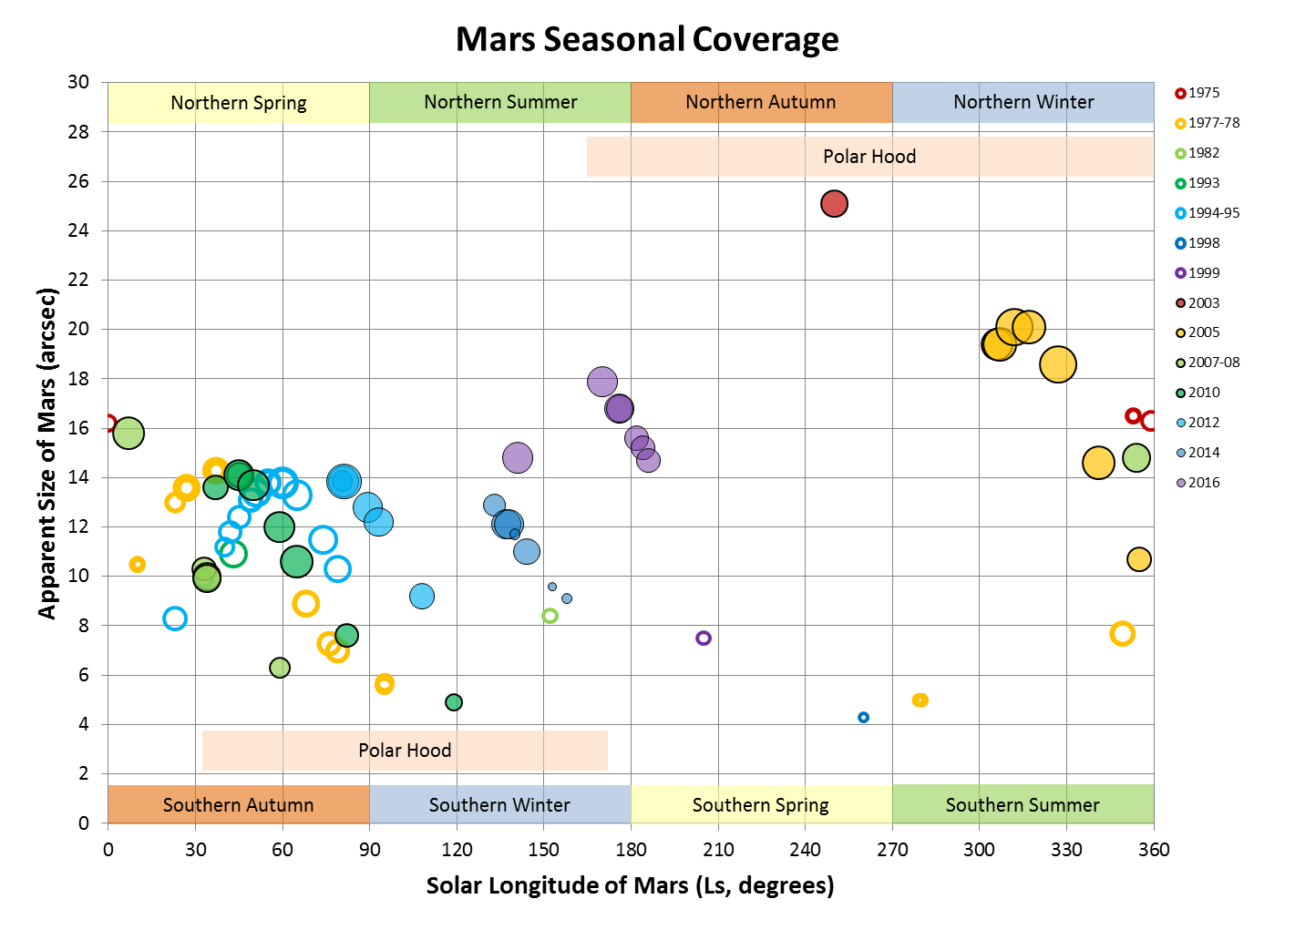**

1. **Surface Mapping (long wavelengths)**

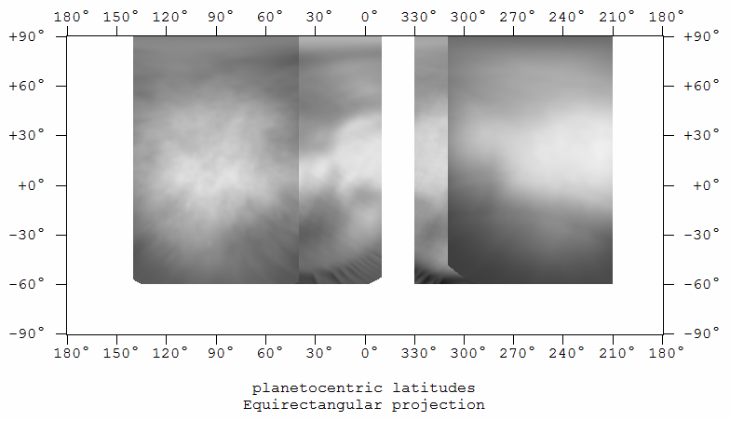

Need to re-verify image navigation and then do a blended 2012 map and apply wavelets

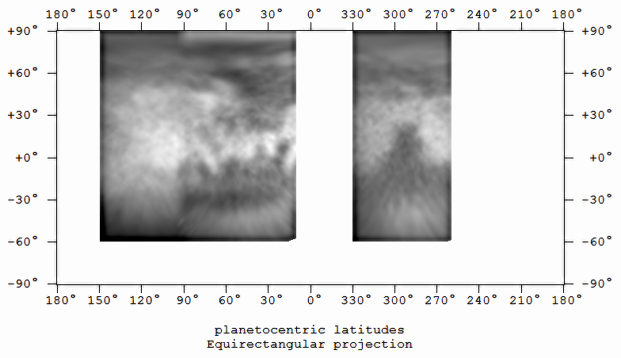

Need to re-verify navigation, particularly between 90-150 deg, since some of the volcanic features seem out of position.

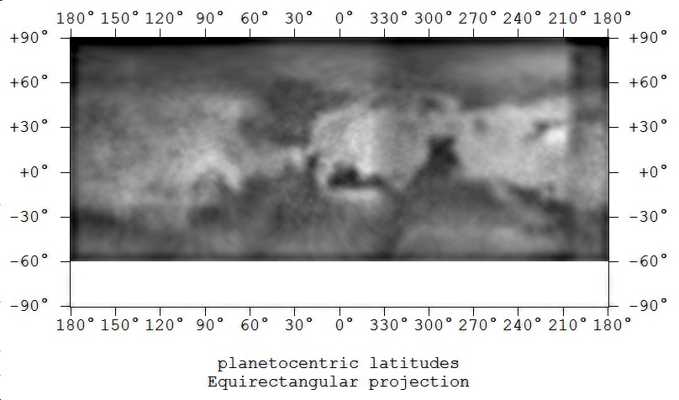

Need to recreate using updated

Mars2016-NIR-Map-Blended-Wavelets.jpg



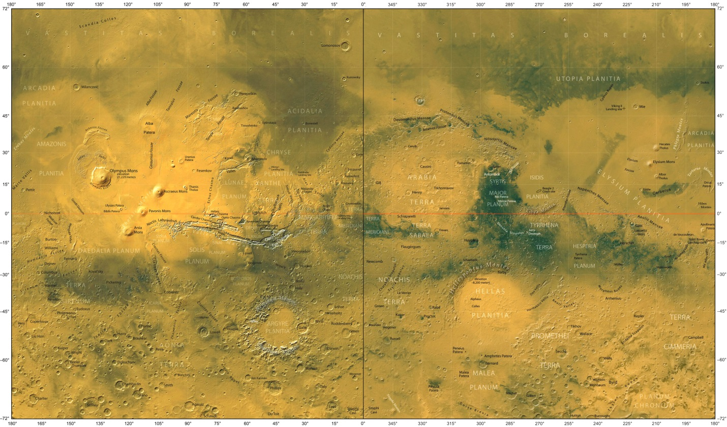

<http://www.karmalimbo.com/aro/pics/refer/Mars-map-mid.jpg>

The blended *surface albedo* map is created as follows:

1. Create stacked images (using WinJUPOS de-rotation) using *all* of the highest signal-to-noise (also best spatial resolution) images taken at the RED and NIR end of the spectrum. An example would be a stack of 807nm, 685nm and RED images.
2. Create PNG maps using WinJUPOS for each of the images covering their best longitudes. All maps should be the same size. Here I’ve used 640 as the default width for the maps. With the font settings on the work version of WinJUPOS this results in a total image size of ~780x460. I can’t seem to duplicate that size on the laptop exactly.
3. Once the individual maps are created, they are opened in MaximDL and cropped to the edges of their respective longitudes (except for the maps containing the latitude scales, they are cropped only on one side).
4. Using the *Mosaic* function MaximDL, the images are recombined with a 200 pixel overlap. This assures blending of overlapping regions as the greatest extent of a given map might be 120 degrees, which translates to 213 pixels.
5. After the blended map is assembled, it can be opened in Registax for further sharpening if the signal to noise will support that kind of processing.
6. Watch out for “seam” artifacts due to limb darkening!
7. **Polar Cap Recession**

I need to look at WinJUPOS files. There are two of them and they need to be reconciled. In addition, south polar hood measurements need to be made for 2014 and I think also for 2012.

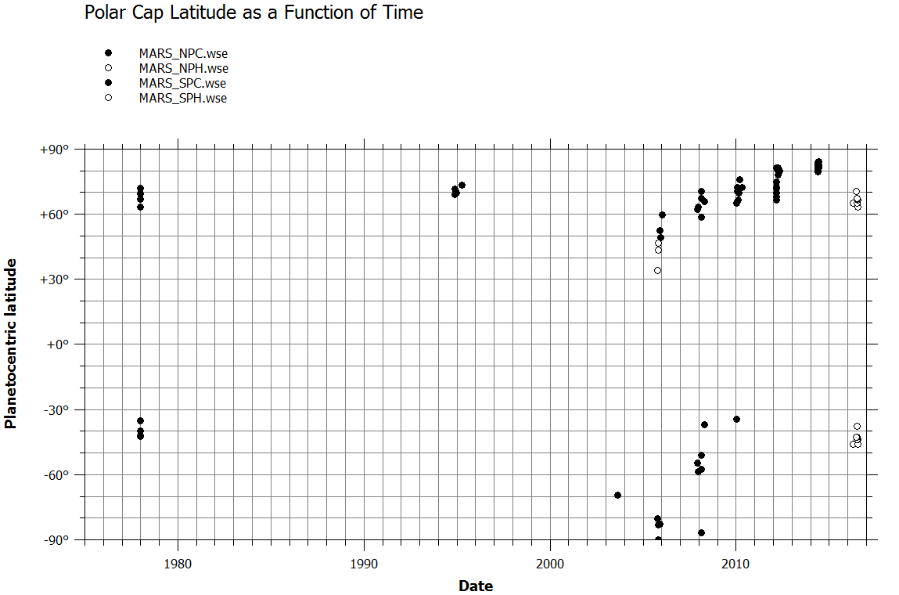

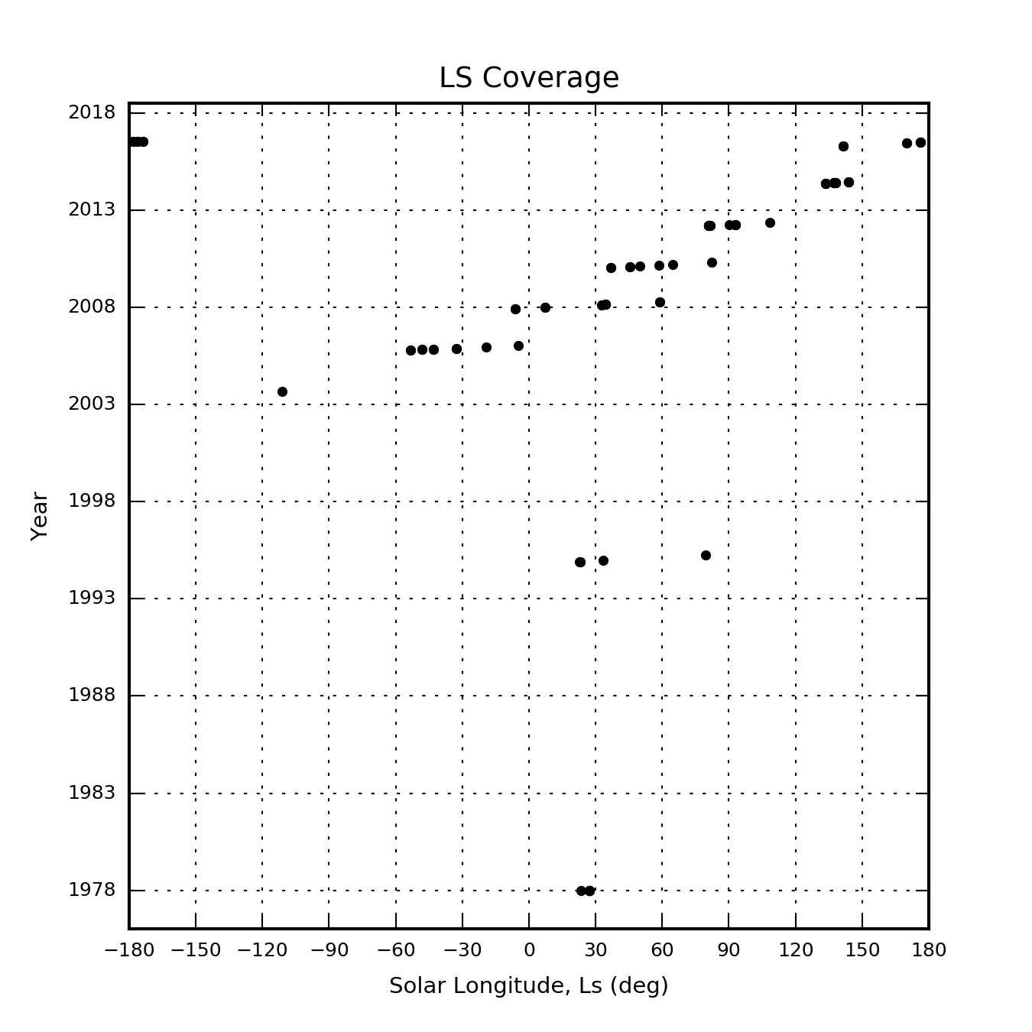

Mars\_Coverage.png

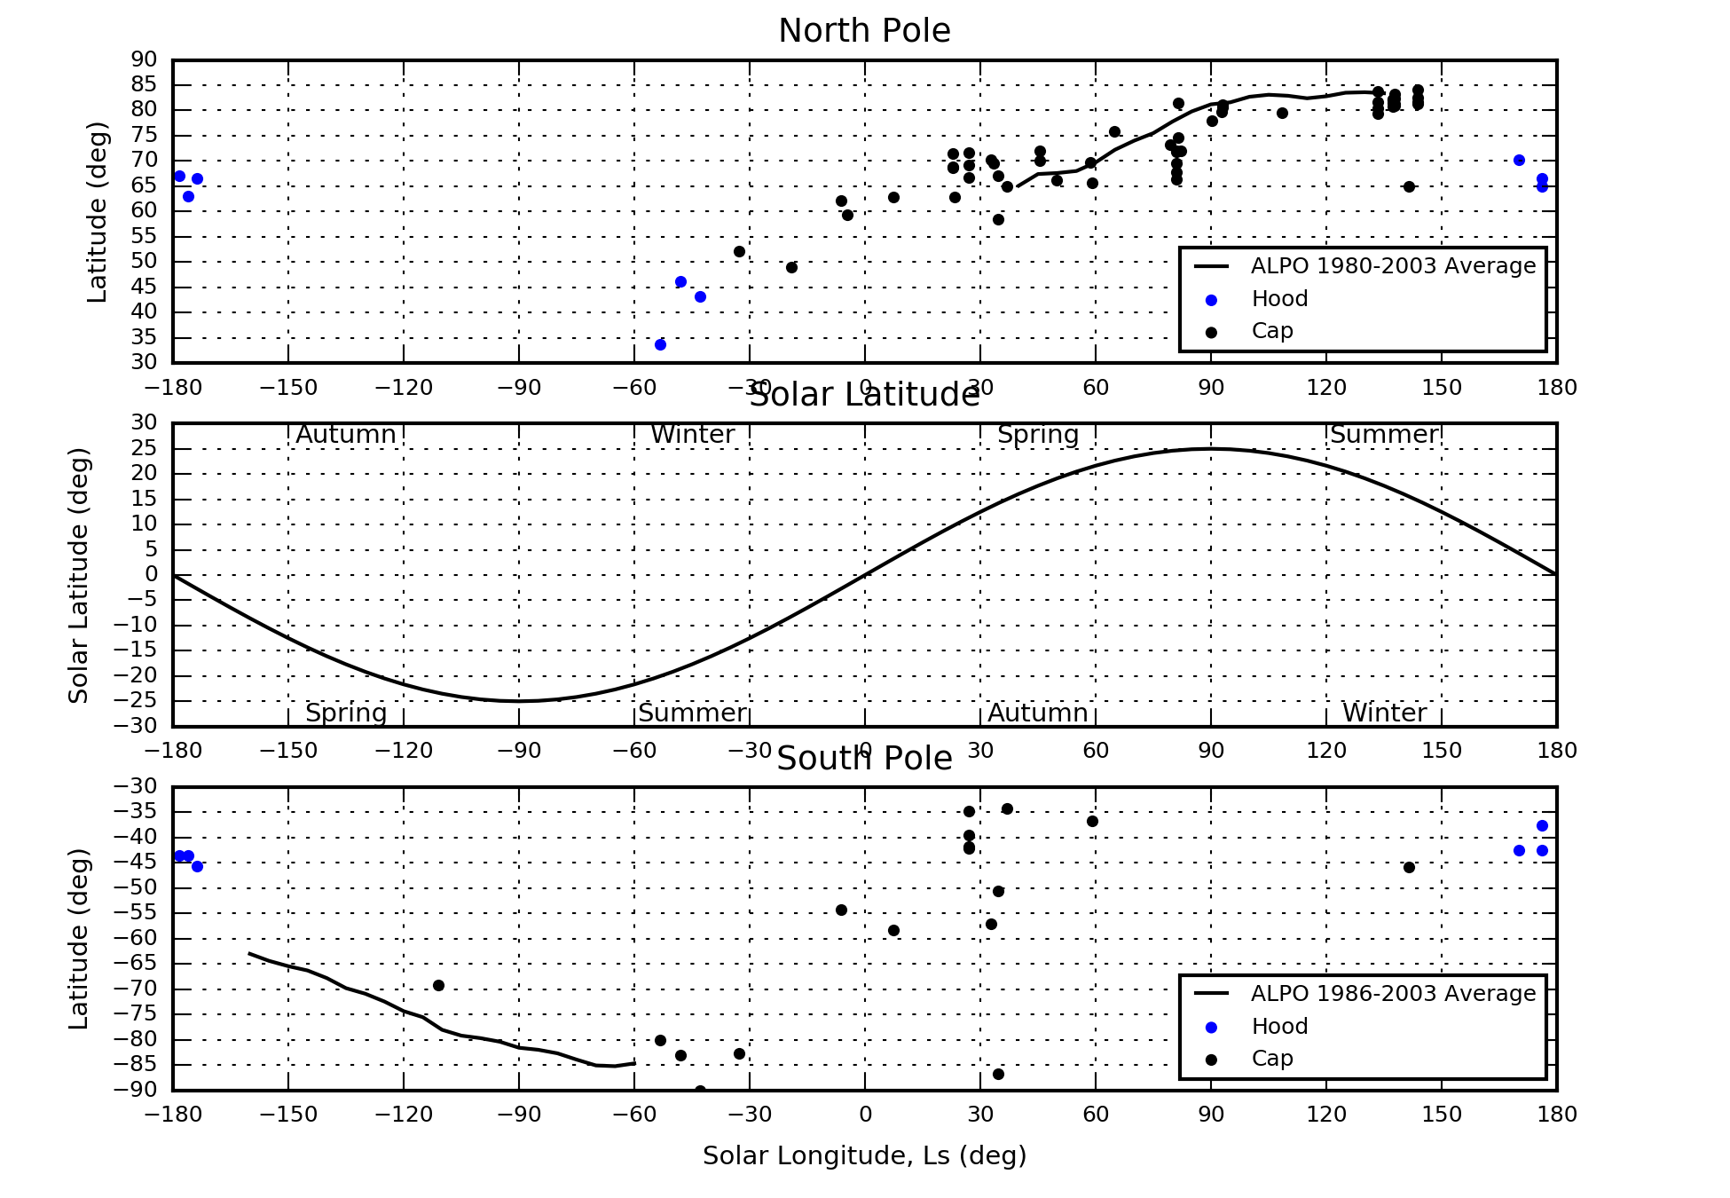

Mars\_Seasons.png from MarsPolarAnalysis.py using HillMars\_mea.CSV

**References:**

Observing the Planet Mars -- By: Jeffrey D. Beish ( Rev. 04-06-2013 ); Retrieved 7/14/2016; <http://www.alpo-astronomy.org/jbeish/Observing_Mars_3.html>

1. **Meteorology (shorter wavelength mapping, both areocentric and local time)**

TBD

To Do:

I need to make maps in G(?)BU and maybe color to distinguish cloud areas that are constrained by geography, e.g., polar clouds or orographic clouds.

Otherwise, I need to measure cloud locations versus solar longitudinal phase angle (equivalent to local time) for afternoon and morning clouds. Is there a way to map this???

### Jupiter

Last Updated 4/10/2016

1. **Introduction and Observing Log**

**20160403UT – CMII ~278**

**20160422UT – CMII ~154**

**20160503UT – CMII~10**

**20160504UT – CMII~165UT**

1. **Mapping (by band? Or just RGB? Start with just RGB for continuity)**

**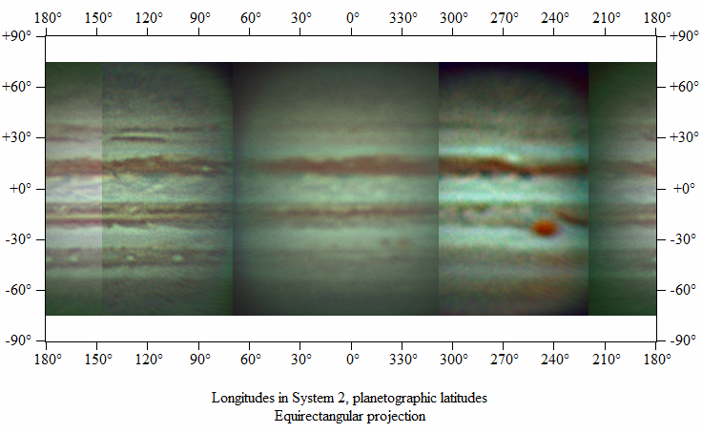**

2016-Hill-Jupiter-RGB-Composite-Map.png

1. **Zonal Measurement and Analysis**
   1. **Traditional point-and-click**

**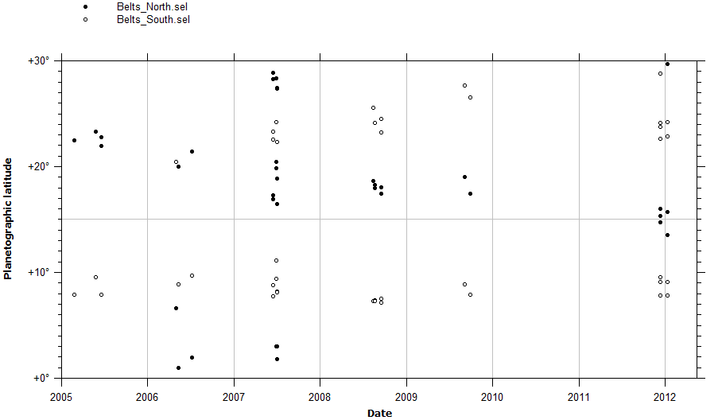**

* 1. **Integrated**

**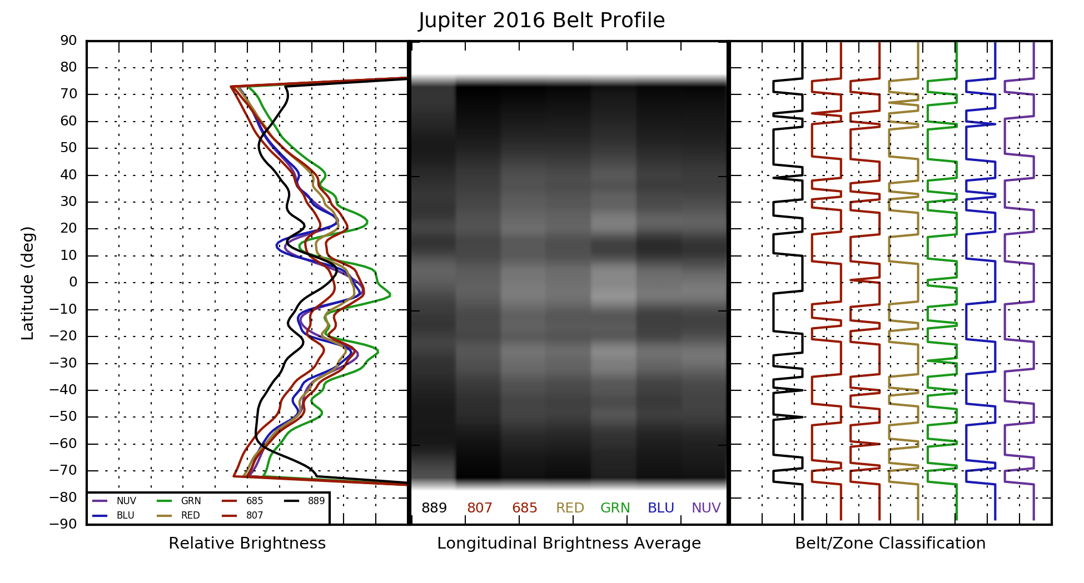**

Jupiter2016BeltProfile.png from BeltProfiles2.py

* 1. **Relative Photometry of Zones and Bands**

1. **Meridional Measurement and Analysis**
   1. **Great Red Spot**
      1. **Drift**

**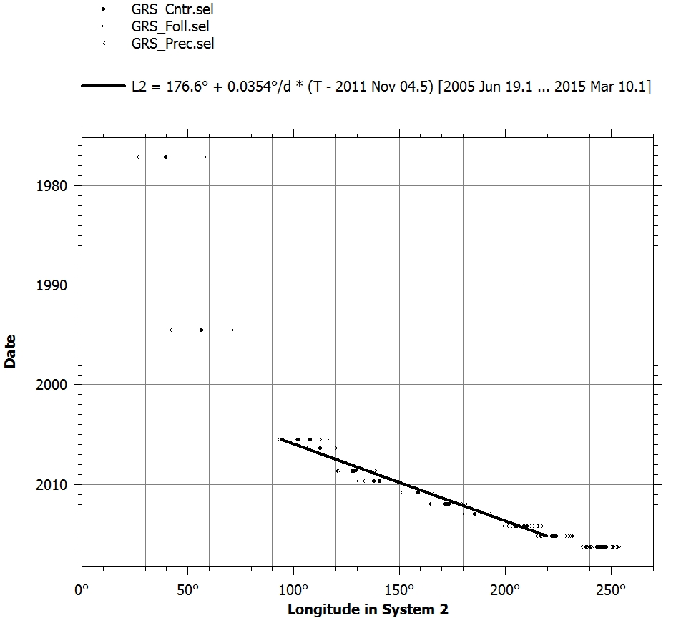**

GRS\_DriftChart\_1975-2020.jpg

**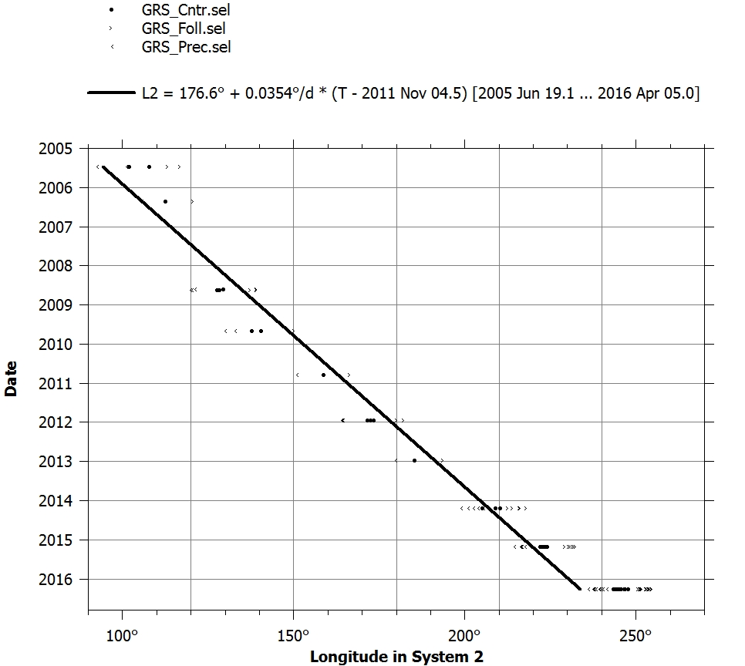**

GRS\_DriftChart\_2005-2017.jpg

* + 1. **Extent (and vs. Drift Rate?)**

**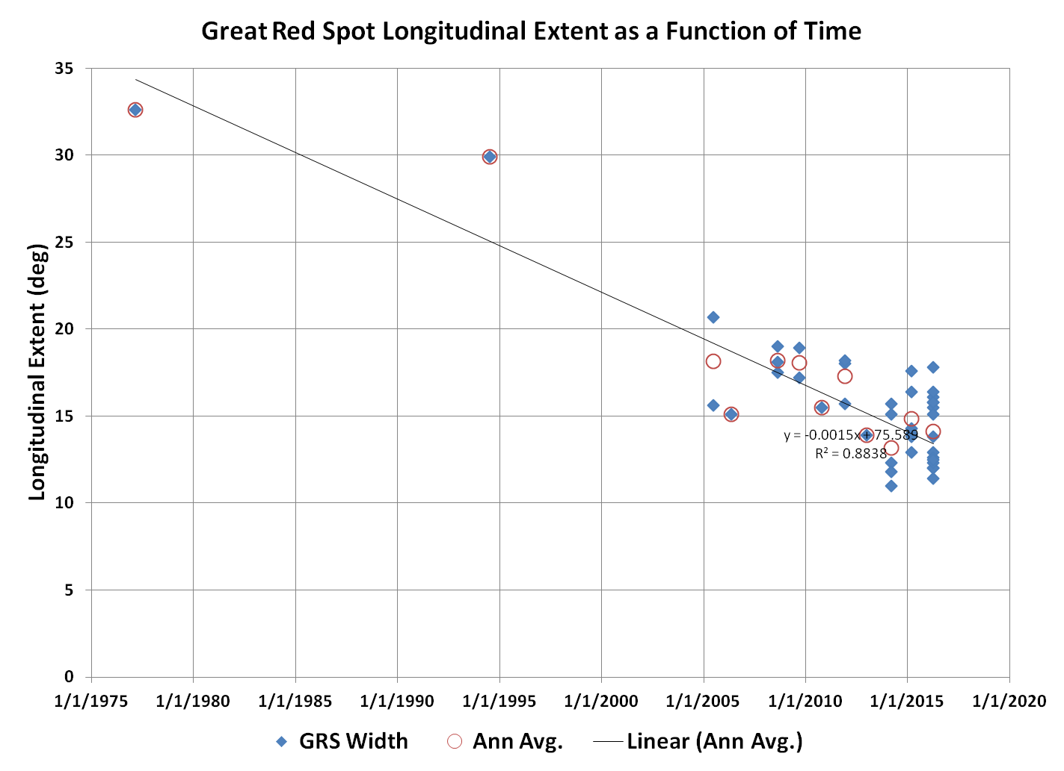**

GRS\_Width A.xlsx

**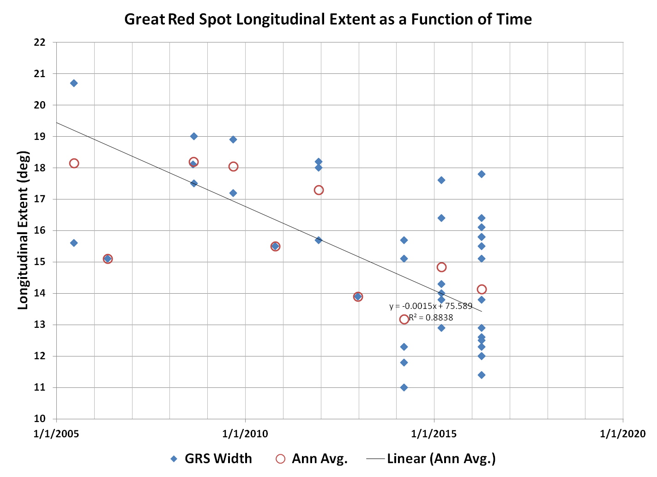**

* + 1. **Color and Photometry (incl. phase angle and/or limb darkening?)**
  1. **Little Red Spot (Oval BA?)**

|  |  |
| --- | --- |
| F:\Astronomy\Projects\Planets\Jupiter\Imaging Data\20160403UT\2016-04-03-0651_8-Hill-Jupiter-RGB-Derotated-Wavelets-Annotated.png | F:\Astronomy\Projects\Planets\Jupiter\Imaging Data\20160422UT\2016-04-22-0402_0-Hill-RGB-SmoothColBalEtc-Wavelets1x5+2x3-Annotated.png |
| 2016-04-03-0651\_8-Hill-Jupiter-RGB-Derotated-Wavelets-Annotated.png | 2016-04-22-0402\_0-Hill-RGB-SmoothColBalEtc-Wavelets1x5+2x3-Annotated.png |
| F:\Astronomy\Projects\Planets\Jupiter\Imaging Data\20160503UT\2016-05-03-0403_2-Hill-RGB-Wavelets-SmthColBal-Annotated.png | F:\Astronomy\Projects\Planets\Jupiter\Imaging Data\20160504UT\2016-05-04-0334_3-Hill-RGB-Wavlets2x3+3x2-SmthColBal-Annotated.png |
| 2016-05-03-0403\_2-Hill-RGB-Wavelets-SmthColBal-Annotated.png | 2016-05-04-0334\_3-Hill-RGB-Wavlets2x3+3x2-SmthColBal-Annotated.png |

* 1. **NEB Wave Structures Periods (Lomb-Scargile in Python)**
  2. **White Ovals, period and drift**
  3. **Other features**

1. **Spectroscopy**

TBD

### Jovian Moons

Last Updated 4/10/2016

1. **Introduction and Observing Log**
   1. **Image Measurement and Navigation**
   2. **FWHM**
2. **Surface Albedo Markings and Size**
3. **Color and Photometry**
4. **Spectroscopy**

### Saturn

Last Updated 4/10/2016

1. **Introduction and Observing Log**

|  |  |  |
| --- | --- | --- |
| **Date (UT)** | **Objects** | **Notes** |
| 2016 Apr 22 | Saturn, Tethys (Dione, Enceladus, Mimas?) | ASI120mm (4500mm) |
| 2016 Jun 27 | Saturn Rhea, Dione, Tethys, Enceladus (Mimas?) | ASI120mm (4500mm) |

1. **Mapping (by band? Or just RGB? Start with just RGB for continuity)**

## Stars

### Vega (Spectroscopy)

Last Updated 10/10/2016

1. Introduction
2. Analysis (relative SED)
   1. Blackbody temperature fit
      1. Select profile to use
      2. Create and use generic response calibration (even though Vega is my main source for response calibration!)
      3. Good link for Python BB profile generator: <http://docs.astropy.org/en/stable/analytic_functions/>
   2. Balmer models and thermometer
      1. Good reference for temperature based on H I alpha and Na I: <http://skinakas.physics.uoc.gr/en/files/projects/StellarSpectraTemperature_p9/P9_STELLAR_SPECTRA_TEMPERATURE.pdf>
      2. General stellar atmospheres and spectra references
         1. <http://www.ifa.hawaii.edu/users/kud/teaching_12/6_Stellar_spectra.pdf>
         2. Stellar Atmospheres: Basic Processes and Equations – Springer <http://www.springer.com/cda/content/document/cda_downloaddocument/9783319069555-c2.pdf?SGWID=0-0-45-1466915-p176746920>
         3. Ionization of Hydrogen <http://www.springer.com/cda/content/document/cda_downloaddocument/9783319069555-c2.pdf?SGWID=0-0-45-1466915-p176746920>
         4. Saha **Python** code <https://github.com/davidvgalbraith/astrophysics/blob/master/saha.py>
         5. Chemical composition from spectra <http://spiff.rit.edu/classes/phys301/lectures/comp/comp.html>
   3. Paschen analysis
   4. Metals analysis?
3. Analysis (absolute SED)
   1. Response calibration for C8
   2. Response calibration for 135mm lens
4. Observing Log
5. Spectral plots
   1. Un-normalized
   2. Normalized
   3. Line Identification

The best general atomic spectral atlas: <http://physics.nist.gov/cgi-bin/ASD/lines1.pl>

Good article on all sky quantitative photometry <http://brucegary.net/Dawn/allsky.html>

**Observing Log**

|  |  |  |
| --- | --- | --- |
| **Date** | **Comments** | **Update** |
| 2015 Sep 13 | Spectra: Took spectra using Star Analyzer 200/mm grating, ST2000, and C8 at f/6.3 (1260mm). Used CLR filter. | 2015-Oct-23 |
| 2015 Sep 20 | Spectra: Took spectra using Star Analyzer 200/mm grating, ST2000, and C8 at f/6.3 (1260mm). Used CLR filter. Unfortunately I discovered that there was icing on the detector at -10C. This ruined the spectra for any quantitative purposes. I’ve permanently deleted the data files. | 2015-Oct-23 |
| 2015 Sep 24 | Spectra: Took spectra using Star Analyzer 200/mm grating, ST2000, and C8 at f/6.3 (1260mm). Used CLR and NIR742 filters for order separation. | 2015-Oct-23 |
| 2015 Oct 13 | Spectra: Took spectra using Star Analyzer 200/mm grating, ST2000, and C8 at f/6.3 (1260mm). Used CLR and NIR742 filters for order separation. | 2015-Oct-23 |
| 2015 Oct 14 | Spectra: Took spectra using Star Analyzer 200/mm grating, ST2000, and C8 at f/6.3 (1260mm). Used CLR and NIR742 filters for order separation. | 2015-Oct-23 |
| 2016 Sep 05UT | Spectra: Took spectra using Star Analyzer 200/mm grating, ST2000, and C8 at f/6.3 (1260mm). Used CLR and NIR742 filters for order separation. | 2015-Oct-23 |

**Spectra**

Discuss apparent systematic error at longer wavelengths for the C8 configuration with lower spectral resolution.

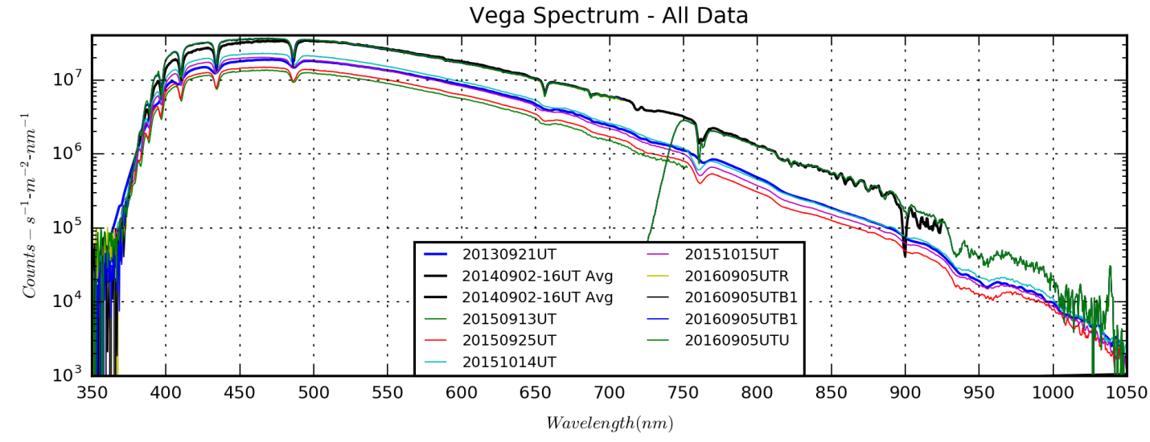

VegaSpectrumAllYears.png (produced by VegaSpectrumAllYears.py)

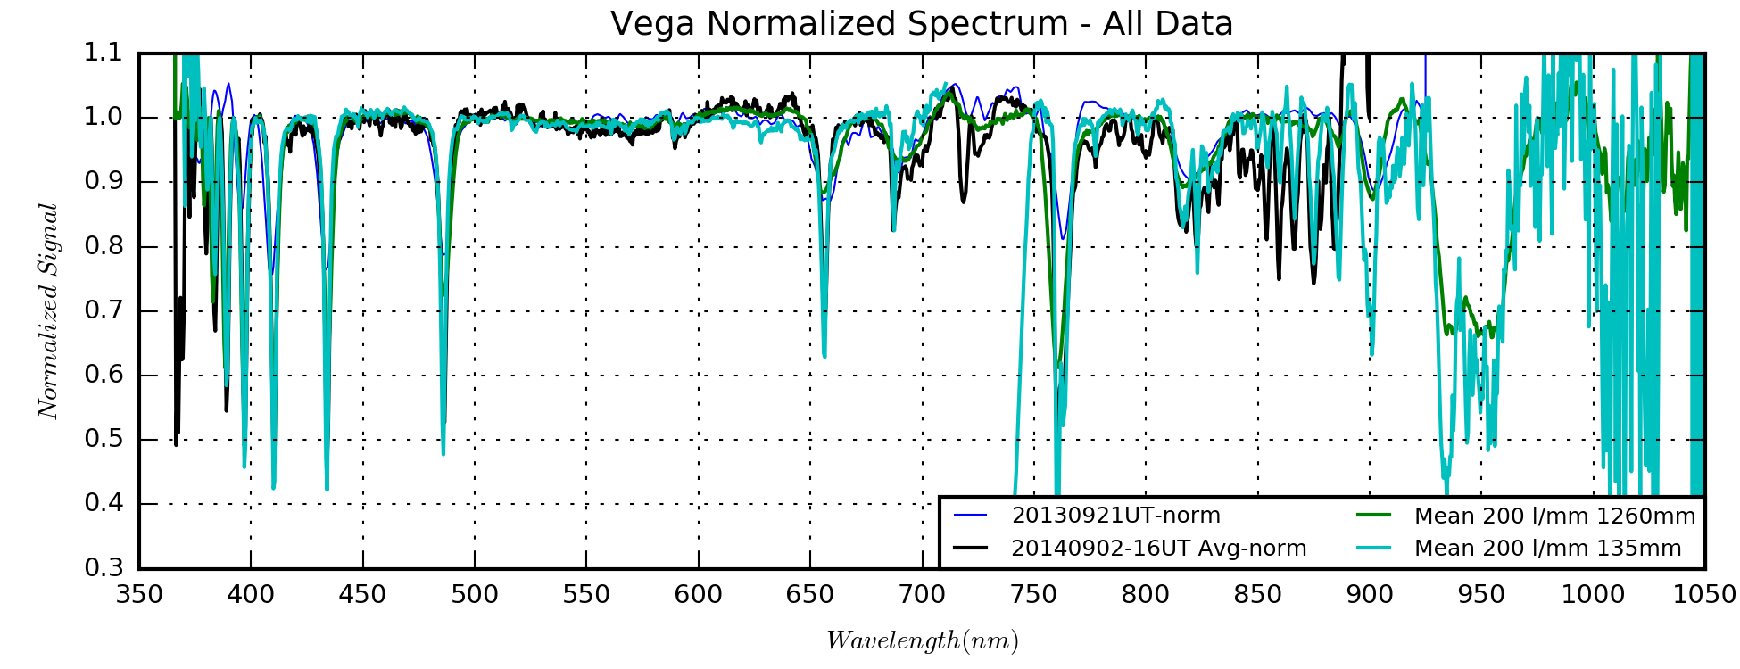

VegaNormSpectrumAllYears.png (produced by VegaSpectrumAllYears.py)

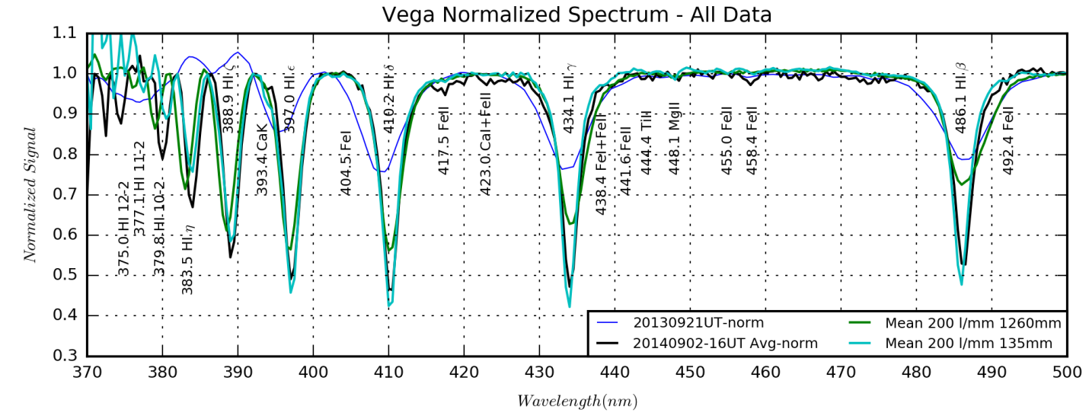

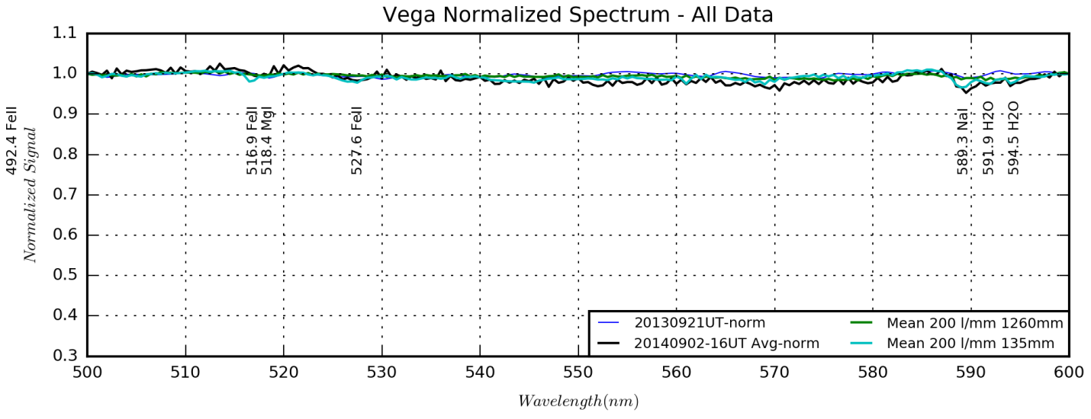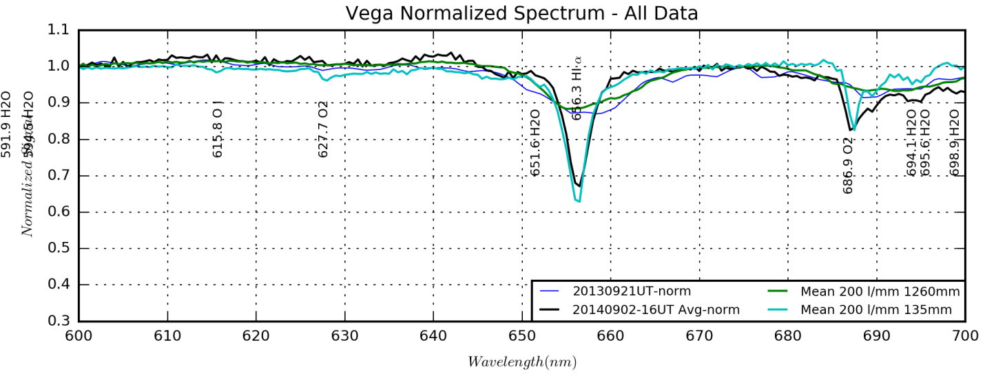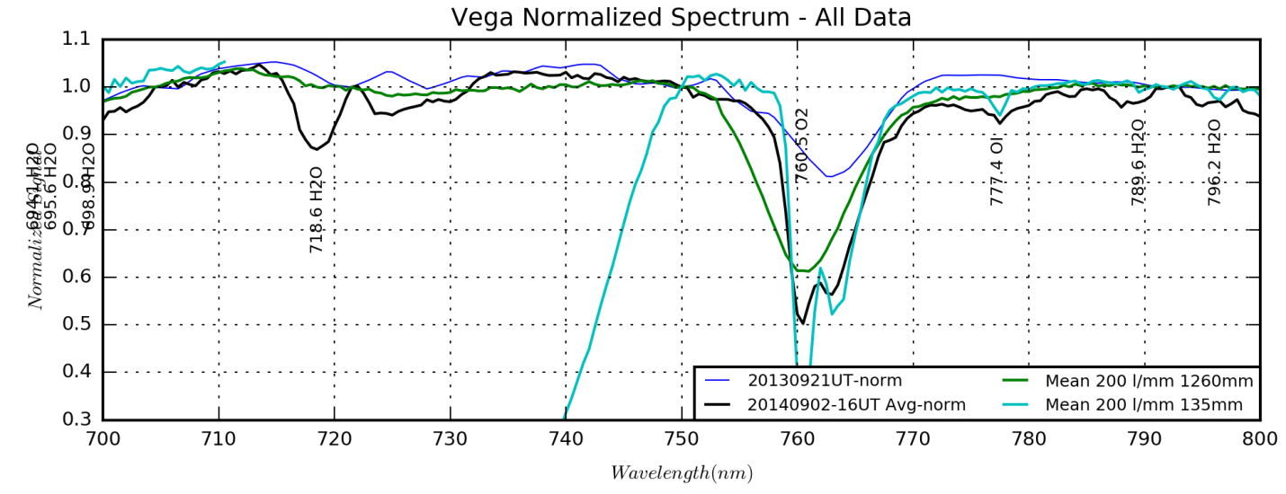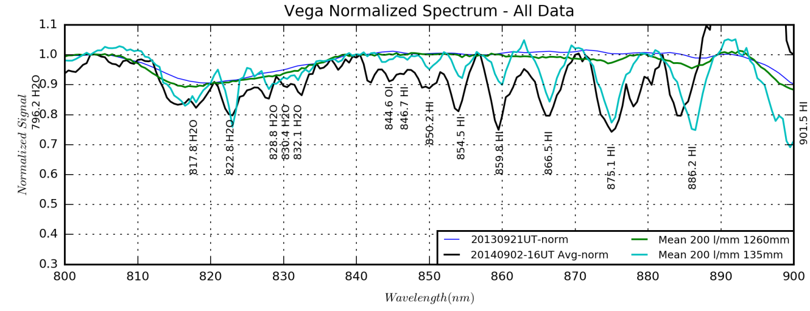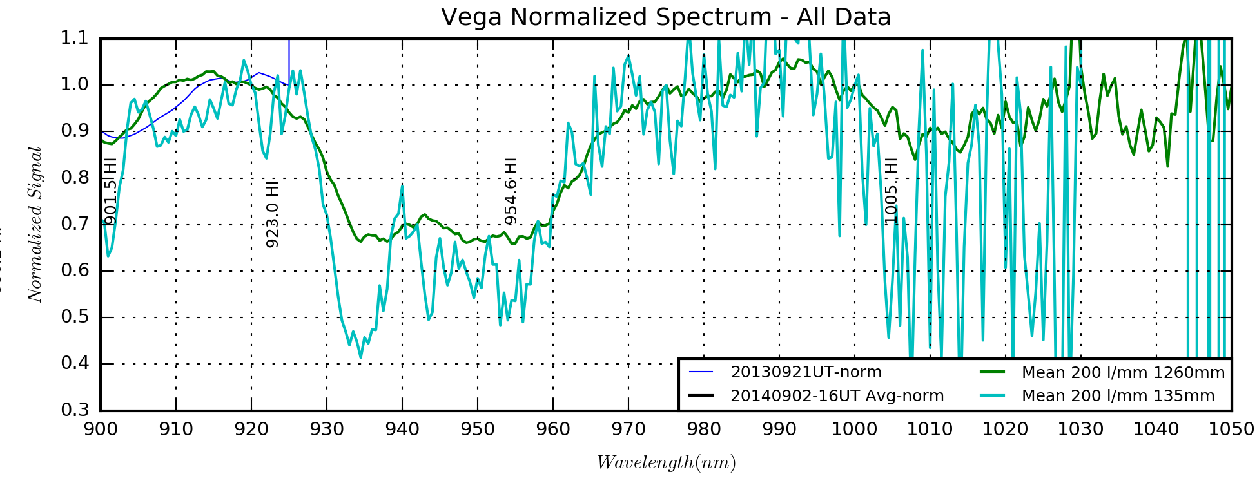

The following resources look really good for the line IDs:

<http://www.astrogeo.va.it/astronom/spettri/stelle-Aen.htm>

<http://www.astrosurf.com/buil/us/vatlas/vatlas.htm>

**Response**

Possibly I could do absolute curves since Vega is a calibration star.

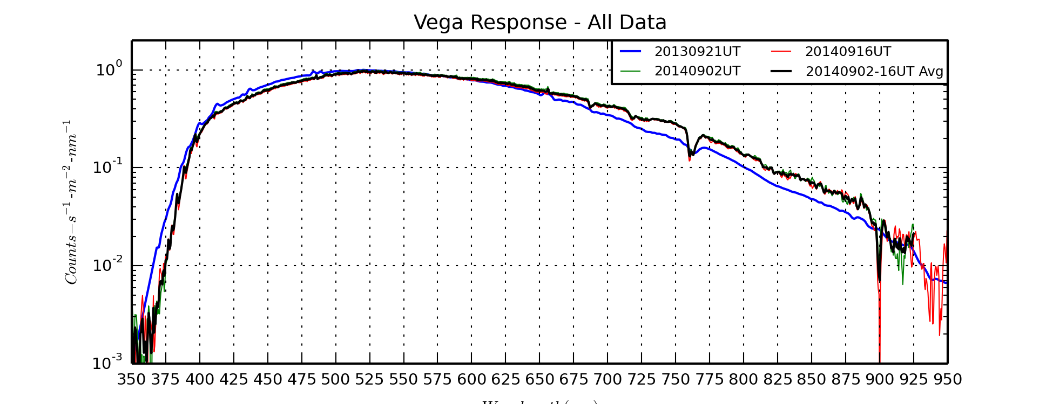

VegaResponseAllYears.png (produced from VegaResponseAllYears.py)

**Balmer Analysis**

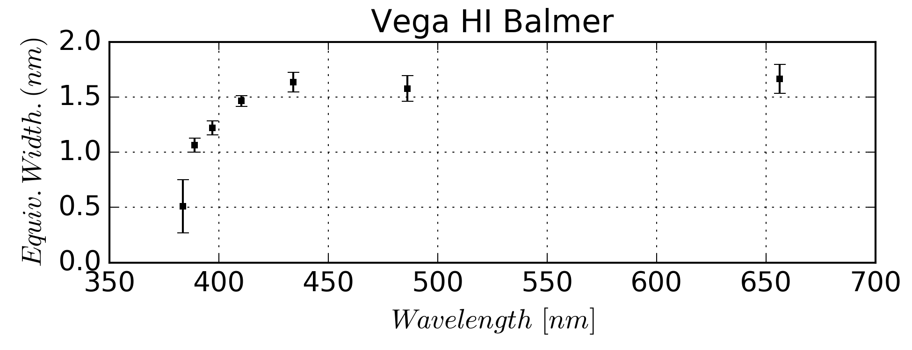

Vega HI Balmer EW.png produced by EW2Astrophysics.py

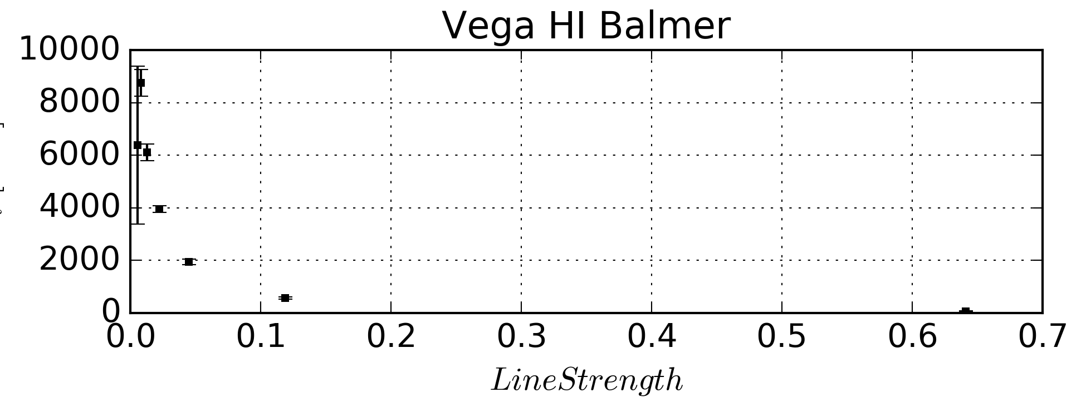

Vega HI Balmer N.png produced by EW2Astrophysics.py

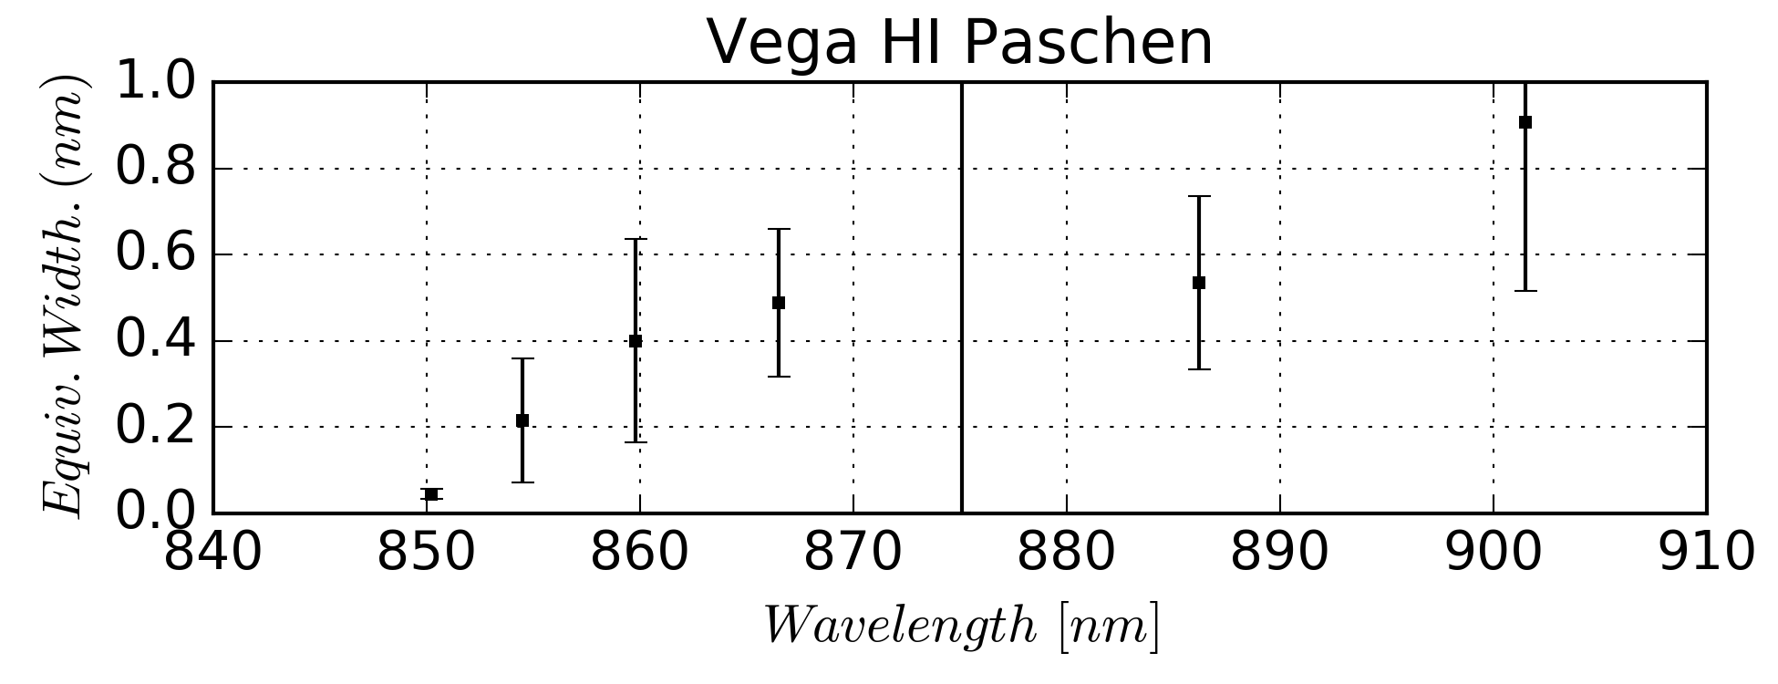

Vega HI Paschen EW.png produced by EW2Astrophysics.py

**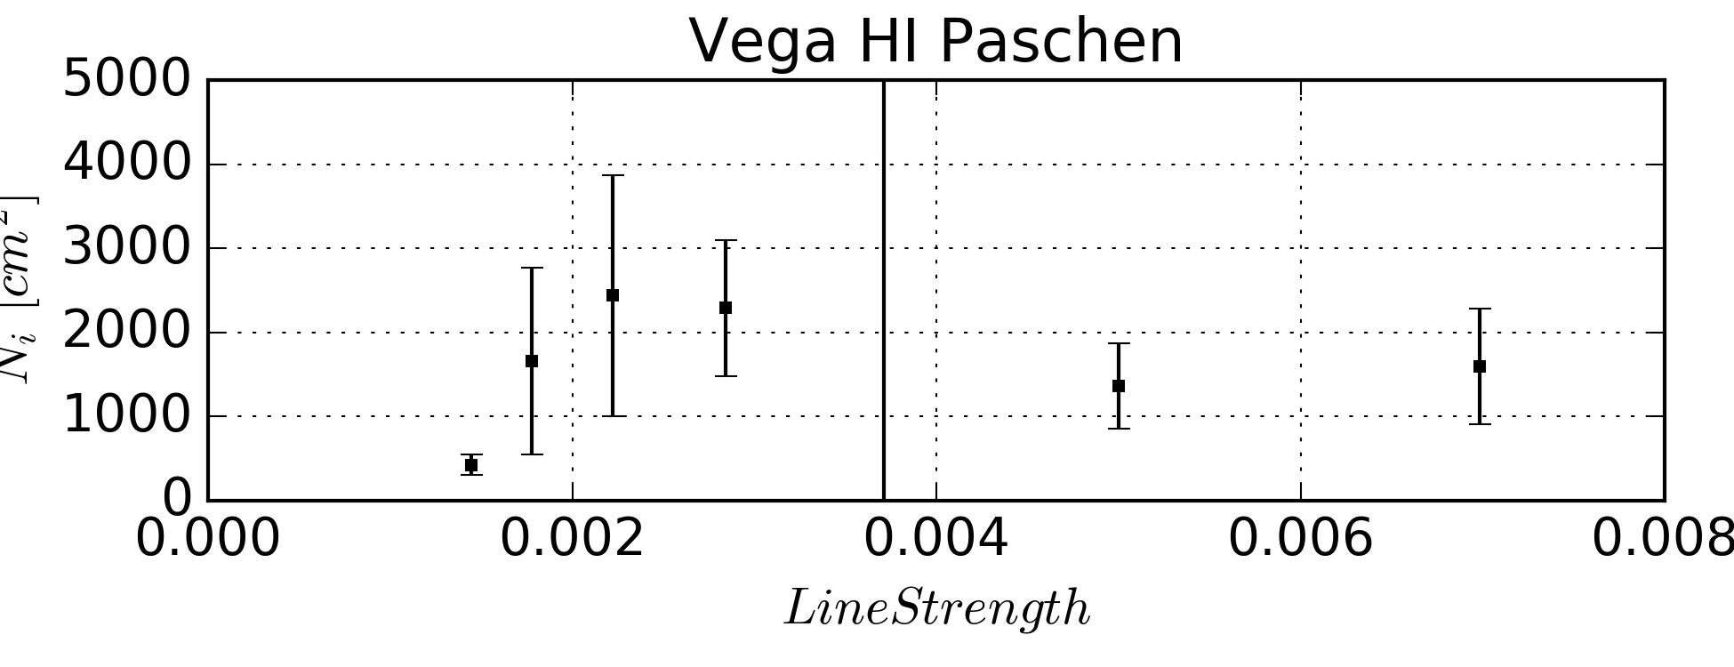**

Vega HI Paschen EW.png produced by EW2Astrophysics.py

**Telluric absorption analysis**

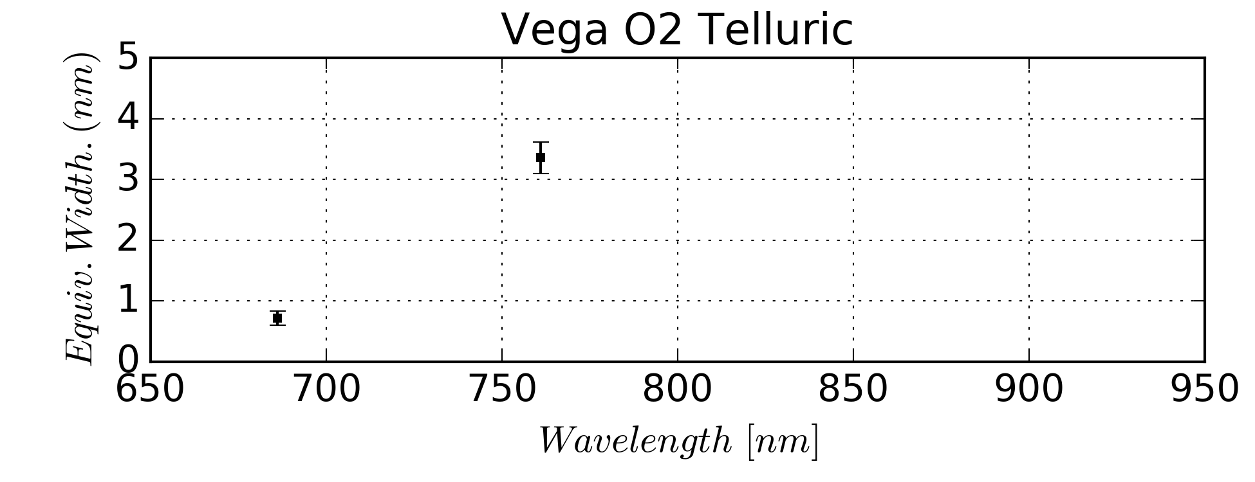

Vega O2 Telluric EW.png produced by EW2Astrophysics.py

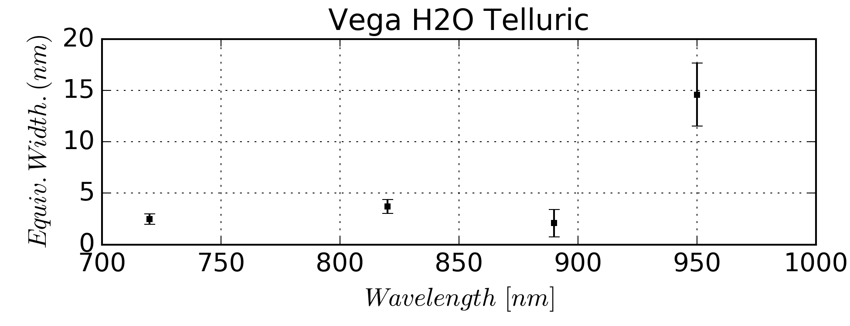

Vega H2O Telluric EW.png produced by EW2Astrophysics.py

The telluric bands have not been corrected for airmass. Need to look up PWV for the dates in question with the resource Chris Lauer provide in a work e-mail on 2014-10-06:

A little bit of informed googling:

GPS derived measurements:

<http://www.suominet.ucar.edu/>

Looks like they have a giant pile of files archive, they even mention SWPC as the other user of GPS data

Here's the best model analysis archive I could find in 10 seconds:

<http://rda.ucar.edu/datasets/ds083.2/>

+---Vega

| +---Spectral Data

| | +---20130921UT

| | +---20151015UT

| | +---20151014UT

| | +---20150925UT

| | +---20150913UT

| | +---20140902UT

| | +---20140916UT

| | +---1D Spectra

| | +---Configuration Files

| | +---EWs

| | +---Analysis

| | \---20160905UT

| \---References

### Beta Lyrae (Spectroscopy)

Last Updated 10/13/2016

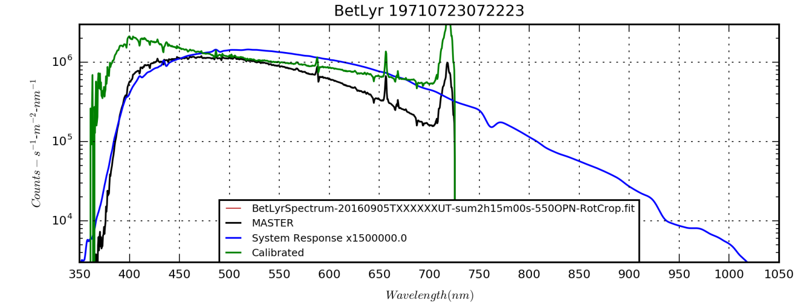

BetLyr\_19710723072223\_1D.png; needs DATE-OBS fixed in FITS header.

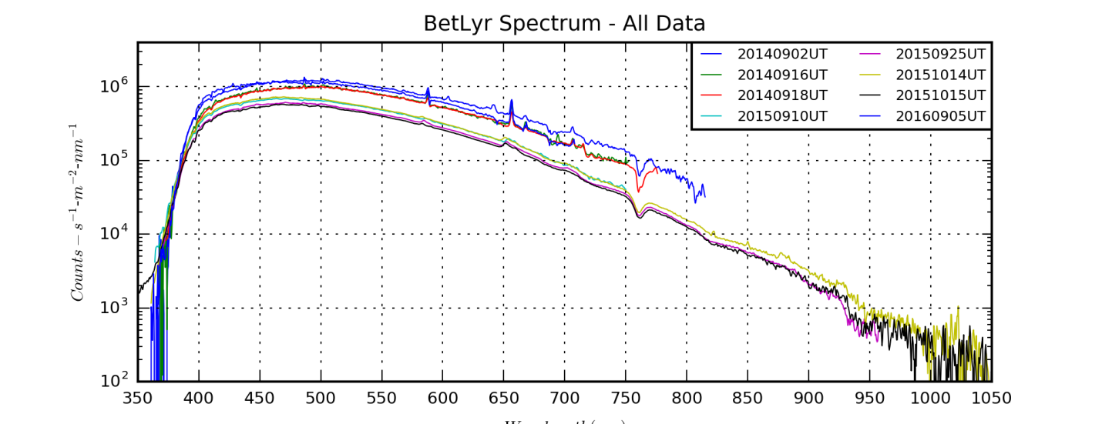

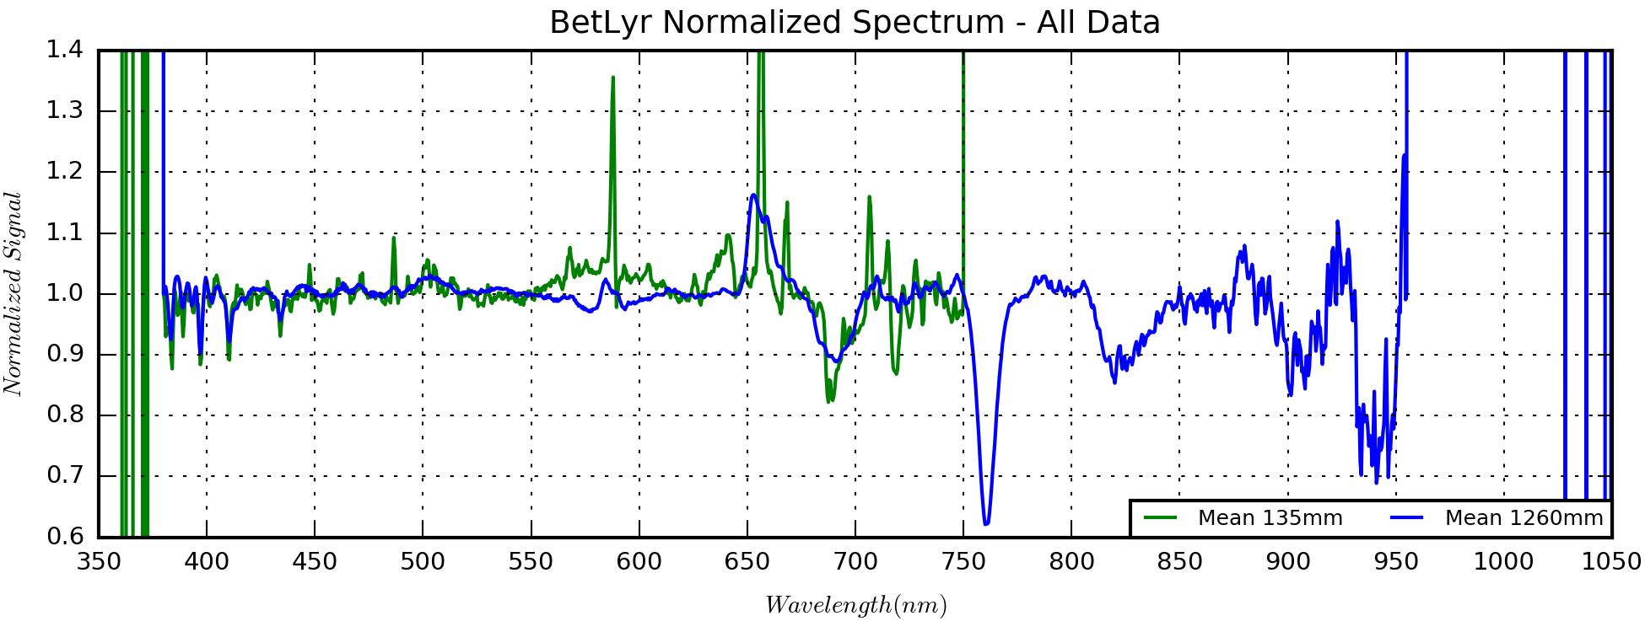

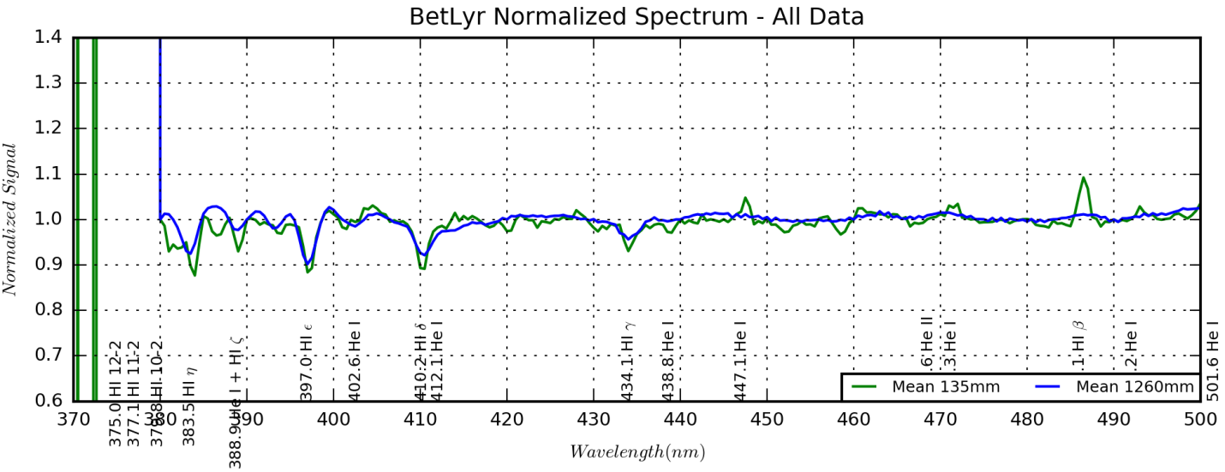

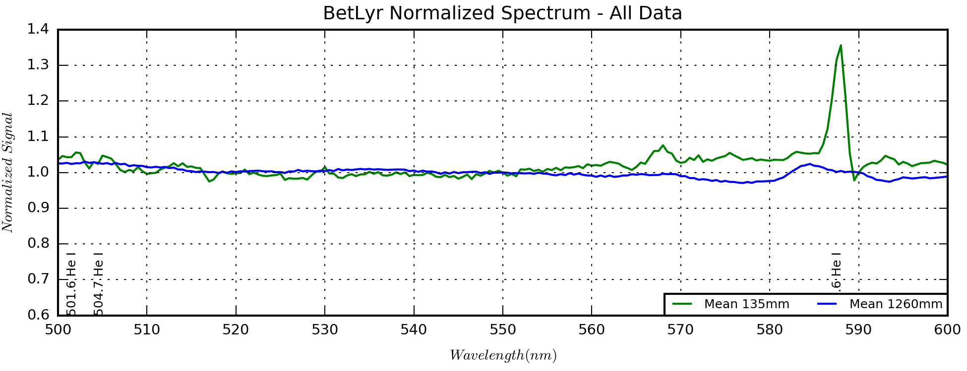

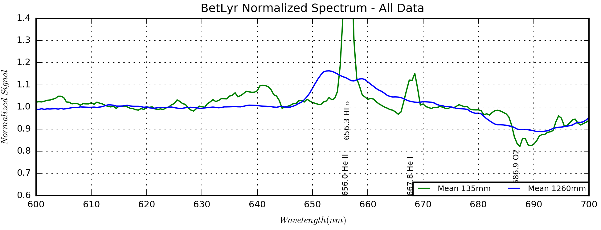

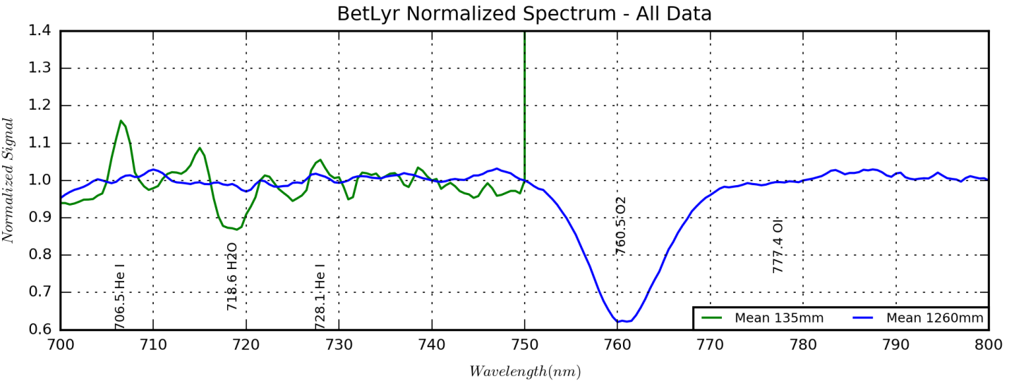

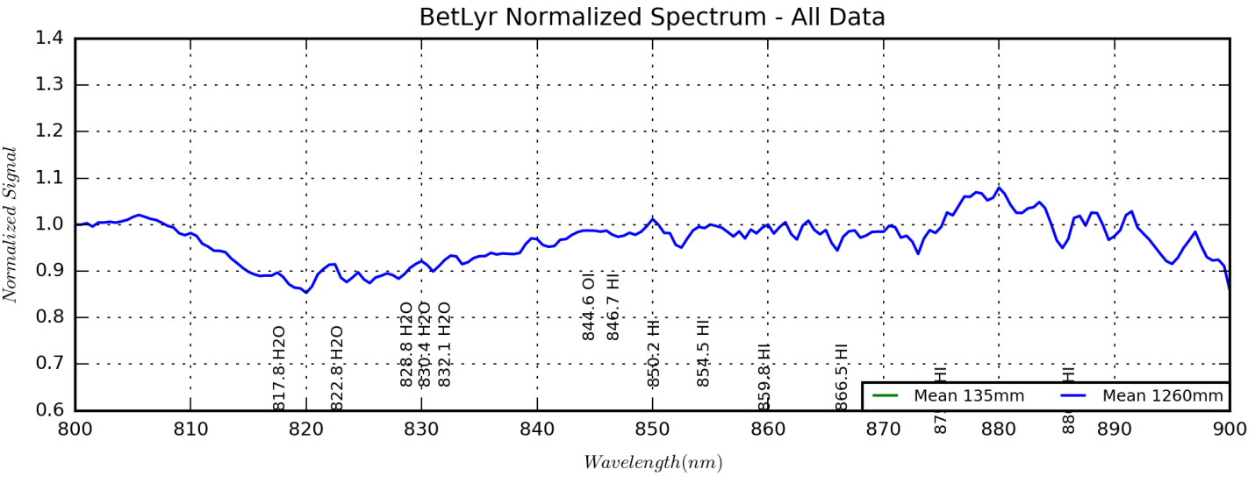

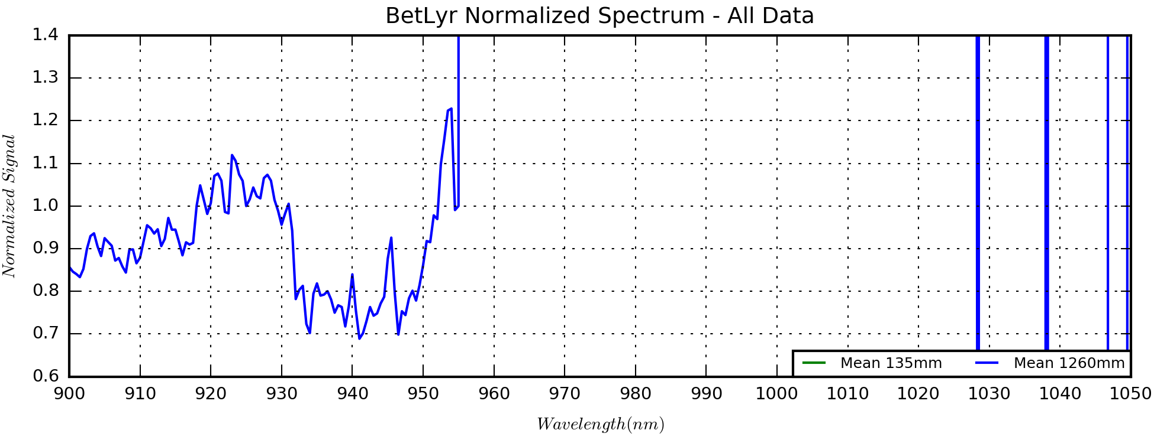

## Nebulae

### Nebula Multi-Band Imaging – Techniques for Signal Decomposition

Last Updated 11/29/2016

1. **Bands of Interest**

**889 CH4**

**Recombination lines** include a contribution from the HI Pa 11 recombination line. The HI Pa line intensity might be estimated using HI decrement models.

**Collisional lines** are non-existent in this band.

**Continuum emission** is proportional to reflected stellar spectrum and the color of reflective dust.

May include HI Pa 11 line at 886 nm (FWHM=10nm) 884-894nm

$${ADU}_{889CH4}=\left(I_{HIP11}^{*}{∙R}_{889CH4}^{886}+C_{889CH4}^{*}{∙W}_{889CH4}^{886}\right)T_{889CH4}^{*}$$

See (and possibly merge) the discussion in the section on Narrow Band filters. Need to have some expectation of signal levels for different types of phenomena, when dust dominates and when HI Pa II dominates. Also need ionization level and effective ionization temperature.

**>807 NIR**

**Recombination lines** contribute negligible signal in this band.

**Collisional lines** include S III 907 and 953nm. These lines represent low temperature plasma (TKE~10,900K). While they are very bright, the reduced sensitivity of silicon detectors at this wavelength leads to raw counts commensurate with weaker lines at shorter NIR wavelengths.

**Continuum emission** is proportional to reflected stellar spectrum and the color of reflective dust. Given the broadness of this band, continuum emission could dominate the collisional lines.

$$N_{}^{807NIR}=\sum_{line}{R_{line}^{807NIR}S_{line}^{}}+E_{}^{807NIR}S_{cont}^{807NIR}$$

$$N_{}^{filter}=\sum_{line}{R_{line}^{filter}T_{line}S_{line}}+E_{}^{filter}{〈T^{filter}〉S}_{cont}^{filter}$$

$$\left[N^{filter}\right]=\left[\sum_{line}{R_{line}^{filter}T_{line}S_{line}}+\sum_{line}{E_{}^{filter}{〈T^{filter}〉S}_{cont}^{filter}}\right]$$

$$\left[\begin{matrix}N^{889CH4} \\ N^{807NIR} \\ N^{742NIR} \\ N^{685NIR} \\ N^{672SII} \\ N^{656HIA} \\ N^{650RED} \\ N^{550GRN} \\ N^{550CLR} \\ N^{501OIII} \\ N^{486HIB} \\ N^{450BLU} \\ N^{380NUV}\end{matrix}\right]=\left[\sum_{line}{R_{line}^{filter}T_{line}S_{line}}+\sum_{line}{E_{}^{filter}{〈T^{filter}〉S}_{cont}^{filter}}\right]$$

$$\left[\begin{matrix}N^{550GRN} \\ N^{501OIII} \\ N^{486HIB}\end{matrix}\right]=\left[\begin{matrix}E^{550GRN} & R_{OIII}^{550GRN} & R_{HIB}^{550GRN} \\ E^{501OIII} & R_{OIII}^{501OIII} & R_{HIB}^{501OIII} \\ E^{486HIB} & R_{OIII}^{486HIB} & R_{HIB}^{486HIB}\end{matrix}\right]\left[\begin{matrix}S_{cont}^{550GRN} \\ S_{OIII} \\ S_{HIB}\end{matrix}\right]$$

$$\left[\begin{matrix}N^{550GRN} \\ N^{501OIII} \\ N^{486HIB}\end{matrix}\right]=\left[\begin{matrix}E^{550GRN} & R_{OIII}^{550GRN} & R_{HIB}^{550GRN} \\ E^{501OIII} & R_{OIII}^{501OIII} & 0 \\ E^{486HIB} & 0 & R_{HIB}^{486HIB}\end{matrix}\right]\left[\begin{matrix}S_{cont}^{550GRN} \\ S_{OIII} \\ S_{HIB}\end{matrix}\right]$$

$$\left[\begin{matrix}N^{807NIR} \\ N^{742NIR} \\ N^{685NIR}\end{matrix}\right]=\left[\begin{matrix}E^{807NIR} & R_{SIII953}^{807NIR} & R_{SIII907}^{807NIR} & R_{ArIII775}^{807NIR} & R_{ArIII714}^{807NIR} \\ E^{742NIR} & R_{SIII953}^{742NIR} & R_{SIII907}^{745NIR} & R_{ArIII775}^{742NIR} & R_{ArIII714}^{742NIR} \\ E^{685NIR} & R_{SIII953}^{685NIR} & R_{SIII907}^{685NIR} & R_{ArIII775}^{685NIR} & R_{ArIII714}^{685NIR}\end{matrix}\right]\left[\begin{matrix}S_{cont}^{\overline{NIR}} \\ S_{SIII953} \\ S_{SIII907} \\ S_{ArIII775} \\ S_{ArIII714}\end{matrix}\right]$$

$$\left[\begin{matrix}N^{807NIR} \\ N^{742NIR} \\ N^{685NIR}\end{matrix}\right]=\left[\begin{matrix}E^{807NIR} & R_{SIII953}^{807NIR} & R_{SIII907}^{807NIR} & 0 & 0 \\ E^{742NIR} & 0 & 0 & R_{ArIII775}^{742NIR} & 0 \\ E^{685NIR} & 0 & 0 & 0 & R_{ArIII714}^{685NIR}\end{matrix}\right]\left[\begin{matrix}S_{cont}^{\overline{NIR}} \\ 0.75S_{SIII} \\ {0.25S}_{SIII} \\ {0.25S}_{ArIII} \\ {0.75S}_{ArIII}\end{matrix}\right]$$

$$\left[\begin{matrix}N^{807NIR} \\ N^{742NIR} \\ N^{685NIR}\end{matrix}\right]=\left[\begin{matrix}E^{807NIR} & R_{SIII}^{807NIR} & 0 \\ E^{742NIR} & 0 & R_{ArIII775}^{742NIR} \\ E^{685NIR} & 0 & R_{ArIII714}^{685NIR}\end{matrix}\right]\left[\begin{matrix}S_{cont}^{\overline{NIR}} \\ S_{SIII} \\ S_{ArIII}\end{matrix}\right]$$

Where

$${N_{SIII}^{807NIR}=R}_{SIII}^{807NIR}S_{SIII}=R_{SIII953}^{807NIR}S_{SIII953}+R_{SIII907}^{807NIR}S_{SIII907}=\left({0.75R}_{SIII953}^{807NIR}+{0.25R}_{SIII907}^{807NIR}\right)S_{SIII}$$

And

$${N_{ArIII}^{742NIR}=R}_{ArIII}^{742NIR}S_{ArIII}=R_{ArIII775}^{742NIR}S_{ArIII775}=\left({0.25R}_{ArIII}^{742NIR}\right)S_{ArIII}$$

$${N_{ArIII}^{685NIR}=R}_{ArIII}^{685NIR}S_{ArIII}=R_{ArIII714}^{685NIR}S_{ArIII714}=\left({0.75R}_{ArIII}^{685NIR}\right)S_{ArIII}$$

Includes HI Pa series and OI at 846 nm and strong emission at SIII 907 (but very weak response there). How do we handle transmission and continuum when we have broadband filters?

$${ADU}_{807NIR}=\left(I_{OI845}^{*}{∙R}_{807NIR}^{845}+I_{HIP}^{*}{∙R}_{807NIR}^{889}+I_{SIII907}^{*}{∙R}_{807NIR}^{907}+C_{807NIR}^{*}{∙W}_{807NIR}^{?}\right)T_{807NIR}^{*}$$

**742-807 NIR**

**Recombination lines** contribute negligible signal in this band.

**Collisional lines** should be dominated by Ar III 775 nm. This line represents low-medium temperature plasma (TKE~13,400K). Another collisional line that may be present at higher temperatures Cl IV 805 nm. In cooler plasmas, it should be negligible.

**Continuum emission** is proportional to reflected stellar spectrum and the color of reflective dust. Given the broadness of this band, continuum emission could dominate the collisional lines.

Includes Ar III 775 and lines included by 807 NIR, though the Ar III line is likely the dominant line emission.

$${ADU}_{SII}=\left(I_{SII}^{*}{∙R}_{SII}^{672}+C_{SII}^{*}{∙W}_{SII}^{672}\right)T_{SII}^{*}$$

**685-742 NIR**

**Recombination lines** include He I 706 nm. This could be a significant contributor in hotter plasmas. In cooler plasmas, it should be negligible.

**Collisional lines** should be dominated by Ar III 714 nm. This line represents medium temperature plasma (TKE~13,400K). Another collisional line that may be present at much higher temperatures (TKE~38,800K) is O II 732 nm. In cooler plasmas, it should be negligible.

**Continuum emission** is proportional to reflected stellar spectrum and the color of reflective dust. Given the broadness of this band, continuum emission could dominate the collisional lines.

Includes He I 707, Ar III 714 and O II 732 in addition to longer wavelength lines.

$${ADU}_{SII}=\left(I_{SII}^{*}{∙R}_{SII}^{672}+C_{SII}^{*}{∙W}_{SII}^{672}\right)T_{SII}^{*}$$

**General Notes:**

Differencing the 742 and 685 channels should highlight the emission of He I 707 and OII 732. While we have no access to other He I lines, if the OII lines at 372 are indeed accessible in the 380 NUV image, then there may be some insight to tie the OII emissions together since the upper level of the 372 lines are populated by the 732 lines.

**672 S II**

**Recombination lines** contribute negligible signal in this band.

**Collisional lines** should be dominated by S II 672 nm. This line pair represents medium temperature plasma (TKE~14,300K).

**Continuum emission** is proportional to reflected stellar spectrum and the color of reflective dust. Given the narrowness of this band, continuum emission is unlikely to dominate the collisional line.

**656 H I Alpha**

**Recombination lines** HI alpha at 656 nm is dominant in this band.

**Collisional lines** include the N II line pair at 654 and 658 nm. This pair is usually strong enough to contribute to the signal in this filter and can sometimes dominate the H I recombination line. This line pair represents medium temperature plasma (TKE~14,700K).

**Continuum emission** is proportional to reflected stellar spectrum and the color of reflective dust. Given the narrowness of this band, continuum emission is unlikely to dominate the collisional line.

**650 RED (615-675 nm)**

**Recombination lines** H I alpha at 656 nm is dominant in this band, but He I 668 is also present. However, He I should generally be small compared to H I.

**Collisional lines** include the S II line pair at 672 nm. But, this is far down the sensitivity curve in the filter so should be a relatively minor contributor. There also may be small signal from OI 630 and S III 631 nm. The relationship of the S III line to the lines at 907 and 953 nm should be determined.

**Continuum emission** is proportional to reflected stellar spectrum and the color of reflective dust. Given the broadness of this band, continuum emission will be important in any gas-poor, dusty nebula and could dominate the emission lines.

**550 GRN (480-570 nm)**

**Recombination lines** H I beta at 486 nm is the dominant recombination line in this band.

**Collisional lines** include the O III line pair at 496 and 501 nm, which should normally be the dominant emission lines in this band. These O III lines indicate hot plasma (TKE~19,400K).

**Continuum emission** is proportional to reflected stellar spectrum and the color of reflective dust. Given the broadness of this band, continuum emission will be important in any gas-poor, dusty nebula and could dominate the emission lines. In addition, absorption by dust will lead to stronger reddening.

**501O III**

**Recombination lines** contribute negligible signal in this band.

**Collisional lines** are completely dominated by the O III line pair at 496 and 501 nm. These O III lines indicate hot plasma (TKE~19,400K).

**Continuum emission** is proportional to reflected stellar spectrum and the color of reflective dust. Given the narrowness of this band, continuum emission is unlikely to dominate the collisional line.

**486 H I Beta**

**Recombination lines** HI beta at 486 nm is dominant in this band.

**Collisional lines** are negligible in this band.

**Continuum emission** is proportional to reflected stellar spectrum and the color of reflective dust. Given the narrowness of this band, continuum emission is unlikely to dominate the collisional line.

**450 BLU (420-505 nm)**

**Recombination lines** H I beta at 486 nm is the dominant recombination line in this band, but H I gamma at 434 nm will also contribute. In hot plasmas, He I 447 and He II 469 nm may make measureable contributions.

**Collisional lines** include the O III line pair at 496 and 501 nm, which should normally be the dominant emission lines in this band. These O III lines indicate hot plasma (TKE~19,400K). O III 436 may also make some contribution, though likely quite small.

**Continuum emission** is proportional to reflected stellar spectrum and the color of reflective dust. Given the broadness of this band, continuum emission will be important in any gas-poor, dusty nebula and could dominate the emission lines. In addition, absorption by dust will lead to stronger reddening.

**380 NUV (375?-390? nm)**

**Recombination lines** He I 389 nm is the dominant recombination line in this band. It looks like there is also the H I 8 band at 389 nm that could contribute. H I epsilon 397 nm is probably out of band.

**Collisional lines** include the Ne III line at 387 nm should normally be the dominant emission lines in this band. The other pair of Ne III at 397 nm is probably out of band. These Ne III lines indicate very hot plasma (TKE~24,800K). The O II line at 373 nm is probably out of band. If present, this line would represent very hot plasma (TKE~25,800K).

**Continuum emission** is proportional to reflected stellar spectrum and the color of reflective dust. This band is relatively narrow, but also very short wavelength. It is unclear how much continuum should contribute in different scenarios. Likewise for absorption and reddening, it is unclear how big the impact should be.

$$N_{380NUV}=\left(\sum_{line}{s_{line}^{}T_{line}^{380NUV}S_{line}^{}}+{s_{cont}^{}E}_{380NUV}^{}S_{cont}^{380NUV}\right)T_{380NUV}^{}$$

**Nomenclature – what is this reference???**

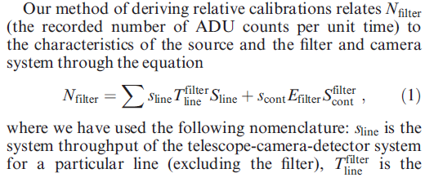

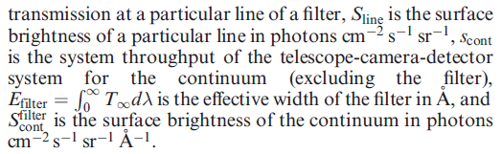

13 knowns: 380NUV, 450BLU, 486HIB, 501OIII, 550GRN, 550CLR, 650RED, 656HIA, 672SII, 685NIR, 742NIR, 807NIR, 889NIR.

9 unknowns: H I (A, B,G), reddening (*magnitude*, shape), N II, O III, S II, Ar III, S III, Ne III and continuum (*magnitude*, shape). In hotter plasmas we can add some unknowns, e.g., He I, He II and O II.

What are the simplest approaches to solutions? First, assume that all we do is scale a reddening model and a continuum model. The functional shape is from a library. If we have left over measurements, we may be able to tweak the shapes.

Second, the GRN band is really self-contained. We should be able to get OIII, HIB and an average continuum from three filters.

Using OIII, HIB and a continuum model from GRN, we should be able to retrieve the HIG signal from the BLU filter. Given that we now have two H I measurements, we can convert that to an overall H I signal level using an assumed Balmer decrement and scaling a reddening model.

With the continuum model, reddening model and H I signal, we can use the HIA filter to get the NII signal.

The RED filter and SII filter should add confirmation of the continuum model and the SII signal.

### M42 Multi-Band Imaging – Observations and First Steps

Last Updated 12/19/2016

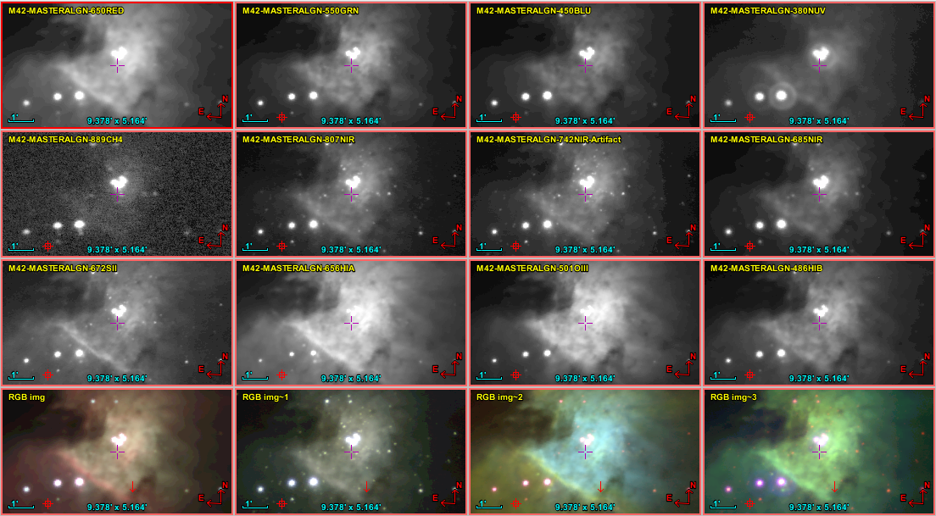

M42-OrionNebula-4x4-Aladin.PNG

1. **Introduction**

This report presents observations and analysis of the Orion Nebula, which was imaged using multiple broad and narrow band filters from the near-ultraviolet, through the visible and into the near-infrared. The images were taken with the SBIG ST-2000XM camera and the C8 at “1260mm (f/6.3)” focal length. This would give a plate scale of approximately 1.1 arcsec-1-pixel. Further analysis after plate reduction (see 2.2) shows the actual plate scale to be 1.019 arcsec-1-pixel, which in turn gives an actual focal length of 1498mm (f/7.49).

Note that several highly spectrally and spatially resolved surveys of the Orion Nebula have been conducted[[3]](#footnote-3),[[4]](#footnote-4),[[5]](#footnote-5). Add Muse M42 science: <http://muse-vlt.eu/science/m42/>.

This report describes the observations and data reduction in detail in Section 2. Section 3 provides a top level discussion of the images in each band and presents basic color renderings. Section 4 covers analyses using band ratios, differences and modeling techniques to understand the “meso-scale” plasma environment. Section 5 locates objects of interest such as HH objects and proplyds. Section 6 summarizes and provides views on future work in the context of massive professional projects such as MUSE.

1. **Observations and Data Reduction**
   1. **Observing Log**

Observations by filter and date are logged in the MS Excel spreadsheet called *M42MultiSpectralPlanning.xlsx*. This is located in the M42 Project directory under the Imaging Data subdirectory. It is maintained manually. Note that short exposures were made in 2005, but are neither detailed nor used here. The processing used different software and the short durations make the benefit of including those images negligible.





* 1. **Observation Characteristics**

Observation characteristics are determined as a result of plate solution by Maxim DL’s PinPoint astrometry tool and inserted into the resulting FITS headers including WCS data. A Python program that plots images is configured to retrieve the pertinent information from a list of files and write a tabulated output. I loaded this output into the spreadsheet MASTER-Images-Info.xlsx to gather statistics. The spreadsheet is located under the M42 Project directory and Imaging Data subdirectory. In this case the data presented is of the master images after co-alignment. Details on the creation of the master images are found in Section **Error! Reference source not found.**.

I wonder how the Maxim DL plate solution FWHM computation accounts for saturated stars.

I also wonder exactly how the zero magnitude value is computed for each band.

* 1. Standard Calibrations

Standard calibrations (bias and dark subtraction and flat fielding) are applied to all raw data frames using MaximDL. A pedestal of 100 is applied to ensure that noise characteristics are preserved. In addition, median filtering and hot pixel corrections are applied to remove residual artifacts, primarily for aesthetic purposes. It is important to note that these corrections are not photometrically conservative.

* + 1. Bias subtraction – No fewer than five bias frames are taken at the same temperature of the data exposures. Using the exact temperature avoids the need for interpolation.
    2. Dark subtraction – Dark frames are taken at the same temperature and duration as both data frames and for the flat field corrections. Using the same temperature and exposure durations means that the corrections do not have to be interpolated.
    3. Flat field correction – Flat field frames were taken using incandescent illumination of a white foam-core board. No fewer than five frames are taken. The light source is place at such a distance from the board as to give visually uniform illumination. When applied to data frames, the flat field frames are bias and dark frame subtracted.
    4. Pixel Corrections – Median filtering and hot pixel corrections are applied as part of the batch script. This is to eliminate the remaining hot pixels after dark correction. However, it can be the cast that individual bright pixels that are ‘corrected’ actually represent physical conditions. This is the source of photometric error introduced by this correction.
  1. Alignment and Co-adding
     1. Individual exposures from a given observing run are aligned using MaximDL’s auto star alignment function. All images are reviewed visually prior to stacking and those of poor quality are deselected from the set to be stacked. Examples of poor quality include tracking errors, airplane trails or low signal to noise due to clouds etc. The images are stacked by summing and the output is saved in IEEE floating point format.
     2. For each observing run stack, a log-scaled, half-size 8-bit JPEG version of the image is created. This version is used to document the observing run results. It often ends up surfacing a need for additional custom calibrations, such as background flattening.
  2. ADU Normalization
     1. Exposure Normalization
     2. Residual Background subtraction (includes removal of pedestal)
     3. Truncation of noise floor (allow negative, but clip at -3σ) – not doing this now! What is the rationale?
  3. Custom Calibrations (As needed)

Custom calibrations are used to correct second order issues with the calibrated images.

* + 1. Background flattening
    2. TBD
  1. Flux Normalization (not fully developed at this time)
     1. Convert ADU to flux (ergs s-1 cm-2 arcsec-2)
        1. Base this on spectral response function and assumed emission function to get weighting function?
        2. May be able to use instrumental zero point to advantage
           1. Note that the **EXPTIME** keyword may need to be set to 1.0 seconds when the images are exposure normalized to make sure the zero point makes sense.
  2. Astrometric Calibration
     1. Determine master image for alignment and align all other images with that image?
     2. Plate solve using MaximDL PinPoint and insert WCS
     3. Export key parameters for documentation, e.g, plate scale, FWHM, zero point, position angle, image center (RA, Dec)



1. **Images Discussion**

Need a general navigational overview? And, then another when we do north-is-up?

* 1. **NIR Images Initial Discussion**

|  |  |
| --- | --- |
| D:\Astronomy\Projects\Nebulae-Diffuse\Orion Nebula (M42)\Imaging Data\20130208UT\M42-20130207-Methane-sum0h22m-Log-HalfSize.jpg | F:\Astronomy\Projects\Nebulae-Diffuse\Orion Nebula (M42)\Imaging Data\20160210UT\M42-20160XXXUT-NIR807-sum01h40m30s-Flattened-Log-HalfSize.jpg |
| M42 889-CH4  M42-20130207-Methane-sum0h22m-Log-HalfSize.jpg | M42 807-NIR  M42-20160XXXUT-NIR807-sum01h40m30s-Flattened-Log-HalfSize.jpg |
| E:\Astronomy\Projects\Nebulae-Diffuse\M42 - Orion Nebula\Imaging Data\742-NIR\M42-20160XXXUT-742NIR-sum01h44m30s-Artifact-Log-HalfSize.jpg | D:\Astronomy\Projects\Nebulae-Diffuse\Orion Nebula (M42)\Imaging Data\20130204UT\M42-20130203-NIR-sum1h20m-Log-HalfSize.jpg |
| M42 742-NIR  M42-20160XXXUT-742NIR-sum01h44m30s-Artifact-Log-HalfSize.jpg | M42 685-NIR  M42-20130203-NIR-sum1h20m-Log-HalfSize.jpg |

**889 CH4**

May include HI Pa 11 line at 886 nm (FWHM=10nm) 884-894nm

$${ADU}_{889CH4}=\left(I_{HIP11}^{*}{∙R}_{889CH4}^{886}+C_{889CH4}^{*}{∙W}_{889CH4}^{886}\right)T_{889CH4}^{*}$$

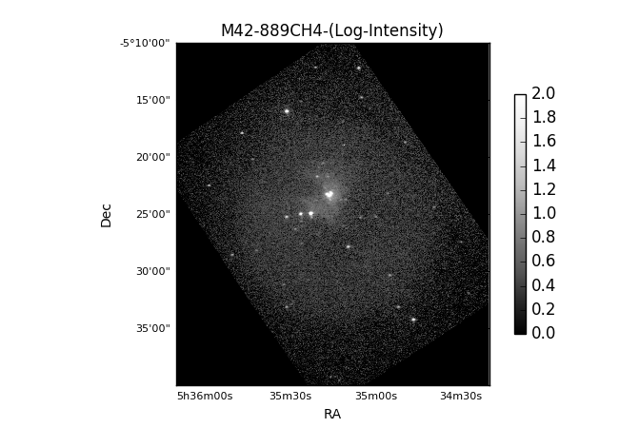

**807 NIR**

Includes HI Pa series and OI at 846 nm and strong emission at SIII 907 (but very weak response there). How do we handle transmission and continuum when we have broadband filters?

$${ADU}_{807NIR}=\left(I_{OI845}^{*}{∙R}_{807NIR}^{845}+I_{HIP}^{*}{∙R}_{807NIR}^{889}+I_{SIII907}^{*}{∙R}_{807NIR}^{907}+C_{807NIR}^{*}{∙W}_{807NIR}^{?}\right)T_{807NIR}^{*}$$

**742 NIR**

Includes Ar III 775 and lines included by 807 NIR, though the Ar III line is likely the dominant line emission.

$${ADU}_{SII}=\left(I_{SII}^{*}{∙R}_{SII}^{672}+C_{SII}^{*}{∙W}_{SII}^{672}\right)T_{SII}^{*}$$

**685 NIR**

Includes He I 707, Ar III 714 and O II 732 in addition to longer wavelength lines.

$${ADU}_{SII}=\left(I_{SII}^{*}{∙R}_{SII}^{672}+C_{SII}^{*}{∙W}_{SII}^{672}\right)T_{SII}^{*}$$

**General Notes:**

Differencing the 742 and 685 channels should highlight the emission of He I 707 and OII 732. While we have no access to other He I lines, if the OII lines at 372 are indeed accessible in the 380 NUV image, then there may be some insight to tie the OII emissions together since the upper level of the 372 lines are populated by the 732 lines.

* 1. **VIS and NUV Images Initial Discussion**

|  |  |
| --- | --- |
| D:\Astronomy\Projects\Nebulae-Diffuse\Orion Nebula (M42)\Imaging Data\20130128UT\M42-20130127-Red-sum1h15m-Log-HalfSize.jpg | D:\Astronomy\Projects\Nebulae-Diffuse\Orion Nebula (M42)\Imaging Data\20130203UT\M42-20130202-Green-sum0h40m-Log-HalfSize.jpg |
| M42 650-RED  M42-20130127-Red-sum1h15m-Log-HalfSize.jpg | M42 550-GRN  M42-20130202-Green-sum0h40m-Log-HalfSize.jpg |
| D:\Astronomy\Projects\Nebulae-Diffuse\Orion Nebula (M42)\Imaging Data\20130203UT\M42-20130202-Blue-sum0h40m-Log-HalfSize.jpg | D:\Astronomy\Projects\Nebulae-Diffuse\Orion Nebula (M42)\Imaging Data\20130205UT\M42-20130204-NUV-sum1h10m-Log-HalfSize.jpg |
| M42 450-BLU  M42-20130202-Blue-sum0h40m-Log-HalfSize.jpg | M42 380-NUV  M42-20130204-NUV-sum1h10m-Log-HalfSize.jpg |

**650 RED**

Significant response extends from about 610 nm to about 663 nm. Thus, emission lines included should be HIA 656 and NII 658, should include only small contributions (<30% response) from the weaker He I 668 and SII 672 lines. In addition, continuum emission is essentially negligible at 0.35-0.5 (see Sanches et al.)

$${ADU}_{SII}=\left(I_{SII}^{*}{∙R}_{SII}^{672}+C_{SII}^{*}{∙W}_{SII}^{672}\right)T_{SII}^{*}$$

This essentially means that by subtracting the HIA signal and a fraction of the SII signal from the RED signal, one would get almost solely continuum (reflected and atomic). This would be a good anchor point at the red end of the spectrum for the slope of that continuum. Also, there should be pretty good correspondence to (some?) NIR images – at least ones that are not dominated by line emission. Perhaps another difference could help isolate line emission in the NIR? Before subtraction, the FWHM of the images should be matched by degrading the higher resolution image. Additional blurring needed could be applied by a Gaussian blur in MaximDL with the FWHM being equal to the root of the difference of the squares of the stellar FWHM values for each image.

**550 GRN**

Significant response extends from about 483 nm to about 575 nm. Thus, emission lines included should be HIB 486 (somewhat attenuated) and OIII 501. Continuum background is

$${ADU}_{SII}=\left(I_{SII}^{*}{∙R}_{SII}^{672}+C_{SII}^{*}{∙W}_{SII}^{672}\right)T_{SII}^{*}$$

**450 BLU**

Significant response extends from about 380 nm to about 501 nm. Thus, emission lines included should be HIE 397, HID 410, HIG 434, HIB 486, OIII 501 (somewhat attenuated) along with continuum and other lines at the short end of the pass band.

$${ADU}_{SII}=\left(I_{SII}^{*}{∙R}_{SII}^{672}+C_{SII}^{*}{∙W}_{SII}^{672}\right)T_{SII}^{*}$$

**380 NUV**

Significant response is *estimated* to be from about 320 nm to about 380 nm. Thus, emission should include significant NUV continuum, many He I, HI and Ne III lines. And potentially signals from the strong OII lines at 372.7 nm.

* 1. **Line Emission Imaging Initial Discussion**

|  |  |
| --- | --- |
| E:\Astronomy\Projects\Nebulae-Diffuse\Orion Nebula (M42)\Imaging Data\672-SII\M42-20160XXXUT-672SII-sum2h10m30s-Log-HalfSize.jpg | D:\Astronomy\Projects\Nebulae-Diffuse\Orion Nebula (M42)\Imaging Data\20130208UT\M42-20130207-Ha-sum0h50m-Log-HalfSize.jpg |
| M42 672-SII  M42-20160XXXUT-672SII-sum01h33m30s-Log-HalfSize.jpg | M42 656-HIA  M42-20130207-Ha-sum0h50m-Log-HalfSize.jpgjpg |
| E:\Astronomy\Projects\Nebulae-Diffuse\M42 - Orion Nebula\Imaging Data\501-OIII\M42-20160XXXUT-501OIII-sum00h54m00s-Log-HalfSize.jpg | E:\Astronomy\Projects\Nebulae-Diffuse\M42 - Orion Nebula\Imaging Data\486-HIB\M42-201602XXUT-486HIB-sum01h46m00s-Log-HalfSize.jpg |
| M42 501-OIII  M42-20160XXXUT-501OIII-sum00h54m00s-Log-HalfSize.jpg | M42 486-HIB  M42-201602XXUT-486HIB-sum01h46m00s-Log-HalfSize.jpg |

**672 SII**

$${ADU}_{SII}=\left(I_{SII}^{*}{∙R}_{SII}^{672}+C_{SII}^{*}{∙W}_{SII}^{672}\right)T_{SII}^{*}$$

**656 HIA**

$${ADU}_{HIα}=\left(I_{HIα}^{*}{∙R}_{HIα}^{656}+{I_{NII}^{*}∙R_{NII}^{658}+C}_{HIα}^{*}{∙W}_{HIα}^{656}\right)T_{HIα}^{*}$$

Where $ADU$ is the observed signal in counts-s-1-pixel-1, is the surface brightness due to line emission at the emitting source in counts- s-1-pixel-1, is the peak system response at the center of a given narrow band filter as a unit-less number, $C_{HIα}^{*}$ is the continuum emission at the emitting source in counts- s-1-pixel-1-nm-1, is the equivalent width in nm of the narrow band filter, and $T_{HIα}^{*}$ is the transmission of the ISM as a unit-less number evaluated at a specific wavelength.

**501 OIII**

$${ADU}_{OIII}=\left(I_{OIII}^{*}{∙R}_{OIII}^{501}+C_{OIII}^{*}{∙W}_{OIII}^{501}\right)T_{OIII}^{*}$$

**486 HIB**

* 1. Basic Color Visualizations
     1. Classic RGB
     2. RGB with added narrow band information into B (HIB and OIII), G(OIII) and R (HIA and SII) channels
     3. SHO image rendered as RGB
     4. HIA+HIB two-color image?
     5. NIR color composite(s) using 889, >807, >742 and >685
     6. NIR color composite differences using >807 or 889, (>742 - >807), (>685 - >742)
        1. There may be issues here with obtaining similarly sharp focus in each of these channels for the image arithmetic.
     7. Five-color rendering for IRGBU – picking the best (sharpest, strongest SNR) NIR channel
     8. Five-color rendering summing narrow band signal with RGB signal and possibly summing NIR signals if similarly sharp focus in each of the NIR bands is obtained.

1. Analyses
   1. Gas
      1. **Hydrogen** 
         1. HIA/HIB: General features of the Balmer decrement as a function of position.

We can rewrite equations TBD above with the intention of characterizing the reddening ${T_{HIα}^{*}}/{T_{HIβ}^{*}}$, NII signal and continuum signal. In particular, we start with the assumption of a nominal Balmer decrement value at the ionization front itself, e.g., ${I_{HIα}^{*}}/{I_{HIβ}^{*}}=2.86$. We can make two immediate simplifications. First, we can set $I_{HIα}^{*}=2.86{∙I}_{HIβ}^{*}$. Second, we can approximate $R_{NII}^{656}=R_{NII}^{658}$. Substituting in known values we have:

$${ADU}_{HIβ}=\left(0.93I_{HIβ}^{*}+C_{HIβ}^{*}{∙W}_{HIβ}^{486}\right)T_{HIβ}^{*}$$

$${ADU}_{HIα}=\left({2.86∙0.52I}_{HIβ}^{*}+{0.52I_{NII}^{*}+C}_{HIα}^{*}{∙W}_{HIα}^{656}\right)T_{HIα}^{*}$$

Knowing the integral of a Gaussian pass band[[6]](#footnote-6), we can compute the equivalent width as:

$W_{HIα}^{656}=\sqrt{2π}{∙R}_{HIα}^{656}∙|0.42466∙{FWHM}_{HIα}^{656}|$, i.e., $W_{HIα}^{656}=1.0645{∙R}_{HIα}^{656}∙|{FWHM}_{HIα}^{656}|$,

which, given that FWHM=8.5 according to vendor literature, further simplifies to approximately:

$$W_{HIα}^{656}=9.048{∙R}_{HIα}^{656}=4.705$$

This same applies similarly HIB channel since its FWHM is the same as the HIA channel:

$$W_{HIβ}^{486}=9.048{∙R}_{HIβ}^{486}=8.415$$

Substituting these values into our original equations, we have:

$${ADU}_{HIβ}=\left(0.93I_{HIβ}^{*}+{8.415C}_{HIβ}^{*}\right)T_{HIβ}^{*}$$

$${ADU}_{HIα}=\left({1.49I}_{HIβ}^{*}+{0.52I_{NII}^{*}+4.705C}_{HIα}^{*}\right)T_{HIα}^{*}$$

Though we only have two measurements and nine unknowns, one can still look at what the ratio of observed fluxes in each band might reveal.

$${ADU}_{HIα}=\frac{\left({1.49I}_{HIβ}^{*}+{0.52I_{NII}^{*}+4.705C}_{HIα}^{*}\right)T_{HIα}^{*}}{\left(0.93I_{HIβ}^{*}+{8.415C}_{HIβ}^{*}\right)T_{HIβ}^{*}}$$

Looking at the spectrum in Figure 1, one may estimate that $I_{NII}^{*}\sim {0.20I}_{HIα}^{*}\sim 0.57I_{HIβ}^{*}$. This is a non-negligible fraction and cannot be ignored. In the same spectrum, the continuum emission level appears to be $C_{HIβ}^{*}\sim C_{HIα}^{*}\sim {0.002I}_{HIα}^{*}\sim 0.0057I_{HIβ}^{*}$. Multiplying these backgrounds by the appropriate equivalent widths gives total contributions of 0.048 at HIB and 0.027 at HIA. It is not unreasonable to consider discarding these values. **Further estimation of continuum emission might be gained by looking at the NIR emission in line-less spectral regions.**

|  |
| --- |
| F:\Astronomy\Projects\Nebulae-Diffuse\Orion Nebula (M42)\Imaging Data\MASTER\M42-MASTERALGN-BLMCOR-HalfSize.jpg |
| M42 Balmer Decrement (HIA/HIB)  M42-MASTERALGN-BLMCOR-HalfSize.jpg |

Not sure how this happened, but the Balmer ratio seems to have increased by a factor of two below with the only difference being added integration time to the HIB image!

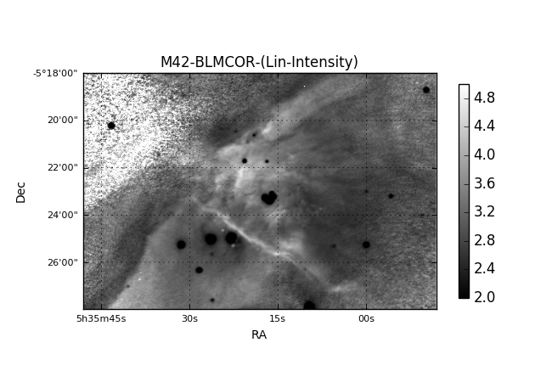

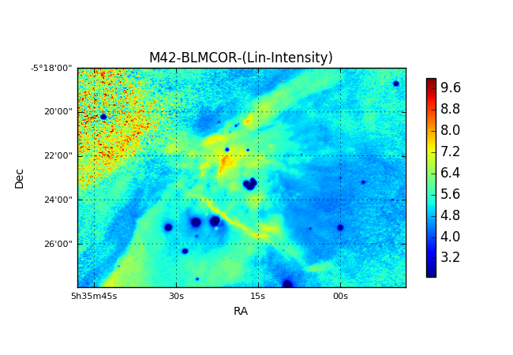

* + - 1. HIA excess: Interpretation for reddening, 658NII retrieval and the impact of continuum contamination

If we look at the comparison of HIA and HIB and leverage the Balmer decrement, we may be able to get *some* traction on dust absorption, dust continuum emission and NII emission.

$${ADU}_{HIβ}=\left(I_{HIβ}^{*}{∙R}_{HIβ}^{486}+C_{HIβ}^{*}{∙W}_{HIβ}^{486}\right)T_{HIβ}^{*}$$

$${ADU}_{HIα}=\left(I_{HIα}^{*}{∙R}_{HIα}^{656}+{I_{NII}^{*}∙R_{NII}^{658}+C}_{HIα}^{*}{∙W}_{HIα}^{656}\right)T_{HIα}^{*}$$

We know the ratio ${I_{HIα}^{*}}/{I_{HIβ}^{*}}≅2.86$ (check reference on this). What we can get a handle on is the observed Balmer Decrement: ${{ADU}_{HIα}^{}}/{{ADU}_{HIβ}^{}}$. We can also make assumptions about the relationship between $T_{HIα}^{*}$ and $T_{HIβ}^{*}$ based on published reddening curves for interstellar dust. The ratio of absorption (from which we can get the transmission) will be stable as long as the dust is optically thin. In this case, we can remove some of the spatial dependency of the dust absorption.

Unfortunately, the continuum spectrum may be more difficult to quantify, but possibly the NIR spectra can help with this as a proxy – albeit far from the desired wavelength – for a continuum measurement near the HI lines. I have located at least one paper on the reflection spectra of dusty nebulae.

* + 1. **658NII**: Synthetic from **HIA-2.86HIB**, of course contaminated with dust reflection continuum and factored only by the *nominal* Balmer decrement.

Finally, emission from NII is likely highly spatially variable. It is unclear whether this could be the dominant source of error in computing the observed Balmer Decrement. There may be some constraints available based on the excitation class of the nebula.

The synthetic “658NII” image is created by correcting both the HIA and HIB images for response subtracting the 2.86x the HIB image from the HIA. The factor of 2.86 represents the nominal Balmer decrement. The equation is then 658NII=192.3xHIA-307.5xHIB.

|  |
| --- |
| F:\Astronomy\Projects\Nebulae-Diffuse\Orion Nebula (M42)\Imaging Data\MASTER\M42-MASTERALGN-658NII-Log-HalfSize.jpg |
| M42 “NII” (Balmer Excess HIA-HIB)  M42-MASTERALGN-658NII-Log-HalfSize.jpg |

However… the difference does not seem to have changed significantly with the added HIB integration time (below).

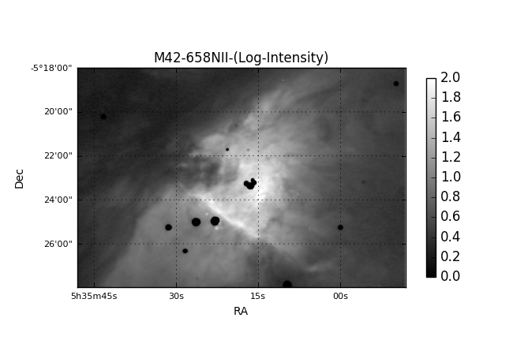

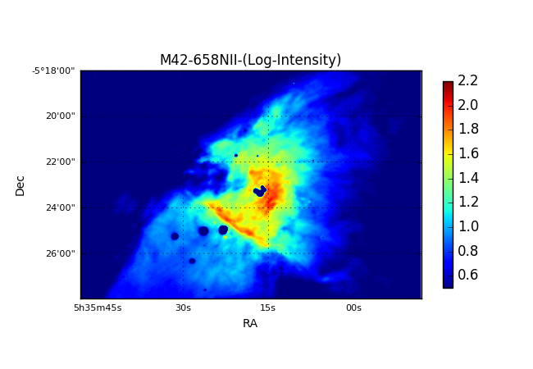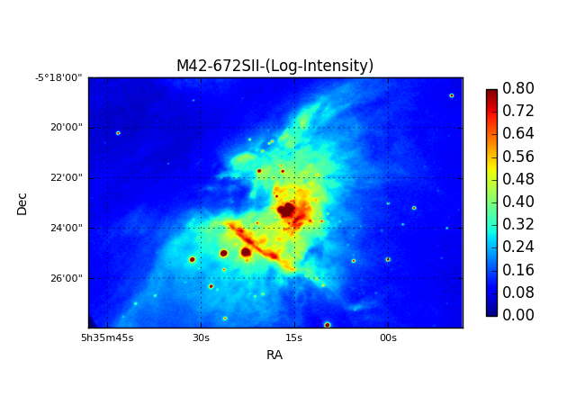

When looking at the NII image above, synthesized from HIB and HIA images, it appeared to have many features in common with the directly observed SII images (presented below with a similar color table). While there is a significant difference in their ionization energies (14.5eV for N vs 10.4eV for S), the excitation energies are very similar for the upper levels (1.8990eV for NII and 1.8455eV for SII).

**Hydrogen H 1 13.5984**

**Helium He 2 24.5874 54.417760**

**Nitrogen N 7 14.5341 29.6013 47.44924 77.4735 97.8902**

**Oxygen O 8 13.6181 35.1211 54.9355 77.41353 113.8990**

**Sulfur S 16 10.3600 23.33788 34.79 47.222 72.5945**

**Argon Ar 18 15.7596 27.62965 40.74 59.81 75.02**

I wondered just how different the flux distributions were – perhaps differences would be indicative of reddening due to dust. So, I created a ratio image (below).

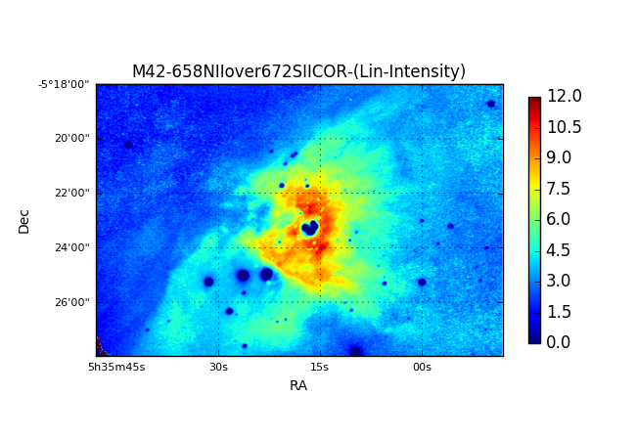

The ratio image certainly smoothed out many of the high contrast details seen in both SII and NII images, as expected if they were very similar. However, substantial visual structure remained. Perhaps the absorption I had been seeking. So, I examined the extinction map presented in Weilbacher, 2015[[7]](#footnote-7). Not even close to a match! I looked at other maps in the paper. Amazingly, the NII/SII ratio showed a remarkable similarity to the Ne plot derived from the SII line ratio.

|  |  |
| --- | --- |
|  |  |
| M42-20160221UT-501OIII-sum00h04m00s-Log-HalfSize.jpg | M42-20160XXXUT-501OIII-sum00h37m00s-Log-HalfSize.jpg |

NOTE: It may be useful to look at the BLU and RED continuum images. Even though they are broadband, they may be complimentary to determining the continuum signals. And, finally looking at spectra of the Orion Nebula may help identify what spectral contributions are negligible in different bands.

* 1. Density (*Ne*) Estimation
     1. NII/SII Analysis
  2. Temperature Estimation
     1. **Temperature Maps: OIII/SII, NII/SII, OIII/NII** giving qualitative temperature maps based on line ratios.
     2. How much composition variation can be expected and what are the implications?
     3. Can some general temperature scale be applied, even if it is very approximate? See the kinetic temperatures presented in the PyNeb section under Python Development
  3. Dust:
     1. Irradiation maps based on NIR intensity
     2. **HIA/HIB** Absorption, reddening and contamination: Balmer Decrement HIA/HIB ratio
  4. Discussion of Gas vs Dust analysis, e.g., Do high NIR surface brightness regions correlate to high temperature gas regions?
  5. Photometry – or is this covered by ratio analysis etc.?
     1. Nebulosity decomposition (sections?) – requires new python code and/or using PyNeb and PySpecKit
        1. Need to establish overall throughput model for observing system along with relative responses of each filter band. May need to take new spectra to establish relative response.
        2. Compare line emission locations to filter response bands and create linear system(s?) of equations
        3. Write code to decompose each pixel.
        4. Try to make a system that works on stars also?
     2. “Interesting” stars
  6. Difference images – many combinations and permutations are possible. What make the most sense?

1. Object and Feature Identification

This PNG is taken from a Aladin stack and two Vizier catalog files. The image codes red as a sum of NIR images (685+742+807) with the intention of highlighting the source stars at the cores of proplyds. The green channel is codes as HIB+HIA and should highlight ionization fronts strongly. Finally, blue is taken from OIII which would be the hottest sources. However, in hindsight, it seems that I should be using SII rather than OIII since proplyds tend to be more on the dense and cool side as opposed to hot and tenuous. It is also possible that some differences in emission line images may highlight proplyds, e.g., HIA-HIB ~ NII (which is cool). Note that the wavelets processing is rather important given the small size of many of these structures.

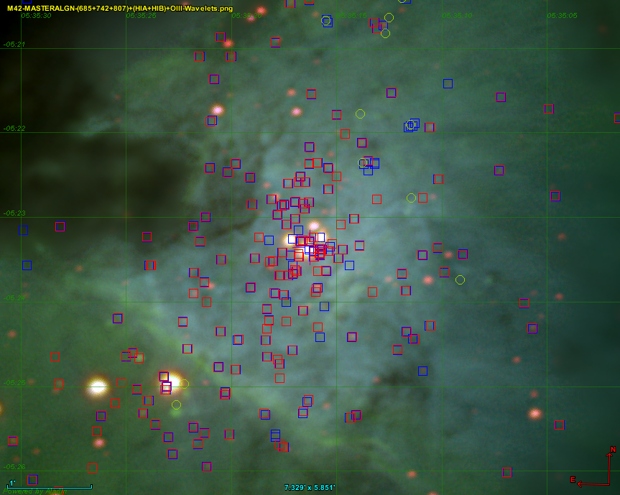

Stack2.png

* 1. HH Object Discussion
     1. A couple of notable objects, readily visible in my images, are HH203 and HH204. References (Reipurth, 2000)[[8]](#footnote-8). These two HH objects are discussed in other literature, which I may want to find, read and reference.
  2. Proplyd Discussion
     1. At the very least, some of the source stars for proplyds are readily visible in my image. References ()[[9]](#footnote-9)

**Quantitative Data Reduction and Analysis**

1. Analysis and Display
   1. Run Python code to display each filter channel with quantitative color bar and grid overlay as desired
   2. Create aesthetic images from the master images using MaximDL or other software. Note that when log scaling images, 1 ADU s-1 pixel-1 serves as a cut off. So in low rate images, there will be an artificial black level clip. This can be overcome by pre-stretching the image (say 16-bit) before converting to a log scale.
   3. Create filter ratios images
   4. Perform photometric analyses

**Aligned all MASTERs with BLU MASTER image**

|  |  |
| --- | --- |
| F:\Astronomy\Projects\Nebulae-Diffuse\Orion Nebula (M42)\Imaging Data\Color Composites\M42-201X0XXX-685-742-807-Update-WV2-sat200pct-HalfSize.jpg | F:\Astronomy\Projects\Nebulae-Diffuse\Orion Nebula (M42)\Imaging Data\Color Composites\M42-201X0XXX-SHO-WV2-sat150pct-HalfSize.jpg |
| M42-201X0XXX-685-742-807-Update-WV2-sat200pct-HalfSize.jpg | M42-201X0XXX-SHO-WV2-sat150pct-HalfSize.jpg |

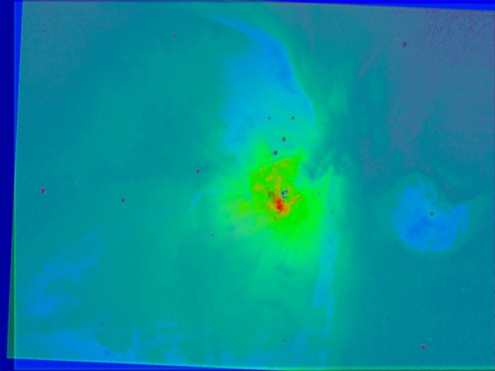

M42-201601XXUT-Stacked-PseudoColorTemp-HalfSize.jpg – ROTATIONAL ALIGNMENT PROBLEM WITH ONE OF THE BAND RATIOS.

pylab color tables: <http://matplotlib.org/examples/color/colormaps_reference.html>

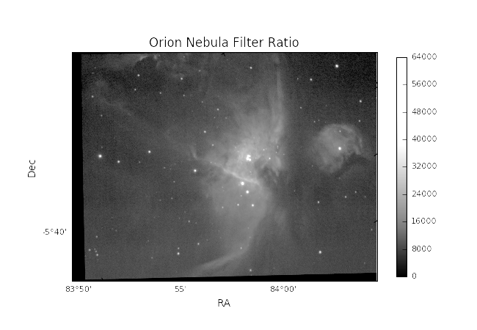

M42-20160128UT-SII-sum0h31m-Log-PinpointWCS-plot.png – this was plate solved using PinPoint in MaximDL. While the coordinate center appears to be approximately correct, the image appears to be simply flipped about the horizontal axis and not rotated to correct for PA at all! No errors were reported in Python.

+---Orion Nebula (M42)

| +---References

| \---Imaging Data

| +---20130128UT

| +---20130203UT

| +---20130204UT

| +---20130205UT

| +---20130208UT

| +---Color Composites

| +---Band Ratios

| +---20150116UT

| +---20160127UT

| +---20160128UT

| +---20160129UT

| \---20160210UT

**Relevant prior work and references:**

1. **ObservingNotes2011.docx** 
   1. NGC 6543 Cat’s Eye (no H I) (1260mm, 5500mm)
   2. Orion’s Sword multispectral work (no H I) (135mm)
   3. IC1805 & IC1848: Heart and Soul Nebulae (including H I) (135mm)
   4. NA Nebula (no H I) (135mm)
   5. M27 (no H I) (405mm)
2. **ObservingNotes2012.docx**
   1. NGC1499 (California Nebula) (including H I) (135mm)
   2. Rosette Nebula (including H I) (135mm)
3. **ObservingNotes2013.docx**
   1. NGC1499 (California Nebula) (CH4) (135mm)
   2. M42 (including H I) (1260mm)
4. **ObservingNotes2014.docx**
   1. Orion’s Sword (H I & CH4) 135mm
   2. M57 (including H I, O III, S II) 1260mm & 4000mm
   3. M8 (including H I, O III, S II) 135mm
   4. NGC7009 Saturn Nebula (no H I) 4000mm
   5. Butterfly Nebula (including H I, O III, S II) 135mm
   6. Bubble Nebula (including H I, O III, S II) 135mm
   7. Bubble Nebula (including H I, O III, S II) 405mm
   8. NGC2392 spectrum
   9. NGC6210 spectrum
   10. NGC7009 spectrum
   11. M57 spectrum
5. **ObservingNotes2015.docx**
   1. Orion’s Sword (S II, O III and NIR channels) 135mm
   2. NGC7009 spectrum
   3. M57 spectrum
   4. NGC7822 and Ced 214 (S II, O III and NIR channels) 135mm
   5. Planetary Nebulae Analysis
   6. Orion Wide Field analysis
   7. Some Thoughts on Additional Narrow-Band Imaging Filters and Spectroscopes

$${ADU}_{BLU}=I_{HIβ}^{*}{∙R}_{BLU}^{486}{+I}_{OIII}^{*}{∙R}_{BLU}^{500}+C_{}^{*}{∙W}_{BLU}^{}$$

$${ADU}_{HIβ}=I_{HIβ}^{*}{∙R}_{HIβ}^{486}+C_{}^{*}{∙W}_{HIβ}^{}$$

$${ADU}_{OIII}=I_{OIII}^{*}{∙R}_{OIII}^{500}+C_{}^{*}{∙W}_{OIII}^{}$$

$$\left[\begin{matrix}{ADU}_{BLU} \\ {ADU}_{HIβ} \\ {ADU}_{OIII}\end{matrix}\right]=\left[\begin{matrix}W_{BLU} & R_{BLU}^{486} & R_{BLU}^{500} \\ W_{HIβ} & R_{HIβ}^{486} & 0 \\ W_{OIII} & 0 & R_{OIII}^{500}\end{matrix}\right]\left[\begin{matrix}C^{*} \\ I_{HIβ}^{*} \\ I_{OIII}^{*}\end{matrix}\right]$$

This is a direct linear solution. If however, we used say the GRN filter and it also measured HIB and OIII, then we might use linear regression??? Here would be an interesting application to try to extract [Ne III] at 386 and 397nm. If this was to be attempted, then scaling and inclusion of the other Balmer lines and probably He II 468 would need to be included in the BLU intensity.

Ionization energy table from University of Michigan:

<https://dept.astro.lsa.umich.edu/~cowley/ionen.htm>

**Hydrogen H 1 13.5984**

**Helium He 2 24.5874 54.417760**

**Carbon C 6 11.2603 24.3833 47.8878 64.4939 392.087**

**Nitrogen N 7 14.5341 29.6013 47.44924 77.4735 97.8902**

**Oxygen O 8 13.6181 35.1211 54.9355 77.41353 113.8990**

**Neon Ne 10 21.5646 40.96296 63.45 97.12 126.21**

**Sodium Na 11 5.1391 47.2864 71.6200 98.91 138.40**

**Magnesium Mg 12 7.6462 15.03527 80.1437 109.2655 141.27**

**Aluminum Al 13 5.9858 18.82855 28.44765 119.992 153.825**

**Silicon Si 14 8.1517 16.34584 33.49302 45.14181 166.767**

**Sulfur S 16 10.3600 23.33788 34.79 47.222 72.5945**

**Chlorine Cl 17 12.9676 23.8136 39.61 53.4652 67.8**

**Argon Ar 18 15.7596 27.62965 40.74 59.81 75.02**

**Calcium Ca 20 6.1132 11.87172 50.9131 67.27 84.50**

**Iron Fe 26 7.9024 16.1877 30.652 54.8 75.0**

**Cobalt CO 27 7.8810 17.084 33.50 51.3 79.5**

**Nickel Ni 28 7.6398 18.16884 35.19 54.9 76.06**

**Krypton Kr 36 13.9996 24.35984 36.950 52.5 64.7**

**References:**

PyNeb

/Projects/Nebulae-Planetary/LineFluxPeaks4PNs.xlsx

“Elcat”

Orion nebula spectrum is from Buil (<http://www.astrosurf.com/buil/nebula/HII/m42/m42.html>).

Note that the continuum (bottom plot with telluric absorption) is *very* low and *very* flat. Both the low magnitude and wavelength independence could be due to the normalization approach used – which is currently unknown. Data files are available, and convolving those files with my system responses will help build the linear systems describing weighting functions in each imaging filter.

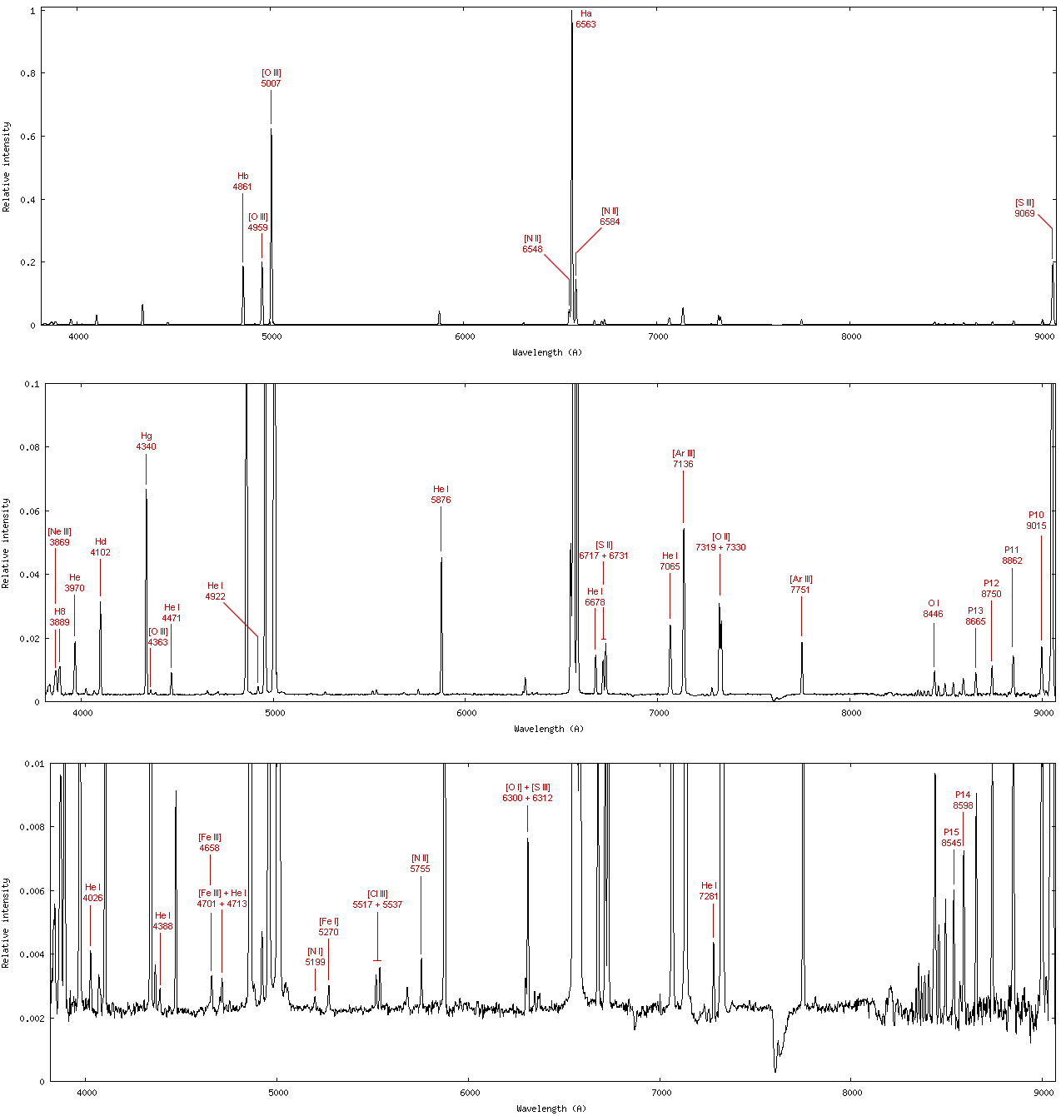

Figure 1: Orion Nebula Spectrum from Buil.

### NGC 6888, the Crescent Nebula – Multiband Imaging

Last Updated 10/26/2015



NGC6888MultiSpectralPlanning.xlsx

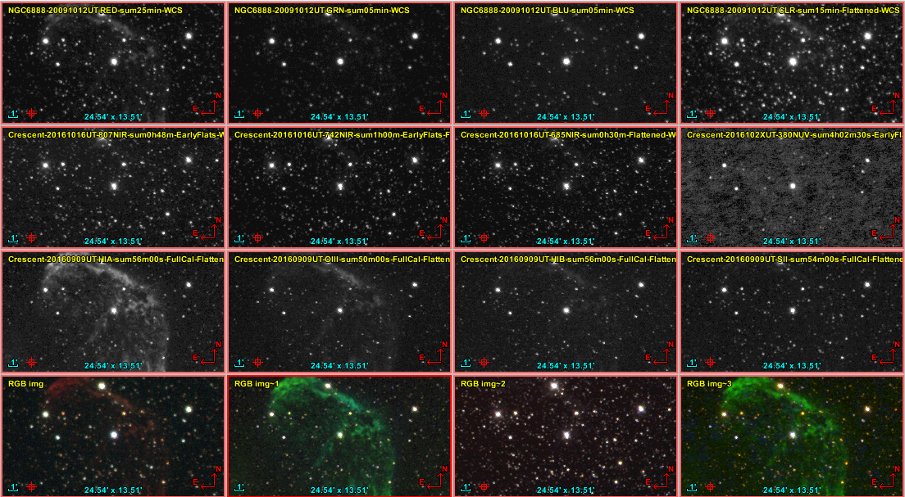

**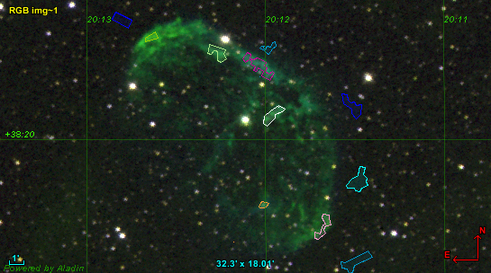**

**RGB and Clear Images**

|  |  |
| --- | --- |
| F:\Astronomy\Projects\Nebulae-Diffuse\NGC6888-Crescent\Imaging Data\20091012UT\NGC6888-20091012UT-RED-sum25min-Log-HalfSize.jpg | F:\Astronomy\Projects\Nebulae-Diffuse\NGC6888-Crescent\Imaging Data\20091012UT\NGC6888-20091012UT-GRN-sum05min-Log-HalfSize.jpg |
| C6888-20091012UT-RED-sum25min-Log-HalfSize.jpg | NGC6888-20091012UT-GRN-sum05min-Log-HalfSize.jpg |
| F:\Astronomy\Projects\Nebulae-Diffuse\NGC6888-Crescent\Imaging Data\20091012UT\NGC6888-20091012UT-BLU-sum05min-Log-HalfSize.jpg | F:\Astronomy\Projects\Nebulae-Diffuse\NGC6888-Crescent\Imaging Data\20091012UT\NGC6888-20091012UT-CLR-sum15min-Log-HalfSize.jpg |
| NGC6888-20091012UT-BLU-sum05min-Log-HalfSize.jpg | NGC6888-20091012UT-CLR-sum15min-Log-HalfSize.jpg |

**RGB and Narrow Band Color Images**

|  |  |
| --- | --- |
| F:\Astronomy\Projects\Nebulae-Diffuse\NGC6888-Crescent\Imaging Data\20091012UT\NGC6888-20091012UT-RGB-HalfSize.jpg | F:\Astronomy\Projects\Nebulae-Diffuse\NGC6888-Crescent\Imaging Data\20091012UT\NGC6888-20091012UT-LRGB-HalfSize.jpg |
| NGC6888-20091012UT-RGB-HalfSize.jpg | NGC6888-20091012UT-LRGB-HalfSize.jpg |
| F:\Astronomy\Projects\Nebulae-Diffuse\NGC6888-Crescent\Imaging Data\20160909UT\Crescent-20160909UT-FullCal-SII-HIA-OIII+HIB-Wavelets-HalfSize.jpg | F:\Astronomy\Projects\Nebulae-Diffuse\NGC6888-Crescent\Imaging Data\20160909UT\Crescent-20160909UT-FullCal-SII-HIA-OIII-ColAdj-Wavelets-HalfSize.jpg |
| Crescent-20160909UT-FullCal-SII-HIA-OIII+HIB-Wavelets-HalfSize.jpg | Crescent-20160909UT-FullCal-SII-HIA-OIII-ColAdj-Wavelets-HalfSize.jpg |

**Narrow Band Images**

|  |  |
| --- | --- |
| F:\Astronomy\Projects\Nebulae-Diffuse\NGC6888-Crescent\Imaging Data\20160909UT\Crescent-20160909UT-SII-sum54m00s-FullCal-Log-HalfSize.jpg | F:\Astronomy\Projects\Nebulae-Diffuse\NGC6888-Crescent\Imaging Data\20160909UT\Crescent-20160909UT-HIA-sum56m00s-FullCal-Log-HalfSize.jpg |
| Crescent-20160909UT-SII-sum54m00s-FullCal-Log-HalfSize.jpg | Crescent-20160909UT-HIA-sum56m00s-FullCal-Log-HalfSize.jpg |
| F:\Astronomy\Projects\Nebulae-Diffuse\NGC6888-Crescent\Imaging Data\20160909UT\Crescent-20160909UT-OIII-sum50m00s-FullCal-Log-HalfSize.jpg | F:\Astronomy\Projects\Nebulae-Diffuse\NGC6888-Crescent\Imaging Data\20160909UT\Crescent-20160909UT-HIB-sum56m00s-FullCal-Log-HalfSize.jpg |
| Crescent-20160909UT-OIII-sum50m00s-FullCal-Log-HalfSize.jpg | Crescent-20160909UT-HIB-sum56m00s-FullCal-Log-HalfSize.jpg |

Contini, M., and G. Shaviv (1980), The calculation of the optical spectra of NGC 6888, *Astronomy and Astrophysics*, *88*, 117-126.

Fernández-Martín, A., D. Martín-Gordón, J. M. Vílchez, E. Pérez Montero, A. Riera, and S. F. Sánchez (2012), Ionization structure and chemical abundances of the Wolf-Rayet nebula NGC 6888 with integral field spectroscopy, *Astronomy and Astrophysics*, *541*.

Parker, R. A. R. (1978), The forbidden N II/H-alpha ratio in NGC 6888, *The Astrophysical Journal*, *224*, 873-879.

Reyes-Pérez, J., C. Morisset, M. Peña, and A. Mesa-Delgado (2015), A consistent spectral model of WR 136 and its associated bubble NGC 6888, *Monthly Notices of the Royal Astronomical Society*, *452*, 1764-1778.

### IC 1318, the Butterfly Nebula – Multiband Imaging

Last Updated 10/26/2015



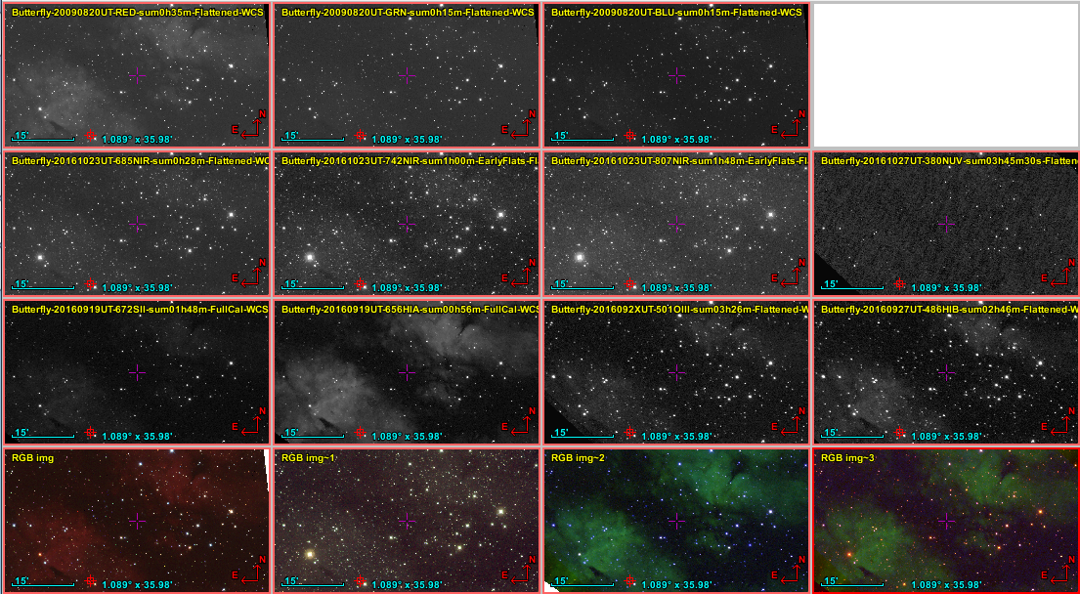

|  |  |
| --- | --- |
| F:\Astronomy\Projects\Nebulae-Diffuse\IC1318 - Butterfly\Imaging Data\20090820UT\Butterfly-20090820UT-sLRGB_sat120pct-HalfSize.jpg | F:\Astronomy\Projects\Nebulae-Diffuse\IC1318 - Butterfly\Imaging Data\20160927UT\Butterfly-201609X-SII-HIA-OIII-HIB-Color-Flattened-ColBal-HalfSize.jpg |
| Butterfly-20090820UT-sLRGB\_sat120pct-HalfSize.jpg | Butterfly-201609X-SII-HIA-OIII-HIB-Color-Flattened-ColBal-HalfSize.jpg |
| F:\Astronomy\Projects\Nebulae-Diffuse\IC1318 - Butterfly\Imaging Data\20160927UT\Butterfly-201609X-SHO-ColBal-Flattened-HalfSize.jpg |  |
| Butterfly-201609X-SHO-ColBal-Flattened-HalfSize.jpg |  |

### NGC 7000, the North America Nebula – Multiband Imaging

Last Updated 11/18/2016



NGC7000MultiSpectralPlanning.xlsx

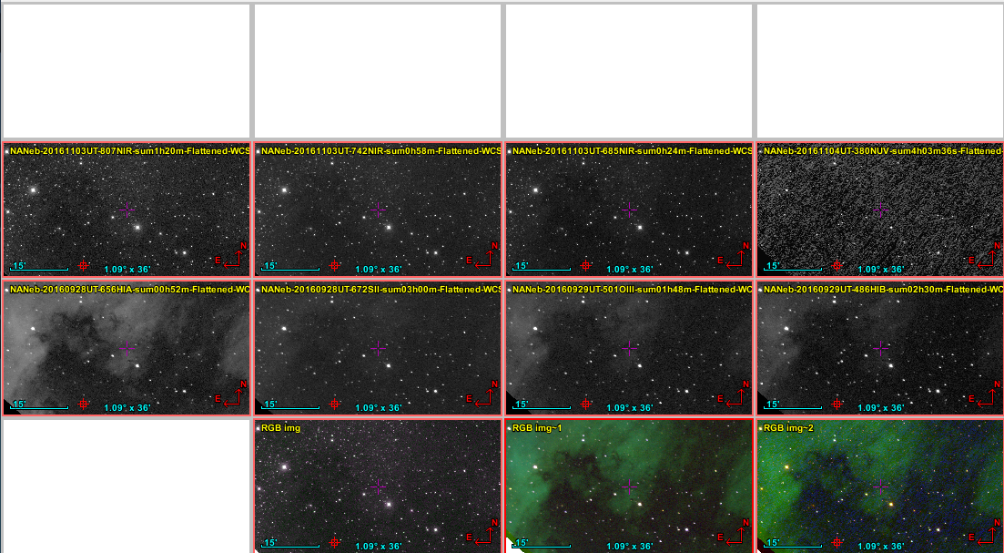

### NGC 7023, the Iris Nebula – Multiband Imaging

Last Updated 12/02/2016



NGC7023MultiSpectralPlanning.xlsx

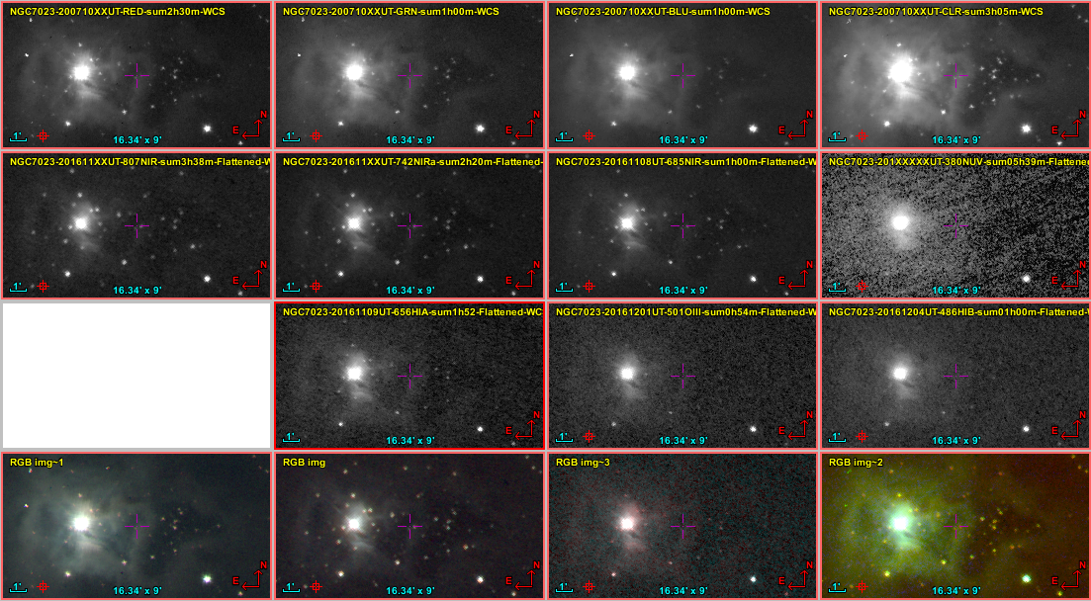

### NGC 7635, the Bubble Nebula – Multiband Imaging

Last Updated 11/18/2016

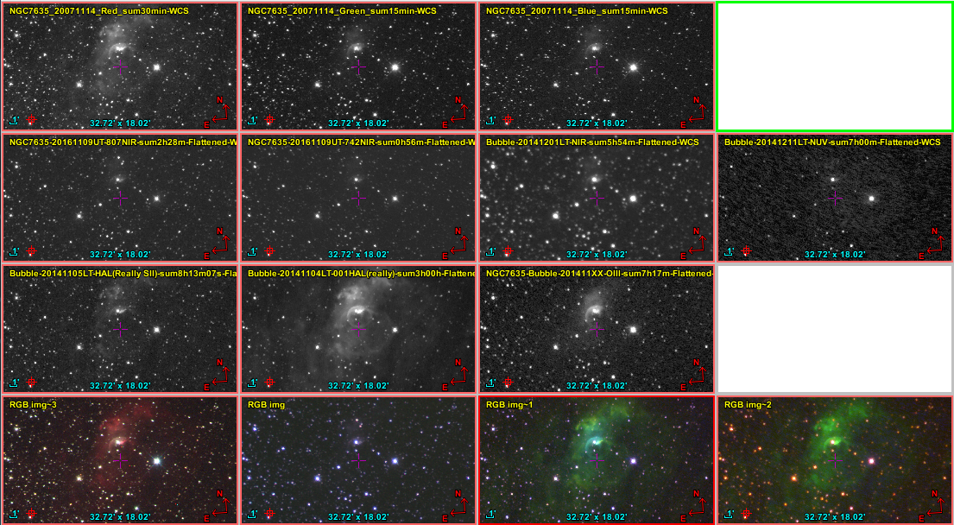

### M57, the Ring Nebula – Spectroscopy

Last Updated 10/13/2015

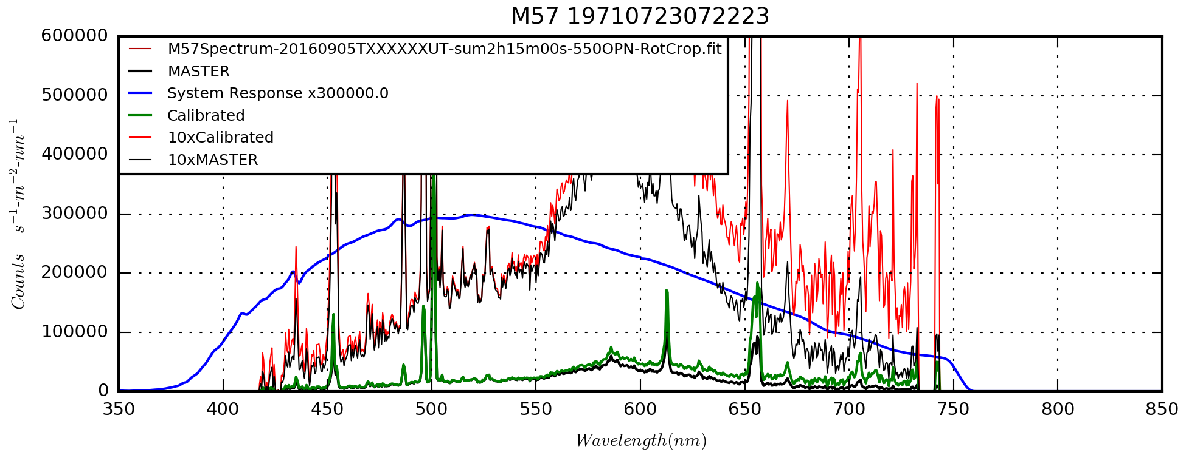

M57\_19710723072223\_1D.png; needs DATE-OBS fixed in FITS header.

## Galaxies

### M82

Last Updated 4/12/2016

TBD

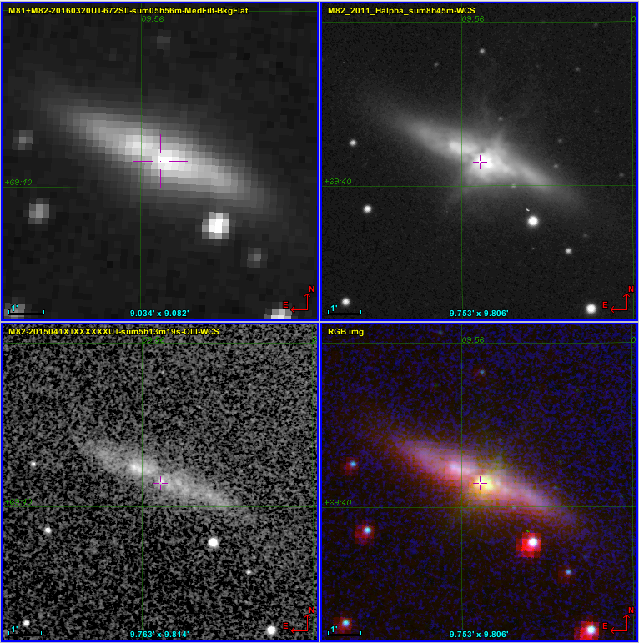

M82QuadStack2Capture.PNG

**Active Supernova Link:** <http://www.supernova.thistlethwaites.com/snimages/>

### M33

Last Updated 12/01/2016

One of the first things evident in the multispectral images of M33 is the variation in the OIII and HIA emission for various HII regions. It turns out that this is a well known and extensively studied dichotomy between HII regions close to the nucleus versus those far out in the disk. M33 as a relatively close, classic grand-design spiral has been well studied.



M33MultiSpectralPlanning.xlsx

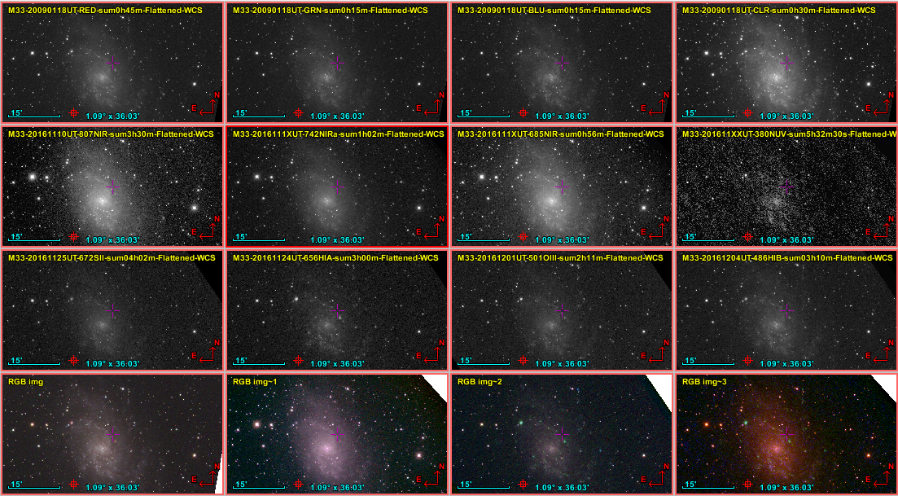

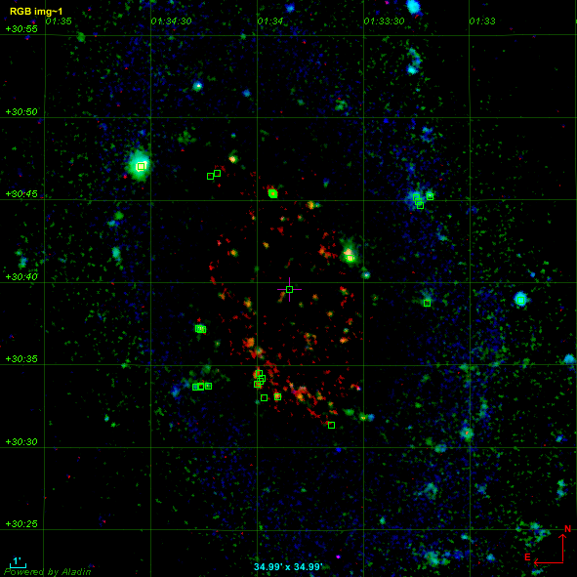

M33-430mm-HIAXS+OIIIXS+SIIXS+HIBXS-BLUXS+Objects-RGBimg1-35x35.png

Uses the program:

F:\Astronomy\Python Play\FITSImageStuff\FilterRatios.py

called in this case by the script:

F:\Astronomy\Projects\Galaxies\M33\Imaging Data\ M33\_FilterRatioScript.py

## Instrument and Filter Response Calibration

### Celestron 8

Last Updated 8/30/2016

**Normalized System Response at Filter Centers**

Based on the code VegaResponse\_AllYears.py, I looked at the graph for the C8 at 1260mm focal length and identified the relative responses listed below. These values can be used to convert the ADU levels to relative energy levels for the different images. That correction will provide a better measure of the spatial distribution of the Balmer Decrement, for example.

Vega Response at 380nm=0.045 (normalized)

Vega Response at 450nm=0.73 (normalized)

Vega Response at 486nm=0.93 (normalized)

Vega Response at 500nm=0.96 (normalized)

Vega Response at 550nm=0.93 (normalized)

Vega Response at 650nm=0.54 (normalized)

Vega Response at 656nm=0.52 (normalized)

Vega Response at 672nm=0.45 (normalized)

Vega Response at 685nm=0.38 (normalized)

Vega Response at 742nm=0.20 (normalized)

Vega Response at 807nm=0.075 (normalized)

Vega Response at 889nm=0.026 (normalized)

Ar III 714nm Vega Response=0.29 (normalized, estimated) – 2e-13 =4.8e-14

Ar III 775nm Vega Response=0.11 (normalized, estimated) – 6e-14=6.6e-15

SIII 907nm Vega Response=0.015 (normalized, estimated) – 3e-13=4.95e-15

SIII 953nm Vega Response =0.0035 (normalized, estimated) – 1e-12=3.5e-15

Further information, particularly in the overlap of the various filter channels might be determined by examining some of the data from **20130117UT**. This was initial spectroscopy work I was doing and ended up taking spectra through many filters. There are other later efforts that include the narrow band filters, but these may be the only ones for the broadband color filters.

**Effective Area**

From the Celestron Manual[[10]](#footnote-10), the clear aperture is stated to be 8 inches (0.2032 m) with a 12% (more precisely 11.82%) obstruction (2.75 inches). The **resulting aperture is 0.02860 m2**. It would be wise to measure both the correcting plate aperture and the central obstruction to verify these parameters.

To obtain the true effective area, which is wavelength dependent, one would need the transmission and reflectivity of the optical elements. This information does not appear to be available in Celestron documentation, but should be a measurable parameter using calibration stars.

### Takahashi TKE Epsilon 130

Last Updated 10/10/2016

Good collimation link:

<http://garyseronik.com/a-beginners-guide-to-collimation/>

### 135 mm Lens

Last Updated 8/30/2016

**Effective Area**

The effective aperture of the 135 mm lens is dependent of the focal ratio (f) setting (since the focal ratio is controlled by stopping down the aperture) and the use of an objective grating. Without using an objective grating, the area may be expressed as A=π(0.0135/f)2. Examples of aperture for different f-stops are shown in the table below.

|  |  |
| --- | --- |
| **f-stop** | **Aperture (m2)** |
| 22.0 | 2.957E-05 |
| 16.0 | 5.591E-05 |
| 11.0 | 1.183E-04 |
| 8.0 | 2.237E-04 |
| 5.6 | 4.564E-04 |
| 4.0 | 8.946E-04 |
| 2.5 | 2.290E-03 |

For the special case of a 1.25 inch objective grating, which has a clear aperture of ~27 mm, we have an aperture area of 5.726E-04 m2.

### Transmission of Narrow Band Filters (Normalized)

What does the code do that’s different than the main FITS to spectrum code? Is it anything other than averaging? Is the spectrum divided by a G2V reference spectrum to obtains an albedo spectrum? Should these codes be merged?

|  |  |  |  |  |  |  |  |  |  |  |  |  |
| --- | --- | --- | --- | --- | --- | --- | --- | --- | --- | --- | --- | --- |
| **Target** | **Date-Time(UT)** | **Band Type** | **Band** | **Start(nm)** | **End(nm)** | **Cont(nm)** | **EW/Intensity** | **Peak** | **Center(nm)** | **Dispersion** | **Disp. Err.** | **FWHM** |
| CH4 | 2014-09-03 | Target | CH4 889 | 875.5 | 904.5 | 3.5 | -11933.4 | 1063.776 | 889.528 | 1.0382 | 0.0094 | 11.21798 |
| HAL | 2014-09-03 | Target | 656HAL | 641.5 | 670.5 | 3.5 | -404663 | 36836.28 | 656.446 | 1.0421 | 0.0003 | 10.98544 |
| NUV | 2014-09-03 | Target | 380NUV | 360.5 | 389.5 | 3.5 | -13810.6 | 897.871 | 379.458 | 1.0600 | 0.0050 | 15.38152 |

Dispersion error between HAL and CH4 is minor, but does add up to ~3nm at CH4. Thus, it is probably representative either of non-linearity or of actual centroid offsets from the specified wavelengths. Looking at additional narrow bands along with calibration against known solar/stellar bands should resolve which type of error(s) exist in the dispersion and permit creating a more accurate general expression for dispersion.

The larger dispersion error for NUV, particularly the fact that it goes against a 2nd order trend, suggests an actual offset from my assumed centroid of 380nm. In this case, the centroid would be more like 372 nm. NUV is also particularly difficult because of the steep gradients in the source spectrum and detector response. So, it is not clear that we’ve isolated the filter transmission totally from these effects. For HAL and CH4, these gradients are much smaller.

**Methane (889CH4) Filter – Make, Model, etc…**

Methane filter spectra with suitable near-point sources are available from 20140309UT. These are co-added, Jupiter-aligned observations with a total integration time of 150 seconds. The Galilean moons serve as the near-point sources. Using Jupiter aligned images does little to blur the moons since the interval over which the images are co-added is small compared to the orbital motion of the moons.

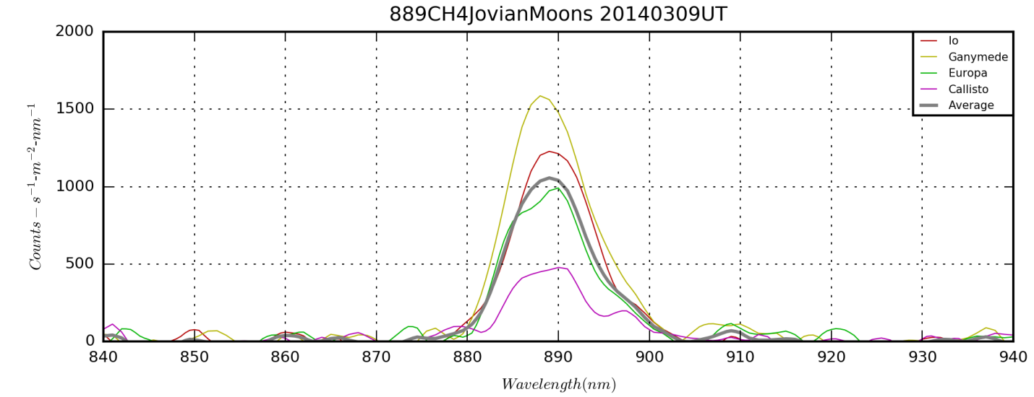

889CH4 Jovian Moons NUV 20140309UT\_1D.png from *FilterSpectumFromFITS.py*.

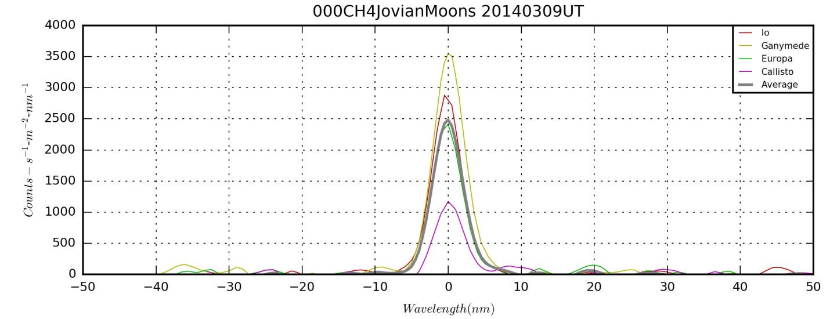

NOTE: Why did I choose Jupiter-Aligned images for this?

FWHM=10.5 nm as measured on screen by mouse. This gives the HIP 11 line at 886.2 nm a relative response of 0.84. The contribution from HIP 10 at 901.5 nm is only about 5.9%.

According to the Buil (maybe non-quantitative?) spectrum, the relative intensity peak for HIP 11 is ~0.015 and the continuum background sits at 0.002 nm-1. The claimed resolution is 800 implying sampling line widths of about 886.2/800~1.1nm. If we treat that as the line’s FWHM, then we have a line EW of ~0.0177nm.

$W_{HIα}^{656}=\sqrt{2π}{∙R}_{HIα}^{656}∙|0.42466∙{FWHM}_{HIα}^{656}|$,

Multiplying by the relative response of the 889CH4 filter at 886.2nm we get a measured contribution of 0.0149 nm.

The EW of the 889CH4 filter (with peak response normalized to 1.0) is 11.22 nm. Thus, the continuum background would contribute about 0.0224 nm EW signal.

ContMean,BandMean= 0.431863164868 411.929080887

Centroid= 889.527697

889.000 1064.2081604

**H I Alpha Filter – Make, Model, etc…**

**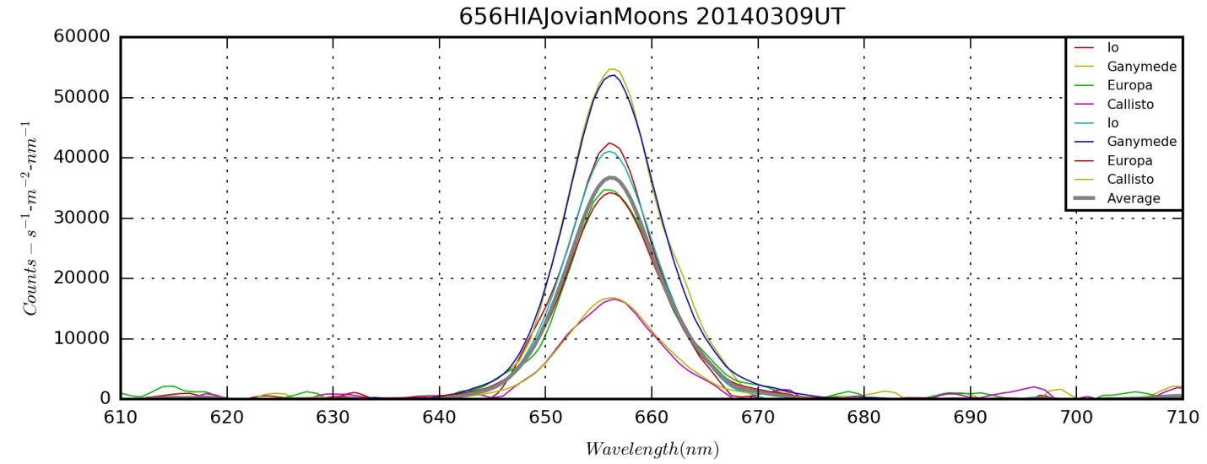**

656HIA Jovian Moons NUV 20140309UT\_1D.png from *FilterSpectumFromFITS.py*.

**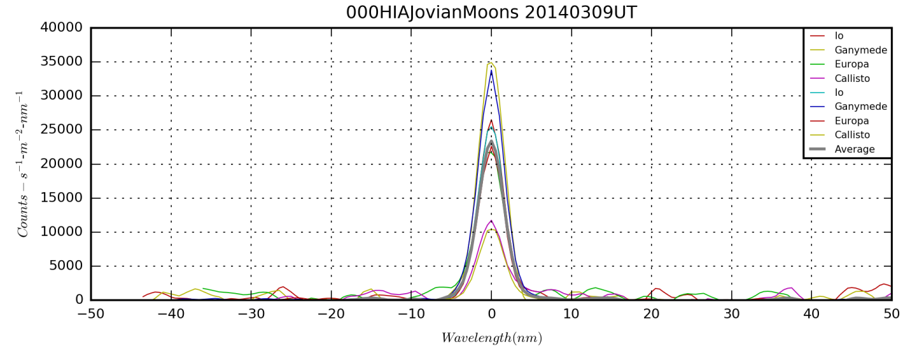**

Dispersion=1.0421±0.0003 nm-pix-1

**Target,Date-Time(UT),Band Type,Band,Start(nm),End(nm),Cont(nm), EW/Intensity,Peak,Center(nm)**

**HAL,2014-03-09 00:00:00,Target,656HAL,641.500,670.500,3.500,-404662.775,36836.278,656.446**

**NUV Filter – Make, Model, etc…purchase date, cost**

Should this go with the broadband filters? Probably. The narrowness of the plot is probably due to shortwave cutoff due the source and atmospheric absorption. Also, I’m wondering how I got the wavelength calibration here since the spectrum seems featureless. I may have simply used a computed calibration base on the dispersion for other filters.

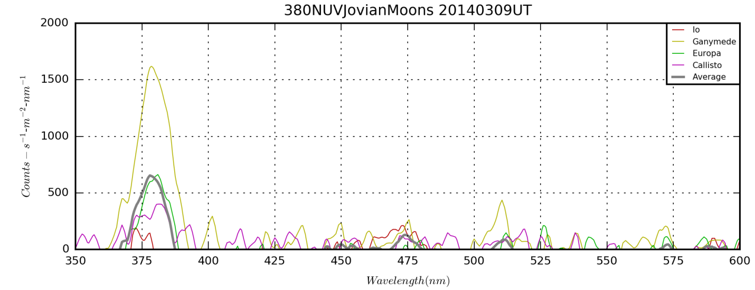

380NUV Jovian Moons NUV 20140309UT\_1D.png from *FilterSpectumFromFITS.py*.

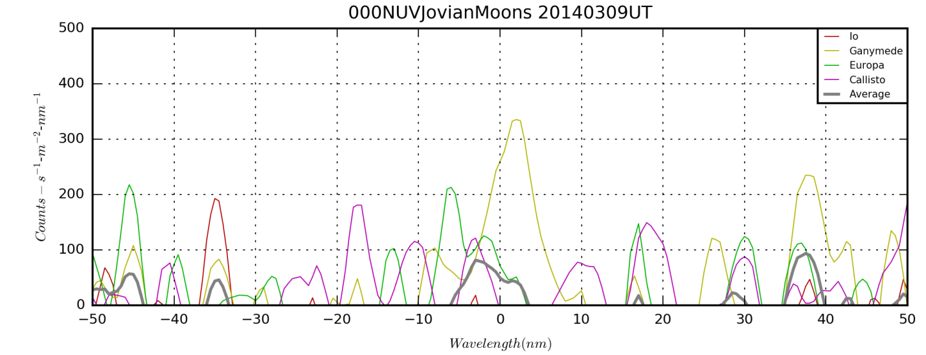

Dispersion = 1.060±0.005 nm-pix-1

### Transmission of Broad Band Filter Transmission (Normalized)

|  |  |  |  |  |  |  |  |  |  |  |  |  |
| --- | --- | --- | --- | --- | --- | --- | --- | --- | --- | --- | --- | --- |
| **Target** | **Date-Time(UT)** | **Band Type** | **Band** | **Start(nm)** | **End(nm)** | **Cont(nm)** | **EW/Intensity** | **Peak** | **Center(nm)** | **Dispersion** | **Disp. Err.** | **FWHM** |
| RED | 2014-09-03 | Target | CH4 889 | 875.5 | 904.5 | 3.5 | -11933.4 | 1063.776 | 889.528 | 1.0382 | 0.0094 | 11.21798 |
| HAL | 2014-09-03 | Target | 656HAL | 641.5 | 670.5 | 3.5 | -404663 | 36836.28 | 656.446 | 1.0421 | 0.0003 | 10.98544 |
| NUV Jupiter | 2014-09-03 | Target | 380NUV |  |  |  |  |  | 382.310 | 0.5515 |  |  |
| NUV Capella | 2014-09-03 | Target | 380NUV |  |  |  |  |  | 364.034 | 1.1095 |  |  |
| NUV Rigel | 2014-09-03 | Target | 380NUV |  |  |  |  |  | 361.496 | 0. 5523 |  |  |

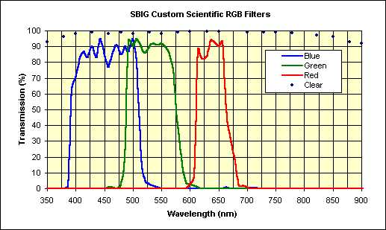

[**http://archive.sbig.com/sbwhtmls/announcement\_custom\_filters.htm**](http://archive.sbig.com/sbwhtmls/announcement_custom_filters.htm)

*This RGBC filter set is the standard SBIG set that comes with the*[*CFW8A filter wheel*](http://archive.sbig.com/products/cfw8a_new.htm)*and is intended for use with the ST-7/8/9/10/2000 cameras.   The set is also available separately.  It is designed to give a proper balance of continuum light from stars and proper ratios of H-alpha and [O-III] emission line sources (e.g., bright nebula and planetary nebula) at the same time.  These professional quality, high transmission, dichroic filters have been tested over time by some of the best astroimagers in the world.  Many of the remarkable images seen in the gallery of Sky & Telescope and Astronomy magazines have been taken with this filter set and an "ST" series camera.  The colored filters are parfocal, antireflection coated and IR blocked.  The clear filter is AR coated only.  Click here for*[*current prices*](http://archive.sbig.com/sbwhtmls/Pricelist.htm#Section XI)*.*

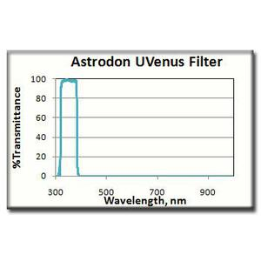

<http://www.astroshop.eu/astrodon-uv-venus-filter-1-25-/p,14692>

**NUV (380NUV) Filter – Make, Model, etc…**

**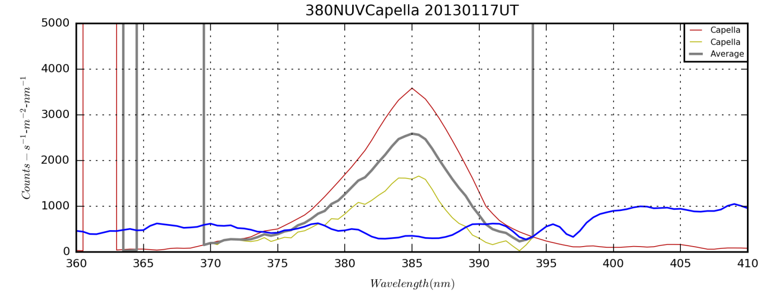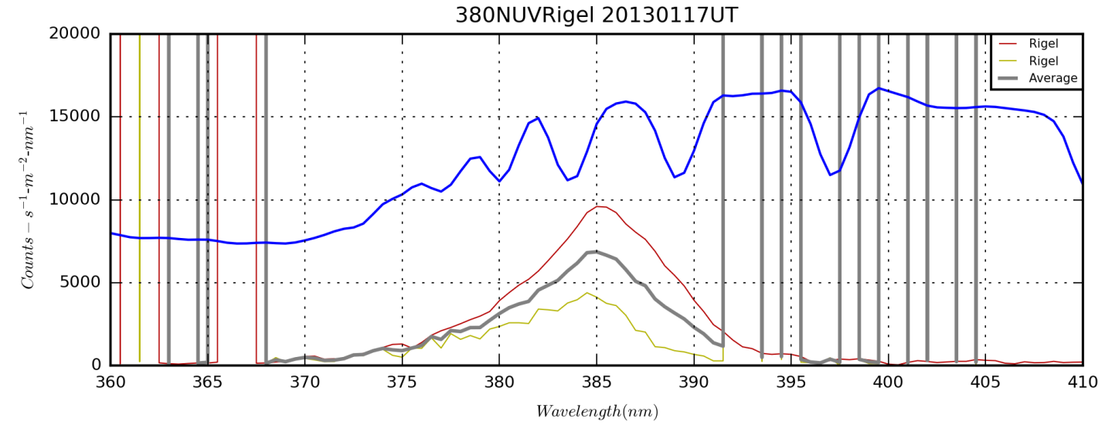**

**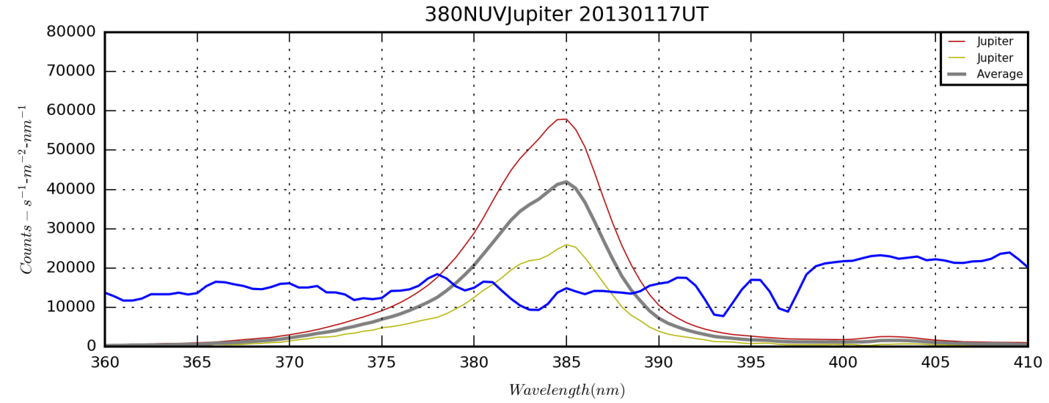**

**Blue (450BLU) Filter – Make, Model, etc…**

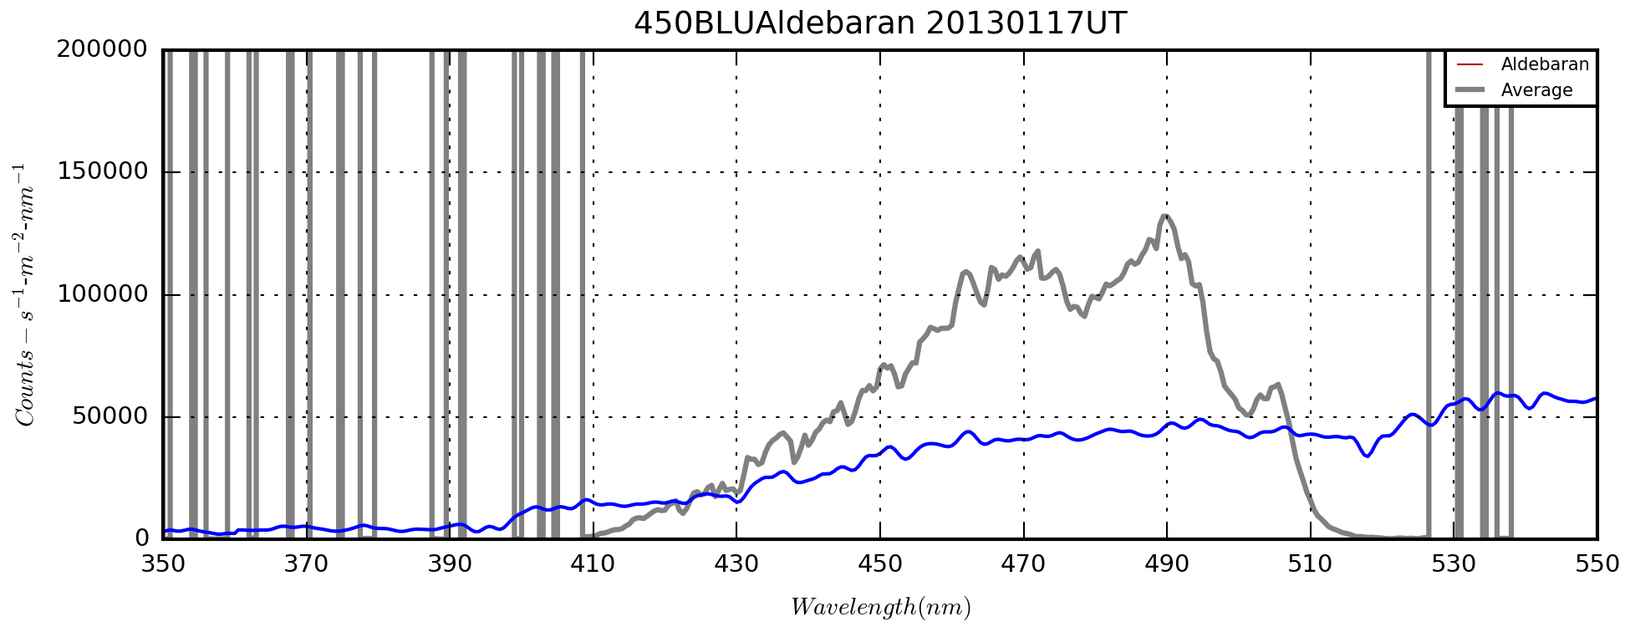

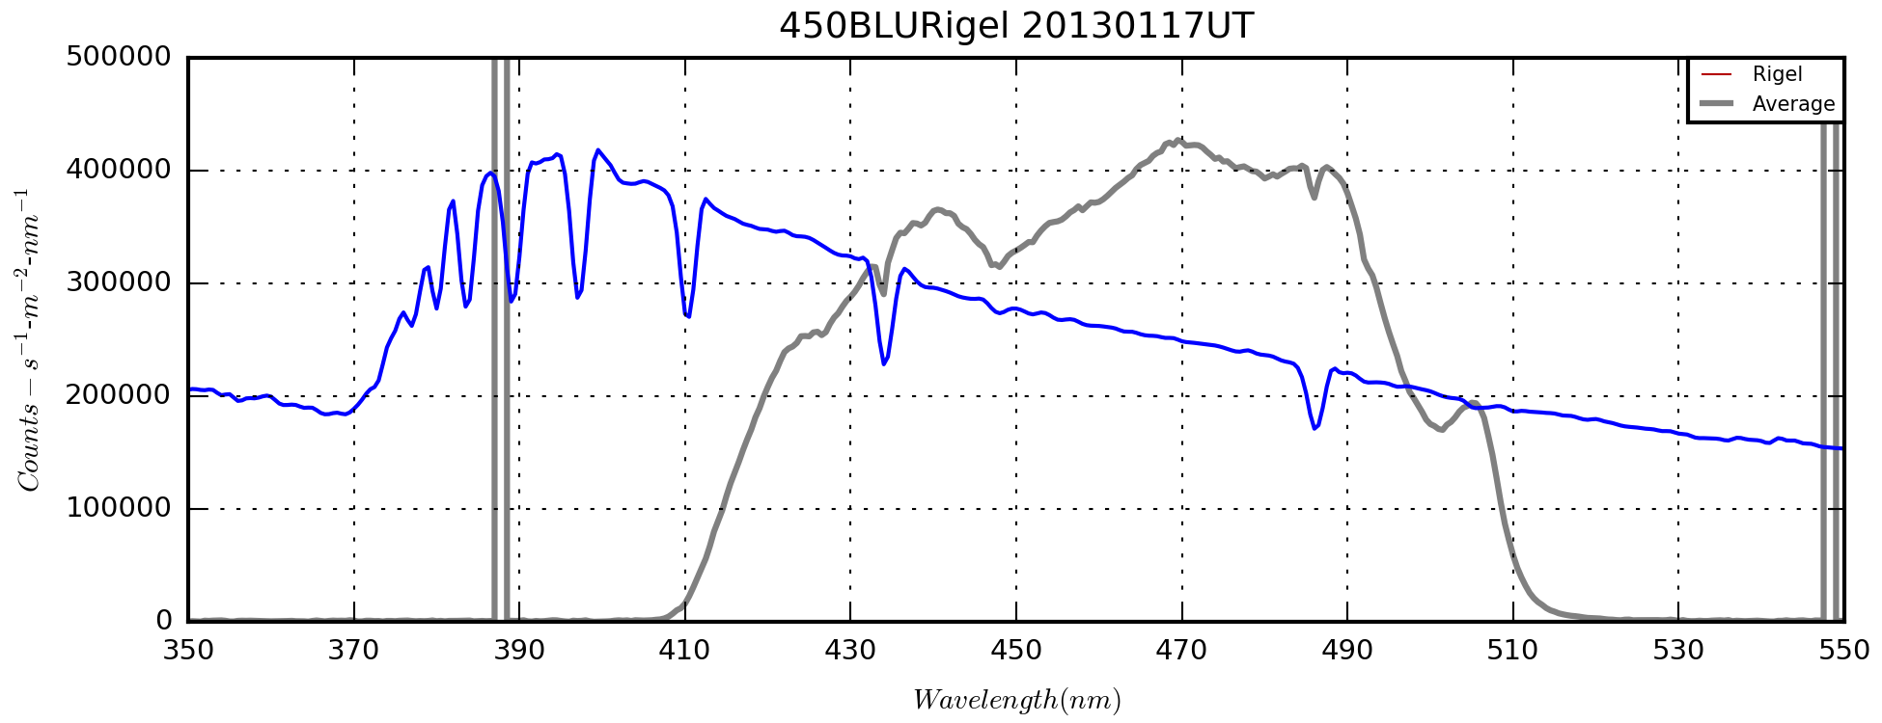

**Green (550GRN) Filter – Make, Model, etc…**

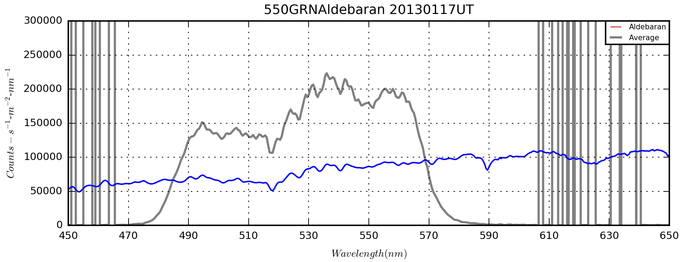

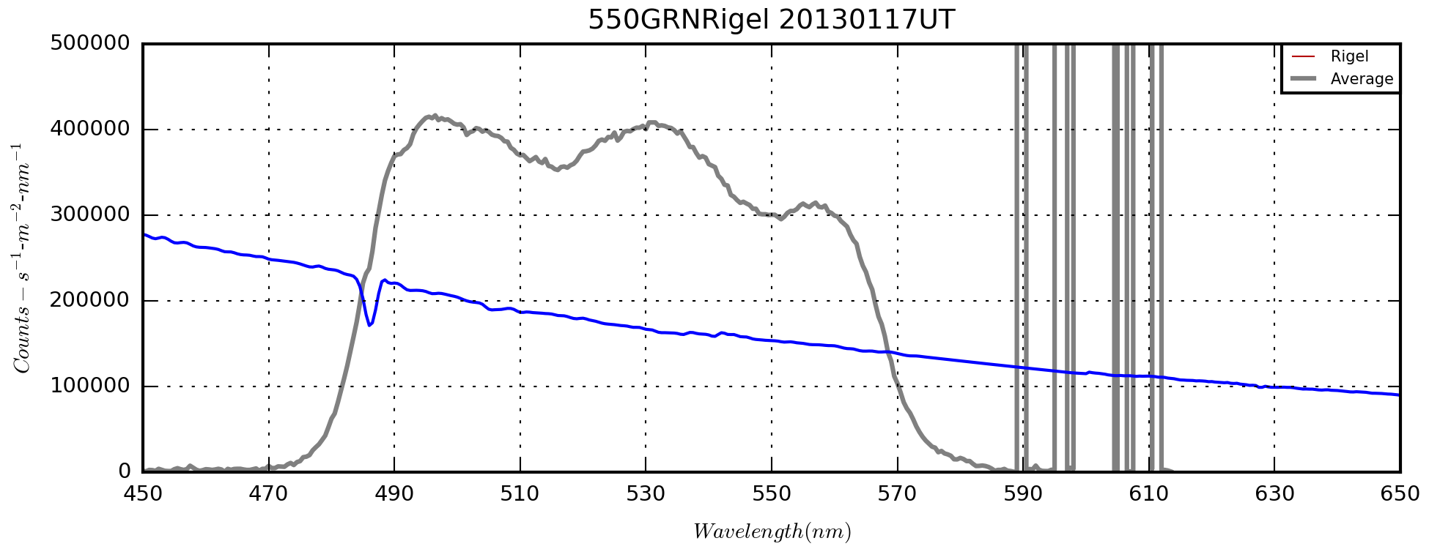

**Red (650RED) Filter – Make, Model, etc…**

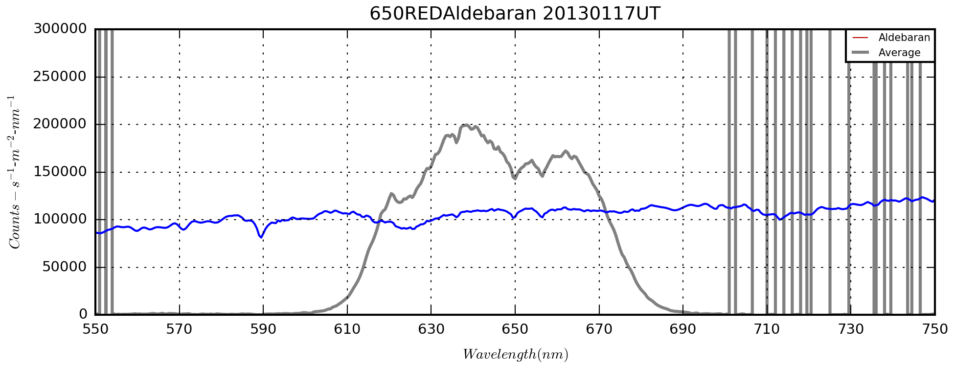

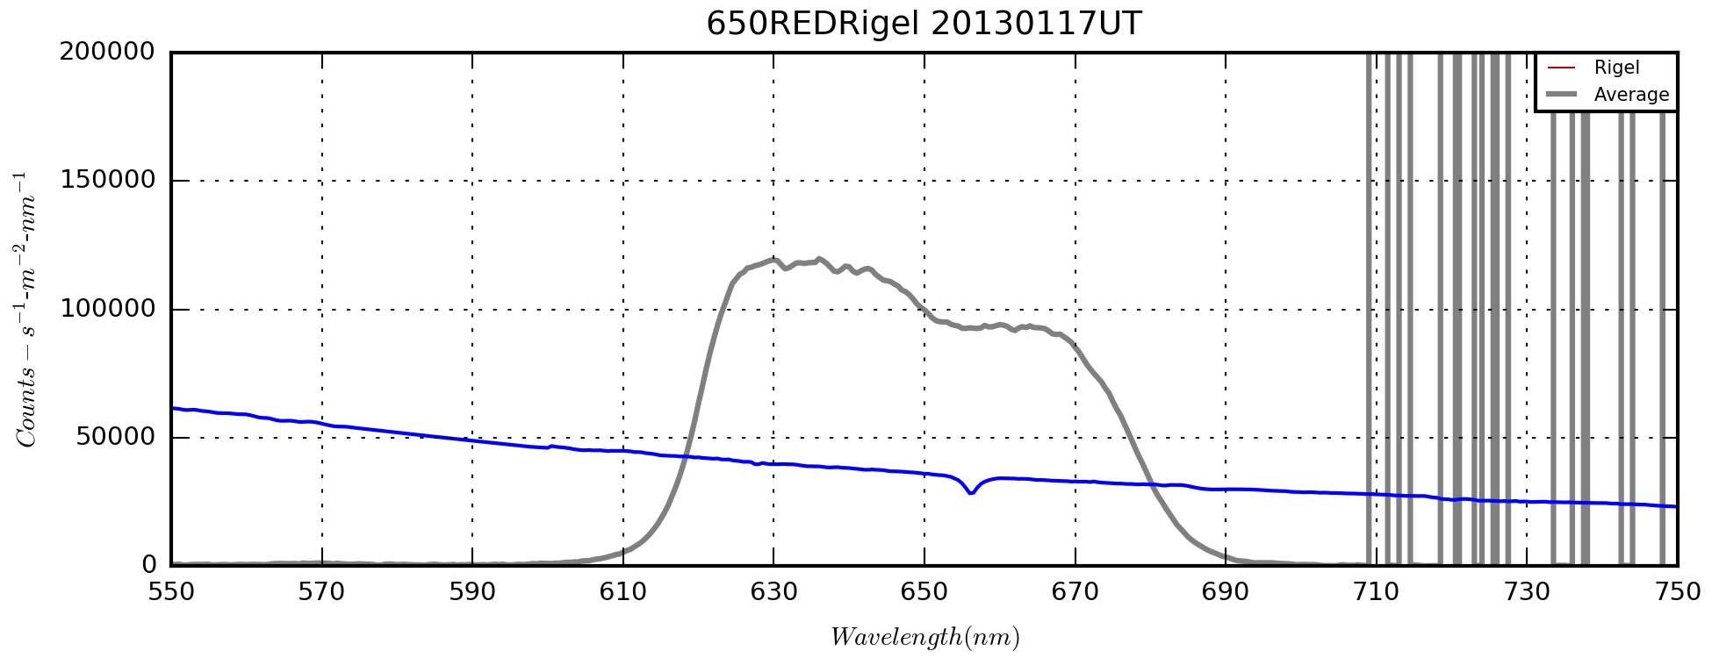

**NIR (685NIR) Filter – Make, Model, etc…**

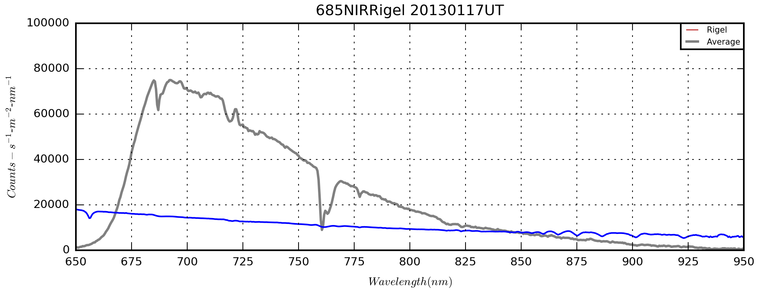

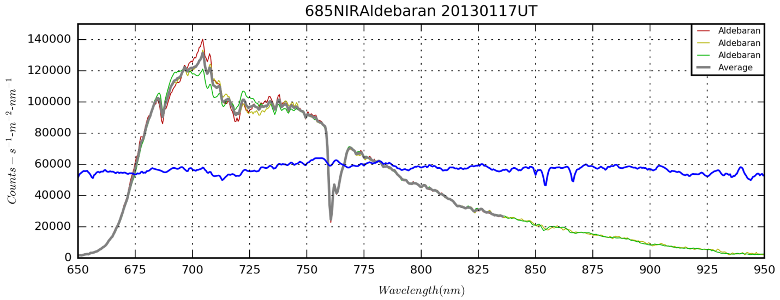

### ASI120MM Response Characteristics

Last Updated 4/4/2016

From e-mail dated 4/11/15:

if(gamma <= 50)  
                        m\_iGammaTable[i]=min(255, 255\*pow((float)i/255,(float)(200.0f-2\*gamma)/100));  
                else  
                        m\_iGammaTable[i]=min(255, 255\*pow((float)i/255,(float)(150.0f-gamma)/100));  
for the brightness, we use the value <<4 to set the offset

From e-mail dated 4/12/15:

brightness, we use the value <<4 to set the offset  
gain we do like this:  
if(Value>=0 && Value<16)  
        {//1x-2x  
                1x analog+2X digital  
        }  
        else if(Value>=16 && Value<32)  
        {//2x-4x  
                2x analog+2X digital  
        }  
        else if(Value>=32 && Value<48)  
        {//4x-8x  
                4x analog+2X digital  
        }  
        else if(Value>=48 && Value<64)  
        {//8x-16x  
                8x analog+2X digital  
        }  
        else if(Value>=64 && Value<80)  
        {//16x-32x  
                8x analog+4X digital  
        }  
        else if(Value>=80 && Value<=100)  
        {//32x-64x  
                8x analog+8X digital

* }

## Python Development

### Nebular Plasma Diagnosics using PyNeb and PySpecKit(?)

Last Updated 11/19/2017

Moved this section its own report as of 11/19/2017.

### Filter Ratio Images

Last Updated 1/26/2017

pip install wcsaxes

### Image Plotting and WCS

Last Updated 2/15/2016

pip install wcsaxes

Use wcsaxes.wcs, NOT astropy.wcs. It seems the latter is deprecated or that the documentation is out of date.

I created two test programs:

D:\Astronomy\Python Play\FITSImageStuff\WCSExample.py

* This program is based on one I found online, but I had to make major changes because much of the code referred to deprecated librarires
* The main purpose of this demonstration code was to show the transformation of images themselves to sky coordinates from pixel coordinates. Especially of interest was to put north facing upward.
* The current code still seems to have some offset issues that I can’t explain.
* The code require plate-solved FITS files, and there are two ways to accomplish that (see below).

D:\Astronomy\Projects\Nebulae-Diffuse\Orion Nebula (M42)\Imaging Data\M42FITSImageTests.py

* This program started as an attempt to be able to display images with color bars and common alignment.
* It also demonstrated display of non-FITS and RGB images

To create the WCS header information in FITS files, there are two options:

* Use PinPoint to do the plate solution in MaximDL. (FYI, I’m still using MaximDL 5.)
* Use Aladin to create the header via pointing and clicking on stars in the image and catalog. With this method, I had some trouble with reading or re-writing the resulting FITS files in MaximDL. There seemed to be some incompatible keywords or keyword formatting.

2/22/2016

As implemented, given a positive angle, the code rotates clockwise from the lower right corner of the image.

### Period Analysis – Lomb Scargile

Last Updated 5/23/2016

pip install TBD

## Computer Build

Last Updated 6/21/2016

### Hardware

### Software (COTS)

* Not for Free
  + MS Windows 10
  + MS Office version? Free from work?
  + MaximDL 6.X
  + RSPEC?
* Free
  + Registax 5.1
  + Registax 6.X
  + CDC
  + SharpCap
  + SX Filter Wheel
  + Python
  + LTVT
  + Lunar Atlas
  + WinJUPOS 10.X

## Archive and Backup

Last Updated 10/10/2016

I need to document where what files I have and where they are or should be. Also, I need to determine the need for additional or newer storage hardware. The 500GB drive is 9 years old. I don’t have the 2TB drive documented in my astronomy purchase list since it is also used to backup the main home computer. I need to find the receipt and determine the age. It must be at least four years old.

### 500GB archive drive:

This drive is quite old. It was purchased in 2007 and files should be moved to a newer storage device.

Volume in drive E is My Book

Volume Serial Number is 3D98-140F

Directory of E:\ASTRO\_ARCHIVE

02/07/2008 10:13 PM <DIR> .

02/07/2008 10:13 PM <DIR> ..

01/03/2009 12:20 PM 811,862,852 200711\_IC1396\_Project.zip

08/27/2008 05:53 PM 16,728,235 20071202.zip

02/04/2010 07:16 PM 121,239,075 20080111\_NGC281andSh2-263.zip

02/18/2009 01:52 PM 93,275,816 20080126\_IC342.zip

08/29/2008 07:20 AM 659,396,734 20080205.zip

08/29/2008 04:34 PM 500,388,102 20080223.zip

08/27/2008 06:00 PM 54,201,182 20080706.zip

11/26/2008 09:56 PM 408,952,350 20080801.zip

11/28/2008 08:13 AM 153,608,871 20080821.zip

11/28/2008 12:02 PM 26,631,487 20080906.zip

12/08/2008 09:24 PM 168,941,174 20080924.zip

12/25/2008 08:51 PM 426,357,645 20081023.zip

11/27/2008 02:22 PM 343,043,335 20081026.zip

11/27/2008 02:29 PM 355,706,353 20081027.zip

11/27/2008 01:58 PM 475,665,066 20081029.zip

12/27/2008 09:44 PM 348,194,954 20081122.zip

11/27/2008 03:29 PM 97,839,850 20081125.zip

12/25/2008 07:14 PM 378,541,749 20081217.zip

01/03/2009 12:08 PM 194,218,443 20090102.zip

01/22/2009 07:58 PM 685,791,267 20090117.zip

01/26/2009 09:34 PM 317,085,669 20090118.zip

01/26/2009 07:44 PM 457,149,158 20090119.zip

01/26/2009 07:50 PM 252,045,578 20090120.zip

02/18/2009 08:30 PM 223,554,388 20090215\_IC342.zip

02/18/2009 08:43 PM 671,386,656 20090215\_NGC2392.zip

02/18/2009 08:06 PM 334,041,630 20090216\_FlameDagger.zip

03/12/2009 07:40 PM 331,685,913 20090219.zip

03/18/2009 10:29 PM 447,587,198 20090221.zip

03/26/2009 02:25 PM 563,020,216 20090226.zip

03/26/2009 10:14 AM 318,259,056 20090227.zip

05/27/2009 08:52 PM 104,795,716 20090308\_Wasp12B.zip

05/17/2009 03:38 PM 221,703,726 20090512\_M108.zip

05/27/2009 08:56 PM 236,468,986 20090516\_NGC4631.zip

11/26/2009 08:43 PM 751,107,004 20090709\_5500mm\_M13andM57.zip

10/09/2009 12:29 PM 253,946,353 20090712\_M13.zip

11/26/2009 09:28 PM 325,714,959 20090714\_M13.zip

08/16/2009 10:32 AM 266,075,345 20090717\_N6207\_A2151.zip

11/26/2009 09:32 PM 189,091,970 20090726\_M13\_Wide.zip

11/01/2009 02:51 PM 189,356,279 20090802\_TrES3b.zip

11/26/2009 09:39 PM 506,169,989 20090810\_M13Wide\_M17\_B72Snake.zip

01/29/2010 04:05 PM 82,334,956 20090811\_IC4604.zip

01/29/2010 04:09 PM 217,511,700 20090812\_IC4604.zip

11/26/2009 08:06 PM 223,998,914 20090819\_Butterfly.zip

11/01/2009 03:03 PM 741,701,607 20090821\_M6M7etc.zip

10/29/2009 07:38 PM 699,021,537 20091011\_M17N6888N7380.zip

10/29/2009 07:44 PM 289,889,245 20091016\_PegI.zip

02/03/2010 07:56 PM 383,197,973 20091017\_Ced199andSH2-132.zip

11/15/2009 04:29 PM 279,941,948 20091019\_NGC6914.zip

11/15/2009 04:06 PM 212,584,436 20091109\_NGC90.zip

11/26/2009 08:15 PM 230,293,910 20091110\_Himalia.zip

11/26/2009 08:22 PM 316,823,316 20091112\_M31andM52.zip

02/03/2010 08:14 PM 279,385,211 20091116\_M31.zip

02/03/2010 08:26 PM 259,182,382 20091117\_M31.zip

02/03/2010 08:31 PM 260,637,105 20091118\_M31.zip

02/03/2010 08:37 PM 254,911,363 20091120\_M31M110.zip

02/04/2010 07:11 PM 258,769,970 20091122\_M31.zip

02/04/2010 07:24 PM 172,082,220 20091218\_M45Alcyone.zip

02/03/2010 07:42 PM 149,881,146 20100109\_M33.zip

02/03/2010 07:48 PM 381,443,410 20100110\_M33andNGC1999.zip

02/03/2010 07:51 PM 225,670,275 20100115\_NGC1999andSirius.zip

10/09/2016 10:33 PM 0 500GB\_ArchiveDrive\_in\_ASTRO\_ARCHIVE.txt

61 File(s) 19,200,092,953 bytes

2 Dir(s) 139,733,368,832 bytes free

1. Note that this is the first of (at least) two times the software has hung on the astronomy laptop. The other time was Feb 09, 2016. [↑](#footnote-ref-1)
2. Note that this is the second of (at least) two times the software has hung on the astronomy laptop. The other time was Jan 27, 2016. [↑](#footnote-ref-2)
3. Sánchez, S. F., N. Cardiel, M. A. W. Verheijen, D. Martín-Gordón, J. M. Vilchez, and J. Alves (2007), PPAK integral field spectroscopy survey of the Orion nebula. Data release, *Astronomy and Astrophysics*, *465*, 207-217. [↑](#footnote-ref-3)
4. O'Dell, C. R., M. Peimbert, and A. Peimbert (2003), Fine-Scale Temperature Fluctuations in the Orion Nebula and the t2 Problem,*The Astronomical Journal*, *125*, 2590-2608. [↑](#footnote-ref-4)
5. Weilbacher, P. M., et al. (2015), A MUSE map of the central Orion Nebula (M 42), *Astronomy and Astrophysics*, *582*. [↑](#footnote-ref-5)
6. Wikipedia contributors, "Gaussian function," *Wikipedia, The Free Encyclopedia,* <https://en.wikipedia.org/w/index.php?title=Gaussian_function&oldid=704595135> (accessed February 26, 2016). [↑](#footnote-ref-6)
7. Weilbacher, P. M., et al. (2015), A MUSE map of the central Orion Nebula (M 42), *Astronomy and Astrophysics*, *582*. [↑](#footnote-ref-7)
8. Reipurth, B. (2000), VizieR Online Data Catalog: General Catalogue of Herbig-Haro Objects (Reipurth+, 1999), *VizieR Online Data Catalog*, *5104*. [↑](#footnote-ref-8)
9. Ricci, L., M. Robberto, and D. R. Soderblom (2008), The Hubble Space Telescope/Advanced Camera for Surveys Atlas of Protoplanetary Disks in the Great Orion Nebula, *The Astronomical Journal*, *136*. [↑](#footnote-ref-9)
10. <http://downloads.celestron.com/Archives/Telescopes/Classic_Orange_Tubes/Orange_Tube_C-5_C-8.pdf> [↑](#footnote-ref-10)